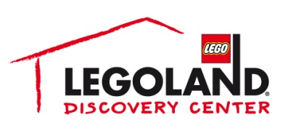
For more information:
Katie Clark
BRAVE Public Relations
404.233.3993
kclark@bravepublicrelations.com

**MEDIA ADVISORY**

LEGOLAND® Discovery Center Atlanta to host Talk Like A Pirate Adult Night, September 21
Phipps Plaza attraction welcomes adults to give their best pirate impression and receive giveaways

ATLANTA (September 13, 2017) – Ahoy matey! Adult LEGO® fans are encouraged to join in on the fun Thursday, September 21, with all hands on deck for Talk Like A Pirate Adult Night. LEGO® and pirate fanatics can recite their pirate impressions and take $5 off their ticket price while making everyone shout “shiver me timbers”! Squashbucklers will be taken on a nautical adventure with pirate-themed activities, including a scavenger hunt, giveaways and more!

WHAT: Talk Like A Pirate Adult Night at LEGOLAND® Discovery Center Atlanta

WHEN: Thursday, September 21 from 7 – 9 p.m.

WHERE: LEGOLAND Discovery Center Atlanta
Phipps Plaza | Buckhead
3500 Peachtree Road NE
Atlanta, GA 30326

HOW: Guests who talk like a pirate at admissions will receive a discount on entry.

For more information, visit www.facebook.com/LDCatlanta
or www.atlanta.legolanddiscoverycenter.com.

