World-renowned violinist Kyung Wha Chung to release a new album on Warner after 15-year hiatus Bach Sonatas & Partitas on October 7

Kyung Wha Chung will also be returning to Carnegie Hall to perform on May 18, 2017

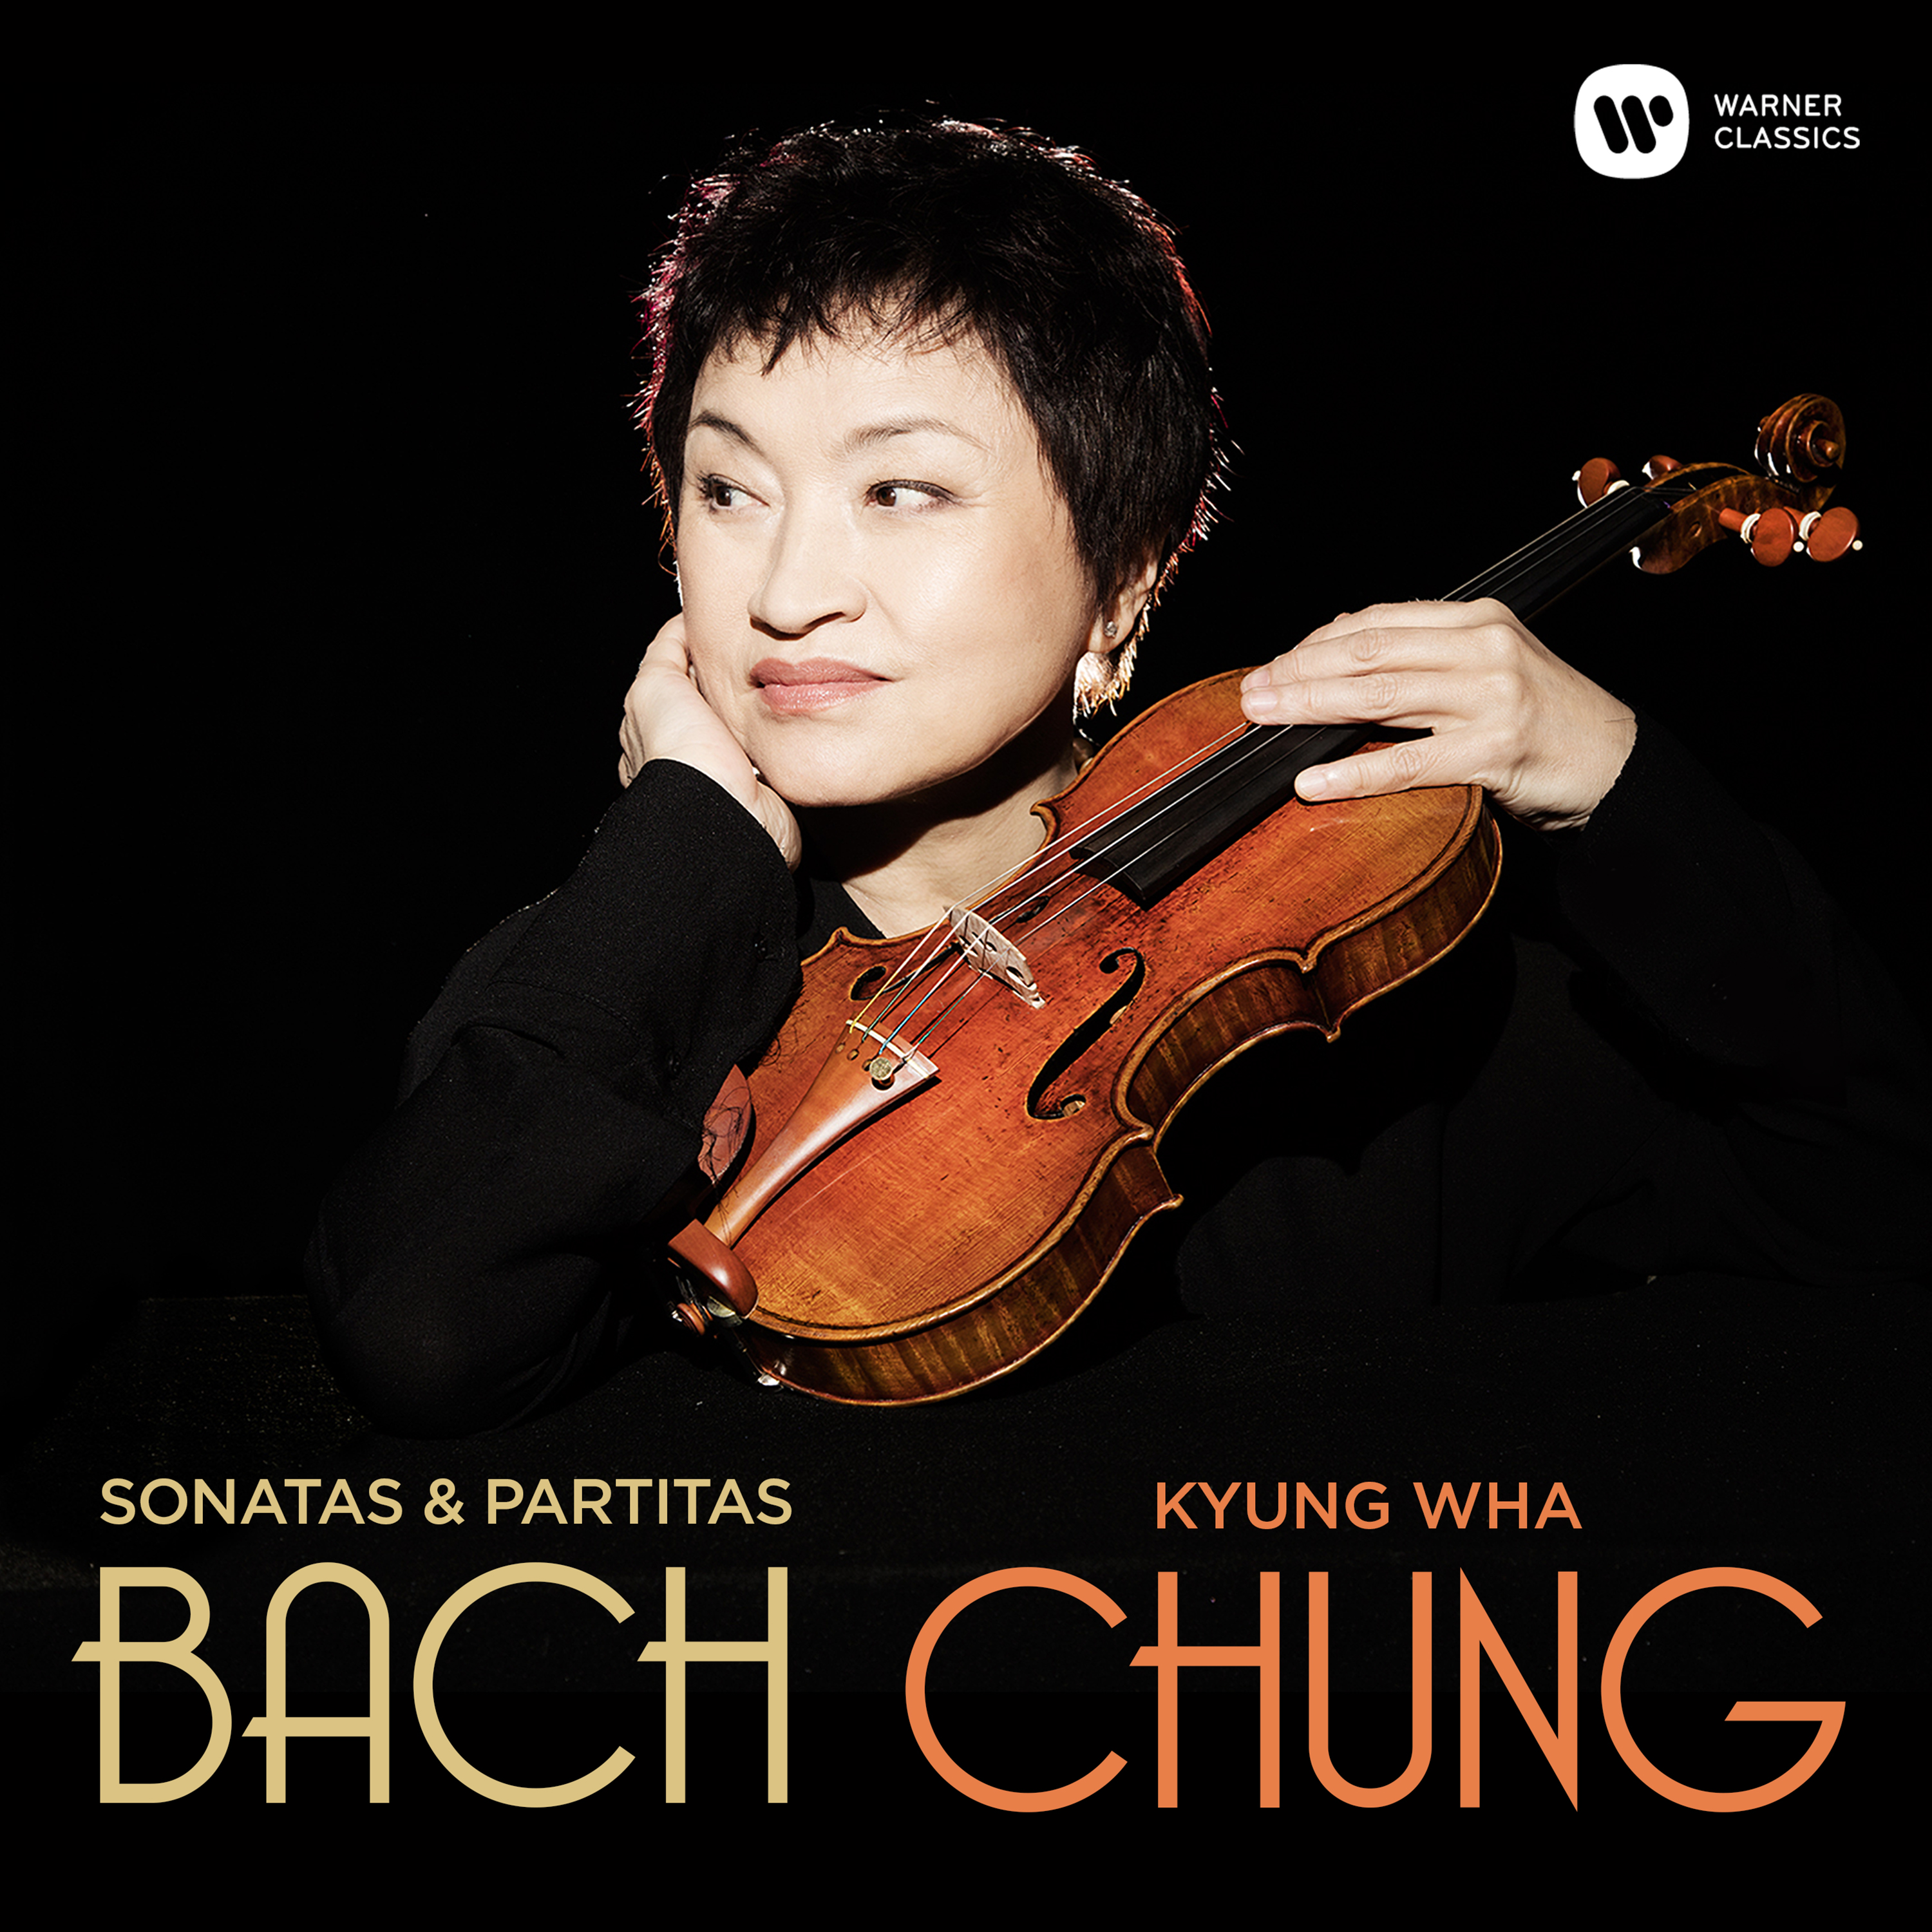

“One of the greatest violinists of the last half-century, revered for her incandescent performances,” was how the Financial Times described Kyung Wha Chung in December 2014. She had just given a recital at London’s Royal Festival Hall, her first concert in the city since 2003. It included an electrifying performance of the monumental Chaconne from Bach’s Partita No.2 in D minor, BWV 1004. Describing the recital, The Sunday Times wrote of “a sound of utter resplendency, a brilliantly shining tone right across the instrument; a projection to make light of the acoustic distances to be travelled; an ardour, physical, musical and spiritual, that seems undimmed by years ... extraordinary music-making.”

Now, Kyung Wha Chung has made her first-ever recording of Bach’s complete works for solo violin, and her first studio recording in some 15 years. In her own words, the project typifies “the unending quest of my musical journey”. It renews her relationship with Warner Classics, which dates back to 1978 and which, during her time as an EMI Classics artist 1988 and 2000, produced an important series of recordings. These included concertos with such conductors as Simon Rattle, Riccardo Muti and Klaus Tennstedt, music for violin and piano with Peter Frankl and Itamar Golan, and works for piano trio with her siblings Myung Wha Chung and Myung Whun Chung.

In 2005 an injury to her left hand forced Chung to stop performing in public for a total of five years. Over that period she focused her efforts on teaching (not least at her alma mater, New York’s Juilliard School) and on raising her family, but, while receiving treatment to repair her damaged finger, she continued with intensive ‘virtual’ practice. As she told Reuters: "… After coming out of five years of not playing, and then to do the six unaccompanied Bach sonatas and partitas, after not having played...I worked it out all in my head...with every possibility of bowing and so on."

She returned to the concert platform in 2010 with Vladimir Ashkenazy and the Philharmonia Orchestra and in 2013 began to tour again in Asia. The Bach Sonatas and Partitas were recorded at St George’s Bristol in Spring 2016 in collaboration with Grammy-winning producer Stephen Johns. Kyung Wha Chung will perform next year at Carnegie Hall on May 18th, 2017.
TRACKLIST
Bach Sonatas & Partitas

CD1
Violin Sonata No.1 in G minor, BWV 1001
- Adagio
- Fuga
- Siciliana
- Presto
Violin Partita No.1 in B minor, BWV 1002
- Allemanda
- Corrente
- Sarabande
- Tempo di Borea
Violin Sonata No.2 in A minor, BWV 1003
- Grave
- Fuga
- Andante
- Allegro
CD2
Violin Partita No.2 in D minor, BWV 1004
- Allemanda
- Corrente
- Sarabanda
- Giga
- Ciaccona
Violin Sonata No.3 in C major, BWV 1005
- Adagio
- Fuga
- Largo
- Allegro assai
Violin Partita No.3 in E major, BWV 1006
- Preludio
- Loure
- Gavotte en rondeau
- Menuet I
- Menuet II
- Bourrée
- Gigue

About Kyung Wha Chung
One of the first musicians from South Korea to achieve international stardom, Kyung Wha Chung began studying the violin aged six. At the age of twelve she went to the USA, where she studied at New York’s Juilliard School with Ivan Galamian (described in the New York Times as “maybe the greatest violin teacher in history''), also receiving coaching from two further legends, Joseph Szigeti and Szymon Goldberg. She leaped to fame when she won the prestigious Leventritt Competition in New York in 1967 and embarked on a high-profile international career. In recent years she has herself become a professor at the Juilliard School, and in South Korea has taught at Ewha University and been active as co-artistic director of the Great Mountains Music Festival.

She described her approach to playing in an interview with The Strad magazine in 1989: “As Szigeti taught, there are colors everywhere in music, and every piece has its own atmosphere. After all, everything is related to nature, all the composers worked with nature and nature is filled with every kind of color. Each player has his own way of gauging the intensities, but every sensitive musician will somehow translate these colors into sounds ... I’ve learned that ego isn’t the determining factor ... the music must come from a deeper source. You must let the music speak through you, and experience it completely. There is no short cut to musical integrity. You must do it honestly.”

