ENCARNA MORENO

Encarna Moreno Hair Salon

Encarna Moreno, with more than 35 years of experience in the sector, owns two hairdressing salons in Seville. The last one was inaugurated in 2019 in the city center with almost 300 meters that include a space dedicated exclusively to training, as well as for commercial brands. it’s the Education Room for L’Oréal Professionnel in Andalusia.

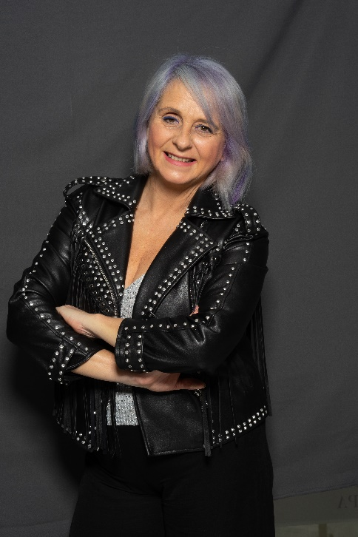
She is passionate about her work, which she enjoys more than anyone else drawing hair with her hands, as she describes her own "art". Encarna is a stylist, a hairdresser and a make-up artist. She has extensively studied, with a Master's degree in aesthetics and as an Image Consultant in Sevilla de Moda, in addition to receiving training throughout an extensive career with leading figures in the hairdressing and makeup sector. In 2018 she decided to start the Master in Executive Management for Excellence in Business for Hairdressing Salons at the prestigious ESCP Europe school with L'Oréal Professionnel. In addition, in 2019 she traveled to New York to train in balayage and to Paris to attend an updos training at the prestigious Alexander Academy. Besides, she took a course on Image Consulting and Personal Shopper Sevilla de Moda. Her goal is always to grow as a professional while she transmits her knowledge to her clients, to whom she offers personalized service and attention to detail.

Brides are an important point in the professional portfolio of Encarna Moreno. She is a reference in the Sevillian bridal field, where she stands out for her work as a trainer in grooming courses for brides that she teaches throughout Spain, where she transmits all her knowledge of both hairdressing and consulting to achieve the best service to brides and guests. Another of her great passions is the world of fashion. Encarna is a Fashion Blogger, she has her own blog where she writes about trends in fashion and beauty and she likes to be up to date with everything related to this world. Her collections are seen every year at numerous events and parades. And not only behind the scissors but also as an organizer, since Encarna is responsible for the artistic group of Peluquería con Arte, an entity that organizes the flamenco hairdressing parade.

As a trainer, she teaches courses and masterclasses throughout the country. Her updos and balayage trainings always enjoy great success, reaching up to 20 editions in the same year. With the inauguration of the new training center in Seville, her training has become more centralized in the Andalusian capital, although she continues to travel to share knowledge in cities such as Barcelona, ​​Madrid, Bilbao, Valencia, Zaragoza, Vigo or Malaga. She is currently the trainer of L’Oréal Paris in the trainings the brand imparts in Andalusia. She has participated in important events such as ArtExpressión, in Asturias, CosmoBeauty Barcelona, ​​in Barcelona, ​​one of the most important in the sector at a national and international level. At the same time, since 2017, she has organized the event, "Brides with charm", alongside renowned professionals from the Andalusian bridal sector and held at the Palacio de los Marqueses de la Algaba. Her latest trainings have been carried out in Barcelona at the Miguel Griñó School, and in Vigo for the Italian firm Consulting Concept.

She also collaborates in events related to the world of cinema and television. In 2019 she collaborated as a hair and makeup assistant for the Goya Awards gala held in Seville and in January 2020 she was selected as the hairdresser for the Feroz Awards. She has also participated in Canal Sur talking about her awards.

Other merits for her professional excellence are the two TheQhair stars she obtained in October 2019, Creativity and Global Salon. In February 2020, she received the Iconic Salon 2020 seal that distinguishes her salon at the national level as one of the best in Spain.

As a creative hairdresser, she also has a track record full of recognition:
- Regional finalist of the L'Oréal Style & Color Trophy (2017)
- Best Andalusian Hairdresser Picasso Awards (2018), being the first woman to win this award.
- Supremes Awards (2018)
- Winner of the Color Challenge Matrix Spain with her collection "Graffiti" (2018), an award that allowed her to travel to New York.
- Best Bridal Hairdresser at the Tocado Magazine Awards (2019)
- Finalist Trend Vision Award in the Creative Artist Spain category (2019)
- Winner of the Cazcarra Award of Andalusia (2019)
- Winner of the Color Trophy Spain of L’Oréal Professionnel as Best Hairdresser in Spain and in the Color category (2020) and representative of Spain in the International Final in 2021.
- Winner of the Wedding Awards of the bodas.net wedding portal from 2016 to 2020, successively.
Her collections have been published in specialized magazines in our country and the rest of the world. The last one in December 2020, when she was on the cover of Interlook magazine, in addition to occupying inside pages. In December 2020 Matrix Spain interviewed her, as well as Salon Secret, about trends in color and balayage.

She is also a member of Club Fígaro, TheQhair and the Association of Business Women of Seville.

Thirty-five years in which she has not wasted a minute to grow and learn make Encarna a professional who shows that passion for work can do anything. And if you also combine it with a service offered by great professionals, the best products and excellent customer service, we have as a result a professional of reference for everyone.

