Jörk Meyerrose becomes New Consumer DIRECTOR at SENNHEISER

Marlow, UK, 1 July 2020 – Sennheiser has appointed Jörk Meyerrose as Consumer Director. In this position, he will be responsible for the entire Consumer Division and therefore the audio specialist's worldwide headphones and soundbar business.

Jörk Meyerrose has been promoted to the position of Consumer Director at Sennheiser, having held a wide variety of positions with the company since he joined in 1999. "Thanks to Jörk's many years at Sennheiser, he not only knows the company, but also our consumer business from numerous perspectives," said Andreas Sennheiser, Co-CEO at Sennheiser. "With his strong sales background and passion for the Sennheiser brand, Jörk brings a strong skillset and wealth of experience with him to further develop the Consumer Division," added Daniel Sennheiser, Co-CEO.

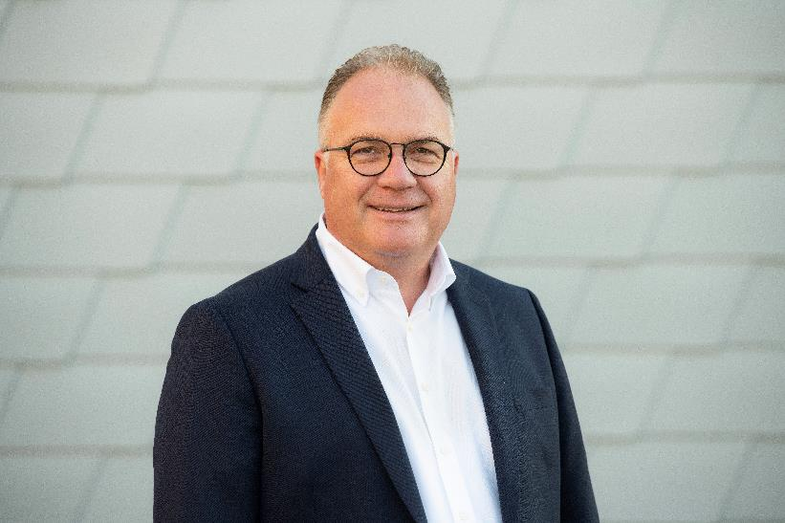
Jörk Meyerrose is the new Consumer Director at Sennheiser

Jörk Meyerrose began his career at Sennheiser in 1999 in the controlling department. He then held various positions in the sales department with roles in market management, global key account management and direct sales. Since 2015, he has been responsible for the successful sales and marketing in the Latin America region.
Under the leadership of Jörk Meyerrose, Sennheiser's consumer business will be further developed in the four core areas of Premium Headphones, Audiophiles, TV Listeners and Soundbars. "In this exciting new role, I am looking forward to the tasks ahead. I will be able to build on my work at Sennheiser with the support of the entire consumer team," said Jörk Meyerrose.

Sennheiser had announced its intention to further strengthen the two Consumer and Professional divisions to make them more independent in order to align the company for new challenges to ensure its' continued success in the future.

About Sennheiser
Founded in 1945, Sennheiser is celebrating its 75th anniversary this year. Shaping the future of audio and creating unique sound experiences for customers – this aim unites Sennheiser employees and partners worldwide. The independent family company, which is managed in the third generation by Dr. Andreas Sennheiser and Daniel Sennheiser, is today one of the world’s leading manufacturers of headphones, loudspeakers, microphones and wireless transmission systems. In 2019, the Sennheiser Group generated turnover totaling €756.7 million. www.sennheiser.com

Global Press Contacts

Maik Robbe
maik.robbe@sennheiser.com

Emily Ackland
sennheiser@harvard.co.uk

