For immediate distribution

Sweetwater Studios to Host Master Class Featuring Rick Nielsen of Cheap Trick
Master Class to be Held on November 2-3 is Open to Students on a First Come-First Served Basis
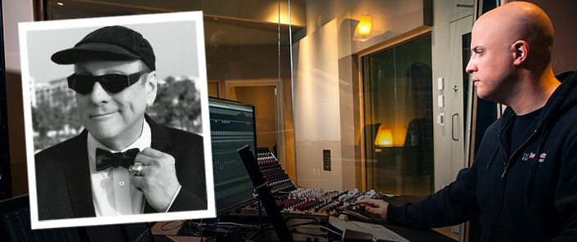
September 26, 2018, Fort Wayne, IN - Sweetwater Studios, the world-class, multi-room recording facility owned and operated by top music retailer Sweetwater, will host another installment of its hands-on recording master classes next month, featuring Rick Nielsen — lead guitarist of the legendary band Cheap Trick. The class, which is the second one in which Mr. Nielsen will have participated in, is to be led by Sweetwater Studios’ Mark Hornsby and will take place on November 2 and 3. The master class is open to registered students on a first come-first served basis.

The master class will be held in Sweetwater Studio’s Studio A and divided up into two jam-packed days. The first day, Pro Recording Techniques and Recording Overdubs will focus on setting up the session, dialing in sounds, and tracking with Rick and Sweetwater Studio’s own musicians: Don Carr, Nick D’Virgilio, Dave Martin, and Phil Naish. Day two, Editing and Mixing Tracks will focus on the fine-tuning process, from comping takes and adding effects to the previous day’s tracks to mixing in Pro Tools and adding post-processing.

- Who: Sweetwater Studios and Senior Producer / Engineer Mark Hornsby
- What: Recording Master Class with Rick Nielsen
- Where: Sweetwater Studios, 5501 US Highway 30 West, Fort Wayne, IN
- When: Friday, November 2 to Saturday, November 3 between 9:00 a.m. and 6:00 p.m.
Rick Nielsen is the celebrated lead guitarist of Rock n’ Roll Hall of Fame inductees Cheap Trick. His blistering guitar work has been a key component of all of their best songs, and for the past four decades he has wowed audiences with his singular stage presence and wit. On top of being a veteran of the stage and studio, Nielsen is also a noted guitar collector and pioneered several unique designs with the Hamer guitar company.
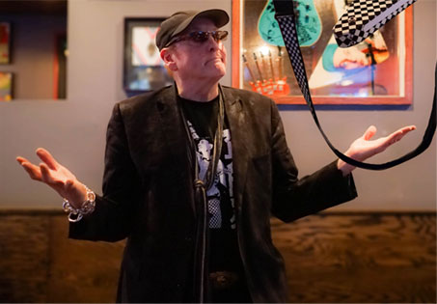
“Our last master class with Rick was so successful that we’re doing it again,” Hornsby said. “Rick has an amazing track record in the studio and a ton of insight from his experience — both as a guitarist and as a key contributor to some of rock’s most memorable recordings. We are truly excited about the energy and learning experiences are bound to come out of these sessions.”

Sweetwater Studios: 360 degrees of talent
Guitarist Don Carr is no stranger to Sweetwater Studios, and his versatile playing and easy-going manner have graced many of Sweetwater’s gear demo videos. In addition to being on the Sweetwater Team, Carr logged two decades with the Oak Ridge Boys while maintaining a busy recording schedule in Nashville. He has also shared the stage with the likes of Lou Rawls, James Brown, and Merle Haggard.

Bassist Dave Martin is a member of the Western Swing Hall of Fame and owned and operated Java Jive Studio in Nashville, TN. His rock-solid bass playing has anchored albums by Robben Ford and Nokie Edwards, to name a few. He has also shared the stage with The Platters, The Box Tops, and Robert Earl Keen among others. Meantime, Keyboardist Phil Naish is a skilled arranger and producer, with several Grammy winning albums to his name. He’s also worked with legendary artists such as Dolly Parton, Boz Scaggs, Elton John, and Kenny Chesney.

Drummer Nick D’Virgilio’s work crosses multiple genres, having played alongside the likes of Genesis, Tears for Fears, Sheryl Crow, and the Animals. In addition to the rock and pop circuits, he’s also made a name for himself in progressive music with his band’s Spock’s Beard and Big Big Train.

Registration is just $1,495 per person and includes:
- Two full days of learning sessions in Sweetwater Studios, including lunches
- Dinner with Mark, Rick, Don, Dave, Phil, and Nick
- Lodging for two nights
- Certificate of completion
To register, please email studio@sweetwater.com or call (800) 386-6434. To learn more, please visit http://www.sweetwaterstudios.com/mc-rick-nielsen-11-02-18/
About Sweetwater Studios
Sweetwater Studios is a wholly owned subsidiary of Sweetwater Sound, Inc., the largest online music instrument retailer in the country. With three world-class studios designed by Russ Berger and access to a greater diversity of musical equipment and professional audio gear than any other recording studio in the world, Sweetwater Studios is able to accommodate just about any recording, mixing or mastering project, no matter how simple or complex. With renowned staff producer Mark Hornsby at the helm, who has worked on many Grammy-award winning albums, Sweetwater Studios also has an exceptional staff of producers, engineers, session musicians and studio technicians. For more information on Sweetwater Studios, please visit http://www.sweetwaterstudios.com.

Media contacts
Steve Bailey
Public Relations
Hummingbird Media
+1 (508) 596 9321
steve@hummingbirdmedia.com

Jeff Touzeau
Public Relations
Hummingbird Media
+1 (914) 602 2913
jeff@hummingbirdmedia.com

