For immediate distribution

Powersoft at InfoComm 2017: Quattrocanali, Armonìa v2.10, New OEM Modules,
DEVA App, RU Credited Training Sessions and More

Orlando, FL, May 30, 2017 – Powersoft [Booth 5871], a leading manufacturer of cutting edge power amplification technology, will demonstrate several of its exciting technologies for Installation and OEM applications at InfoComm 2017, including the United States debut of the company’s brand new Quattrocanali amplifier platforms for installation and MiniMod 4 and LiteMod 4HC modules.

At InfoComm 2017, Powersoft will also unveil the latest iteration of its latest Armonìa Pro Audio Suite™ software, Armonìa v2.10. The updated software, which is now fully integrated with Rational Acoustic Smaart v8, hosts a new interactive tuning plugin — delivers an impressive array of features that promise to bring even greater efficiency to the end user. Among these are offline manipulation of settings such as Gain, Polarity, Delay, Sum, Average, Merge and many others.
In the realm of training and development, Powersoft will also offer a Renewal Unit (RU)-granting course entitled “How to Optimize Fixed Install Design Using DSP in Class D Amplifiers,” which is available for pre-registration now by visiting this registration link.
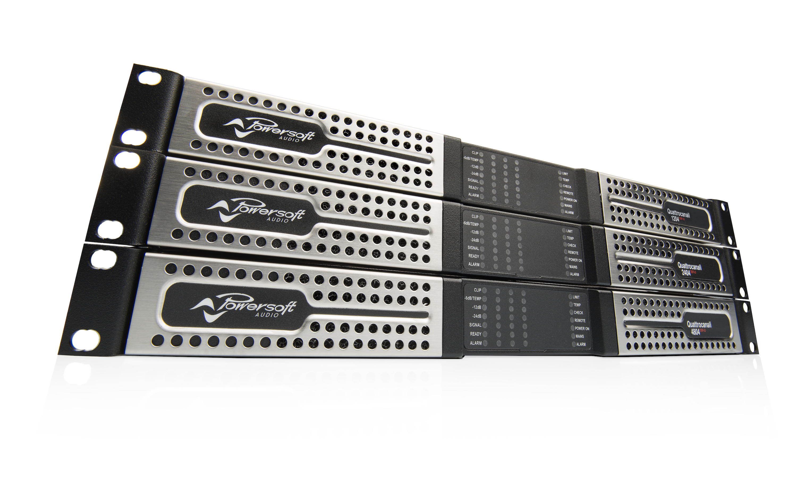
The Powersoft InfoComm booth provides a valuable opportunity for industry professionals to gain insight on the forward-thinking features of Powersoft products. This year, four dedicated zones, dedicated to Amplifier Modules, M-Force, Installation, and Deva, will surround a hospitality and bar area.

Powersoft will conduct face-to-face sessions at two demo areas at the booth: one of which will be designated for OEM products and the other for installation lines. Staff-led demonstrations will offer training in some of the remote control capabilities of Armonía Pro Audio Suite in installation settings, including Quattrocanali remote GPI/VCA with small speakers, the X series web app, and 3rd party remote control with QSC, Crestron, and Xilica speakers. OEM-directed demos will delve into the Armonia ProManager software, touching upon installation processes, creation of custom models, and integration with Armonía.

Quattrocanali, MiniMod 4, and LiteMod 4HC Hit the US

Powersoft’s Quattrocanali 4-channel Class D amplifiers will be making their U.S. debut at this year's InfoComm booth. Delivering the crystal-clear sound and remarkable efficiency that Powersoft is known for in a single rack space unit, the Quattrocanali provides installation designers with an exciting new option for any install where space comes at a premium but top-notch performance is a requirement. Three models will be available ranging from 300-1200 watts per channel and rounding out Powersoft’s 2-channel Duecanali and 8-channel Ottocanali offerings.

The MiniMod 4 and LiteMod 4HC modules will also be making their US debut. MiniMod 4 is an integrated module offering universal mains switching mode power supply with Power Factor Correction and a total of 600W of audio amplification. Configurable as four, three, two channels, or a single high power output channel, it is a versatile and compact solution for low power applications.
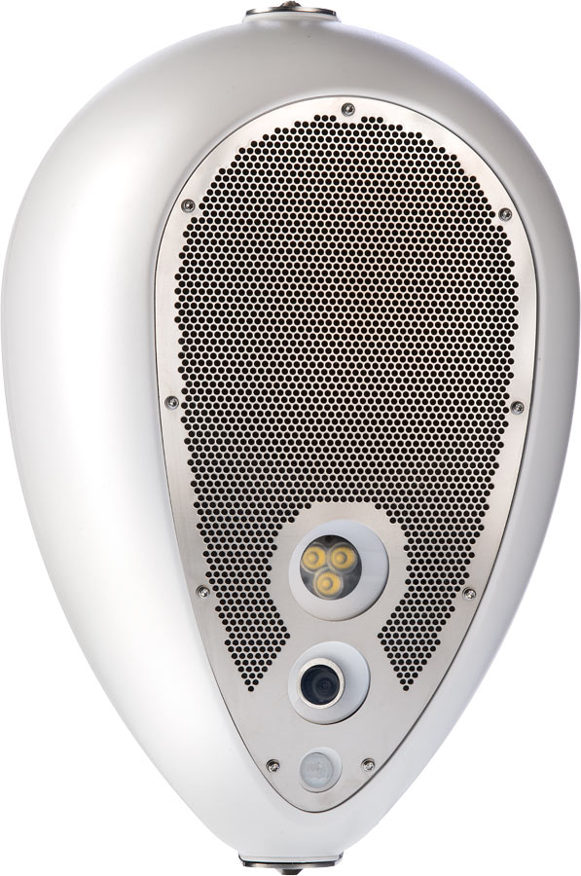
Like the MiniMod 4, LiteMod 4HC is a versatile module packing an impressive 2400 watts of power across four output stages while remaining incredibly compact. It can be configured for four, three, two, or single-channel output and both 2Ω as well as 8Ω operation and is perfect for high channel count applications, three- and two-way systems, subwoofers and satellite systems.

New Deva App
Powersoft will also introduce the new DEVA App, which allows unprecedented control of Deva multimedia units. Through an iPad, attendees can interact with units programmed for Infotainment, Entertainment and Safety services. Attendees will be guided through using the app to monitor individual DEVA units in a zone, access zone details, and perform actions such as playback, all remotely.

“We are excited to have the US debut of some of our latest offerings for the Installation and OEM sectors take place at InfoComm 2017 this year,” says Francesco Fannichi, Brand and Communication Director, Powersoft. “Quattrocanali completes our oft-specified series of efficient, powerful, and great-sounding amplifiers for install applications in an elegantly compact package, while our new MiniMod 4 and LiteMod 4HC OEM modules enable exciting possibilities for powered speaker design. We are also excited to continue our tradition of providing high-value training opportunities for InfoComm attendees with both our credited training session and booth demonstration programs.”



RU Credited Training Session
Powersoft will provide InfoComm attendees with an opportunity to earn certification renewal credits while learning how to easily design and specify fixed install systems using DSP integrated Class D power amplifiers. The on-site training session will be hosted by Powersoft’s Marc Kocks, Business Development Manager, Fixed Install. Those participating in the course will earn 1.5 Renewal Units (RUs) towards their Infocomm Certified Technology Specialist (CTS) credential and a Certificate of Completion.

Kocks will guide attendees through crest factor calculation as it pertains to system performance, delve into the capabilities of Powersoft’s Class D amplifiers, and discuss DSP processing featured on Powersoft’s X series and DSP+D amplifiers. The session will culminate in a walk-through of the system design process with the aid of powerful tools designed to optimize system performance.

Session registration is required and is now open on a first-come, first-served basis for trade show registrants. To sign up, please visit this link and navigate to course MT61.

For further information, contact:
Jeff Touzeau (media contact)  Hummingbird Media  Tel : +1 (914) 602 2913  Email: jeff@hummingbirdmedia.com | Francesco Fanicchi  Powersoft (Florence, Italy)  Tel: +39 346 9719798  Email: francesco.fanicchi@powersoft.it

Or visit www.powersoft-audio.com

About Powersoft:
Powersoft is the world leader in lightweight, high power, single rack space, energy efficient amplifiers for the professional audio market. Founded in Italy in 1995, headquartered in Florence, Italy, with offices in Camarillo, CA, Powersoft couples the experience and precision of its production department with exceptional components to deliver products with perfect audio response and high performance reliability. Its state-of-the-art amplifiers can be found in an array of markets, ranging from stadiums, sporting arenas, theme parks, performance venues and airports to convention centres, churches and clubs, and are used by the world's leading tour sound companies. For more information, visit the Powersoft website @ www.powersoft-audio.com

