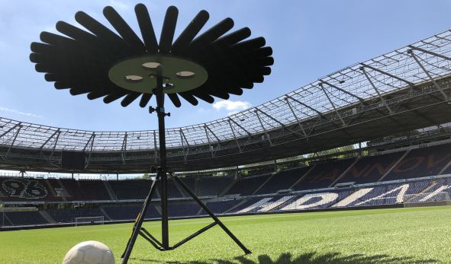

NAB 2019: Sennheiser and Neumann to showcase microphone, wireless and monitoring highlights

Wedemark/Berlin, March 26, 2019 – Audio for video solutions for every camera type, wireless microphone systems from entry-level to high-end professional, as well as studio monitoring and microphone solutions – at NAB 2019, the portfolio on show from Sennheiser and Neumann reflects the breadth of today’s broadcasting world. Product highlights from Sennheiser include the SK 6212 mini-bodypack transmitter from the Digital 6000 series and the new XSW-D series entry-level camera kits. Neumann will spotlight the new KH 750 DSP subwoofer and the Neumann NDH 20 studio headphone. Certain to generate a buzz at NAB is Sennheiser’s immersive AMBEO 3D audio technology, with a prototype of an AMBEO Sports Microphone Array for capturing 360º sound on display. Visitors can also experience Sennheiser’s remarkable AMBEO Soundbar first hand.

“There is an incredible diversity in both broadcasting and audio for video but all of our customers are united in striving to deliver extraordinary content that is also technically impeccable,” said Greg Beebe, Director Professional Audio, Sennheiser. “We are proud to help customers take on this challenge with a portfolio of innovative and leading-edge audio solutions that make it possible to be extraordinary, every day.”

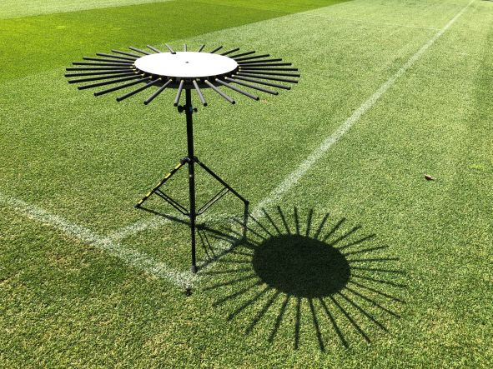 | The prototype of an AMBEO Sports Microphone Array for 360° sound will be on display at the Sennheiser and Neumann NAB booth (C1307)

Sennheiser Wireless Audio
Sennheiser’s latest wireless series, XS Wireless Digital, includes entry-level audio for video solutions for DSLR and DSLM cameras. Working on 2.4 GHz for worldwide operation, the systems provide videographers and content creators with a wireless system that adds effortless audio to their video. The XSW-D Portable Lavalier Set includes an easy-to-use transmitter/receiver combo and ME 2-II lavalier mic as well as all accessories to get started immediately. The XSW-D Portable ENG Set features an additional transmitter for an existing handheld dynamic microphone.

Sennheiser’s XSW-D series is an ideal entry into wireless audio for video | 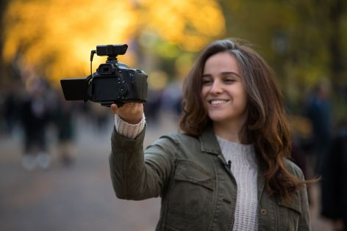

Content creators who prefer to work with their smartphones, will find an interesting alternative in the Memory Mic. This clip-on model works wirelessly with any smartphone, at any distance, via a companion app.

Sennheiser will also display the ew 100 ENG G4 combo system from its best-selling wireless series for camera use, evolution wireless. The kit includes a camera receiver with both a plug-on transmitter and a bodypack with a lav. The ew 500 FILM G4 is both a performance and sound upgrade, featuring more bandwidth/channels, increased RF output power and the professional MKE 2 lavalier mic with a fur windshield. Also on show will be the ew 500 G4-KK205 system, which combines Sennheiser wireless technology with the sound of the Neumann KK 205 microphone capsule.

The tiny SK 6212 is the latest addition to Sennheiser’s Digital 6000 series | 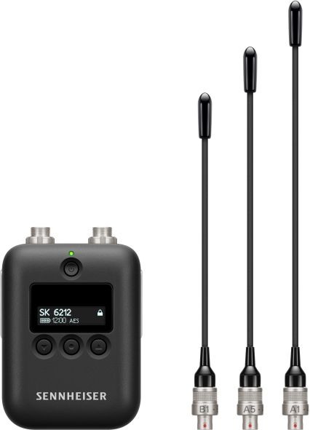

Looking to digital solutions for broadcast, film and music productions, Sennheiser’s Digital 6000 series offers the ideal wireless audio tools. Both the Dante-enabled rack-mount receiver and the digital/analog camera receiver of the series, the EK 6042, will be shown at NAB. These partner with handheld and bodypack transmitters, including the new SK 6212 mini-bodypack transmitter. Also on display is the rack-mount charging solution for the transmitter batteries.

Sennheiser camera and boom microphones
For users seeking an on-camera microphone for DSLRs/DSLMs, Sennheiser will be presenting its MKE microphones, including the MKE 400 mini-shotgun, the larger MKE 600 and the MKE 440 stereo model. Meanwhile, the MKH series provides ideal options for professional filming and broadcasting tasks: Sennheiser’s classic MKH 416, alongside the MKH 8060 short gun microphone for on-camera use and the MKH 8070 long gun microphone for accurate long-range pick-up will all be on display at the booth.

AMBEO
The Sennheiser AMBEO range offers various recording solutions for 3D audio: From the AMBEO Smart Headset that captures immersive audio with smartphone simplicity to the AMBEO VR Mic and the AMBEO Sports Microphone Array for 360° audio pick up in sports broadcasting. NAB visitors will also get the opportunity to listen to the brand-new AMBEO Soundbar, available from the end of May. The all-in-one 5.1.4 soundbar – which does not require additional speakers or subwoofer – will enable (sports) broadcast mixers to critically monitor how their immersive content would sound on a real-world device.

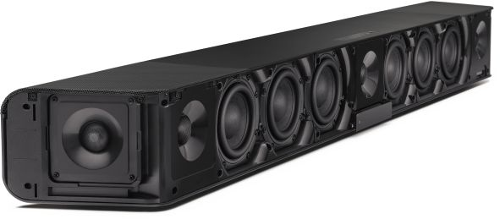 | The AMBEO Soundbar – pictured here without its cover – provides immersive 5.1.4 sound without the need for a subwoofer. It enables broadcast mixers to critically evaluate their mixes on a premium product

Neumann studio headphones
Neumann has expanded its product portfolio to also include studio headphones: The new NDH 20 combines a newly developed Neumann transducer with a comfortable, closed-back design that includes soft memory foam ear pads. Featuring a balanced, linear sound image, fine resolution and excellent isolation, the headphone is ideal for monitoring, editing and mixing even in loud environments. The NDH 20 is foldable for easy transport, and is delivered with two detachable cables, one coiled, one straight.

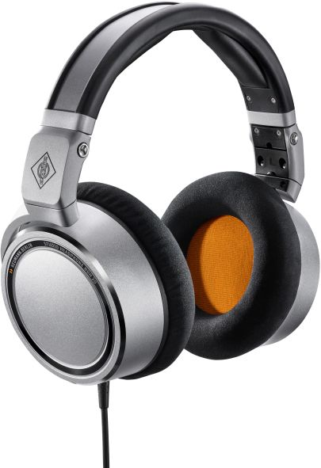 | The Neumann NDH 20 is a closed-back studio headphone with a flat frequency response and natural, detailed sound
Neumann monitoring loudspeakers – new KH 750 DSP subwoofer
The booth’s sound room gives NAB guests the opportunity to listen to the ultra-compact KH 80 DSP nearfield monitor and the new KH 750 DSP subwoofer. Both models are an ideal choice for the confined spaces of broadcast studios. A DSP engine optimises their output, enabling critical monitoring with reference class sound despite their compact size. In addition, both the KH 80 DSP nearfield monitor and the KH 750 DSP subwoofer can be controlled with the Neumann.Control app for iPad.

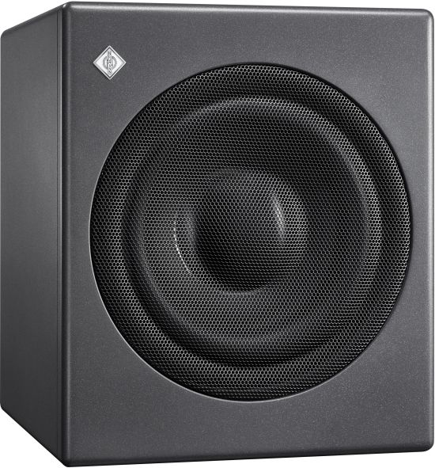  The new KH 750 DSP is a particularly compact subwoofer for broadcast, music and post production studios | 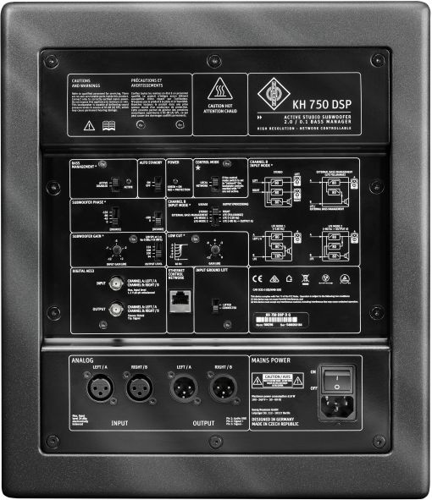

Neumann studio microphones
No Neumann presentation would be complete without classic studio microphones such as the U 87 Ai and the U 67 re-issue. Also available to experience hands on are the compact TLM 102, TLM 103 and TLM 107 studio mics, as well as the BCM 104 radio station mic. The KU 100 binaural head rounds off the microphones on show.

Visit Sennheiser and Neumann at NAB, Booth No. C1307.

iPad® is a trademark of Apple Inc., registered in the U.S.A. and other countries.

About Sennheiser and Neumann
Shaping the future of audio and creating unique sound experiences for customers – this aim unites Sennheiser employees and partners worldwide. Founded in 1945, Sennheiser is one of the world’s leading manufacturers of headphones, microphones and wireless transmission systems. With 21 sales subsidiaries and long-established trading partners, the company is active in more than 50 countries and operates its own production facilities in Germany, Ireland, Romania and the USA. Since 2013, Sennheiser has been managed by Daniel Sennheiser and Dr. Andreas Sennheiser, the third generation of the family to run the company. As part of the Sennheiser Group, Georg Neumann GmbH, known as “Neumann.Berlin”, is the world’s leading manufacturer of studio microphones. Founded in 1928, the company has been recognised with numerous international awards for its technological innovations. Since 2010, Neumann.Berlin have expanded their expertise in electro-acoustic transducer design to also include the studio monitor market, and have recently added studio monitoring headphones to their portfolio. In 2017, the Sennheiser Group generated turnover totaling €667.7 million.
www.sennheiser.com | www.neumann.com

Global Press Contacts

Andreas Sablotny Stephanie Schmidt
andreas.sablotny@neumann.com stephanie.schmidt@sennheiser.com
T +49 (30) 417 724 – 19 T +49 (5130) 600 – 1275

