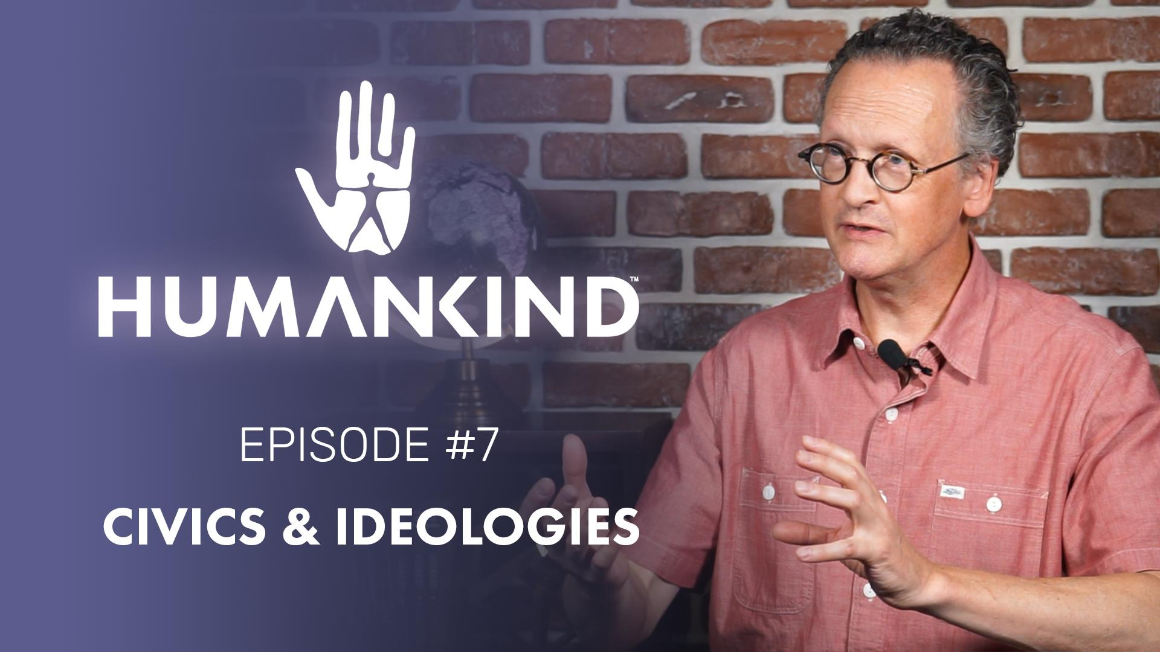

HUMANKIND FEATURE FOCUS #7 – “CIVICS & IDEOLOGIES”

AVAILABLE NOW

In Humankind, each moral and gameplay decision you make will shift your civilization’s ideologies, shaping your society and the story of your people.

Paris, July 23rd – What structure will your government have? Will your military have conscripts or professional soldiers? Will land ownership be Inherited or Communal? You may not be able to change these things in the real world, but these are the decisions that you will be making to shape your society in Humankind, our upcoming turn-based historical strategy title.
Each Civics decision has direct impacts on gameplay and will help to position the player along 4 ideological axes: economy, geopolitics, government, and society. These axes represent values and societal structure in the game world. Civics decisions will be triggered by game situations, so that they make sense in context, and will have direct gameplay impacts that will last throughout the game. Narrative events based on real historical situations will present additional choices that will shape your ideologies.
To see all of this in action, we invite you to check out the 7th installment of our Feature Focus series, “Civics & Ideologies”, available now!
We hope you enjoy,

- The Ampliteam
--
For more information about Humankind visit https://humankind.game, or follow us on Facebook, Twitter, & Instagram. Learn more about SEGA at https://sega.co.uk.

