RME Offers New Program Approved for AVIXA CTS Renewal Units
The course, “Unraveling Audio Networking: An In-Depth Look at Dante, AVB and MADI,” will count towards 2 RU units

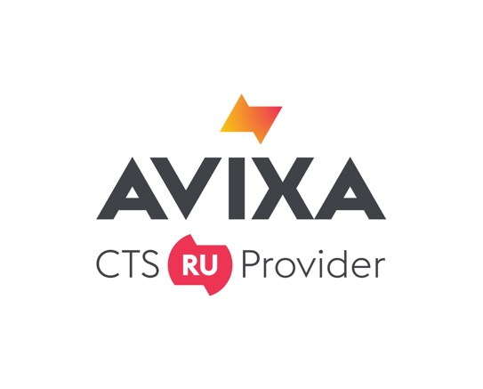
Fort Lauderdale, FL, February 19, 2019 – RME, premier German manufacturer of audio interfaces, has announced it has been named an official AVIXA CTS® Renewal Unit (RU) provider, granting more than 12,000 professionals holding AVIXA's Certified Technology Specialist™ credentials the ability to earn renewal units towards their certification by completing the course, titled “Unraveling Audio Networking: An In-depth Look at Dante, AVB and MADI” for 2 Renewal Units (RUs). Derek Badala, who serves as Director of Sales for Synthax, RME’s distributor, will lead the education program and participant Q&A.
"From recording studios to major concert productions, today's digital audio systems are more flexible and, as a result, more adaptable to the user's needs, in addition to being reliable and functional,” Badala said. “While these systems might be new to some users, they offer a plethora of benefits, including quicker setup times and easy operation. You no longer have to be an IT expert to use these systems.
“We designed this course to provide Certified Technology Specialists with the opportunity to learn the ins and outs today’s digital audio systems — including Dante, AVB and MADI,” Badala continued. “This course teaches how to harness the particular advantages of each system and helps specialists find the system that best suits their needs.”
As an AVIXA Renewal Unit Provider, RME demonstrates its commitment to providing quality education and training for audiovisual professionals, including Certified Technology Specialist™ (CTS®) holders and the specialized designations CTS®-D (Design) and CTS®-I (Installation).
RME submitted this course for approval to the AVIXA independent Certification Renewal Committee to offer industry-specific learning opportunities to CTS holders and others for continuing their professional development. To obtain approval, RU programs must feature experienced instructors with clear evidence of qualifications in the session topic. Each class must contain at least one relevant learning objective or industry-related purpose, relate to a specific exam topic area and exam level, then conclude with an assessment tool to demonstrate participants that have grasped the objectives. These criteria are vigorously reviewed by AVIXA's Certification Renewal Committee.
“Continuing education is critical to professional growth in an industry as dynamic as pro AV,” said Amanda Beckner, CTS, Vice President of Learning, AVIXA. “We are pleased to be associated with partners like RME, which is committed to investing in education and providing CTS holders access to its programs.”
For more on RME, visit rme-usa.com

About Synthax, Incorporated
Synthax Inc. is the exclusive USA distributor for RME digital audio solutions, Ferrofish advanced audio applications, myMix audio products, and ALVA cableware. We supply a nationwide network of dealers with these products for professional audio, broadcast, music industry, commercial audio, theater, military and government applications. For additional information, visit the company online at http://www.synthax.com.

About the Certified Technology Specialist Credential
AVIXA’s Certified Technology Specialist, Certified Technology Specialist – Design and Certified Technology Specialist – Installation are the only audiovisual certifications accredited by the International Organization for Standardization's (ISO) United States representative, the American National Standards Institute (ANSI). Accepted by the U.S. Veterans Administration for reimbursement under the Montgomery G.I. Bill, AVIXA certification programs are designed to establish and maintain widespread credibility for the audiovisual industry and the professionals who perform the work. AVIXA's CTS, CTS-D, and CTS-I holders renew their credential every three years through continuing education. Each certification holder is required to attain 30 renewal units (RUs). To learn more about AVIXA and the Certified Technology Specialist (CTS) certifications, visit www.avixa.org/certification.

Media Contacts:
Katie Kailus
Public Relations
Hummingbird Media
+1 (630) 319-5226
katie@hummingbirdmedia.com

Jeff Touzeau
Public Relations
Hummingbird Media
+1 (914) 602 2913
jeff@hummingbirdmedia.com

