Conrad Tao to be featured in World Premiere performance
of David Lang’s new opera The Loser at BAM, September 7-11

The piece, which features mezzanine-only seating with Conrad and baritone Rod Gilfry performing atop raised platforms, opens the 2016 Next Wave Festival
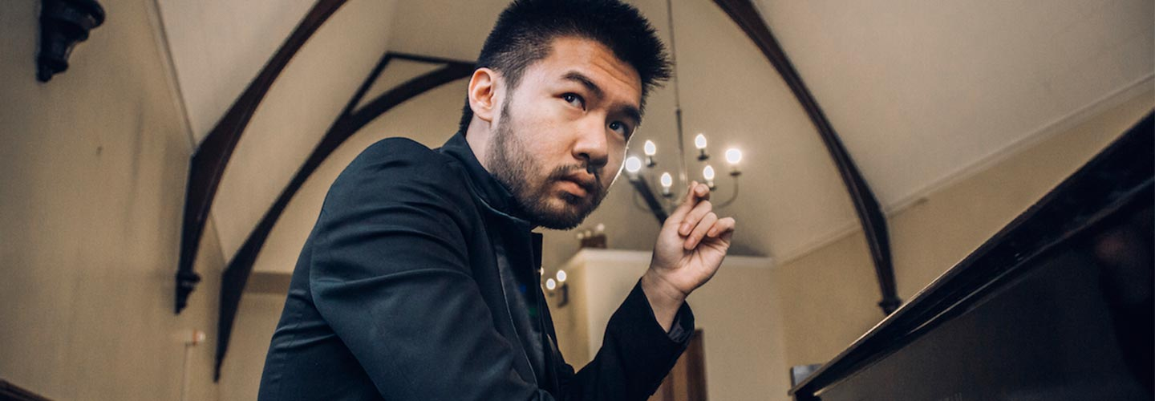

New York, NY - Conrad Tao will be one of two visible performers featured in the World Premiere of David Lang’s new opera monodrama The Loser, which will open BAM’s 2016 Next Wave Festival September 7-11 at the Howard Gilman Opera House. The work tells the story of an angry, misanthropic man whose dream of becoming a concert pianist is crushed when he and his friend encounter the genius of Glenn Gould.

Performances will feature an unusual stage design with custom-built platforms for Conrad and baritone Rod Gilfry, allowing the mezzanine-only audience to envision a loner engulfed in the void of an empty theater. Below and out of site will be conductor Karina Canellakis, and an ensemble of musicians associated with Bang on a Can.

In addition to the opera, Conrad also bookended his recent Warner Classics album, Pictures, with two pieces by David Lang alongside Mussorgsky’s Pictures at an Exhibition. The New York Times’ Anthony Tommasini called it “a fascinating album [by] a thoughtful artist and dynamic performer…played with enormous imagination, color and command.”

At just 22 years of age, Conrad Tao has been praised as a musician of “probing intellect and open-hearted vision” by The New York Times, a “thoughtful and mature composer” by NPR, and “ferociously talented” by Time Out New York. He was also the only classical musician selected to the Forbes influential “30 Under 30” list of people changing the world in 2011.

