**LONGINES DOLCEVITA X YVY – or when a leather strap redefines a watch**

*The winged hourglass brand is launching the new LONGINES DOLCEVITA X YVY line. Swiss designer Yvonne Reichmuth has given the famous rectangular timepieces a new identity, with sophisticated leather straps. Referencing the equestrian world so dear to LONGINES, their design is evocative of bridles and harnesses.*

**Shared values**

The complementary worlds of Longines and YVY have come together in an almost instinctive collaboration. Made of leather, the straps of the Longines DolceVita X YVY models are adorned and reinforced with metal details. Their finishes are impeccable and they feature striking references to the beloved equestrian world of the winged hourglass brand. “We wanted to develop a new approach together to the world of horses and their bridles”, explains Yvonne Reichmuth, founder of YVY.

The bond uniting the rider with his mount, that essential accessory that dresses the head and neck of the horse, reminds us of the alliance that develops between the human wrist and its timepiece. The designer adds: “The idea of a modular strap came about with the aim of creating a watch that could be worn with class in different styles.”

**Tradition rejuvenated by modernity**

Dressed in this contemporary design accessory, the youthful and glamorous Longines DolceVita X YVY line adapts to the desires of every wearer, as well as the events of their day thanks to the interchangeable strap system. Although it can be worn on its own, when the slim, complementary strap is combined with the watch, they transform into a stylish object that will captivate and touch every generation. “It is available with two different case sizes, to suit both men and women,” promises Matthias Breschan, CEO of the St-Imier based watch brand.

As the summer invites watch-wearers to bare their forearms and reveal the timepieces adorning them, the winged hourglass brand is unveiling its new line of Longines DolceVita X YVY models. The watch brand has matched its timepieces here with subtle double straps in leather, in three shades: double beige leather, brown and black with rivets. The design of these models was entrusted to the Zurich-based company YVY, creators of sophisticated glam-rock accessories popular with international stars and clientele looking for exclusivity.

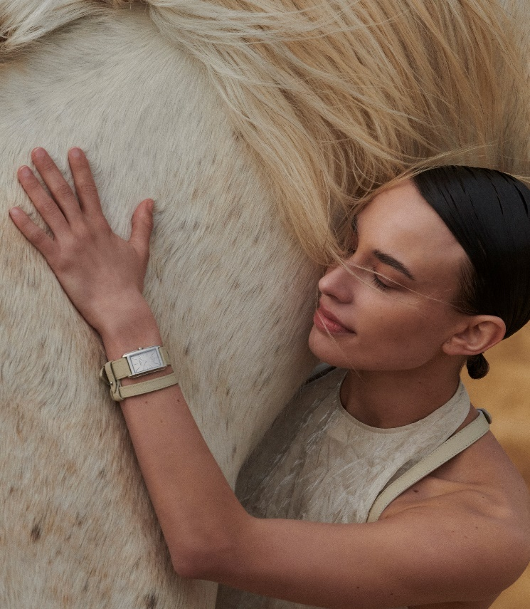

**Yvonne Reichmuth, YVY and Longines.**

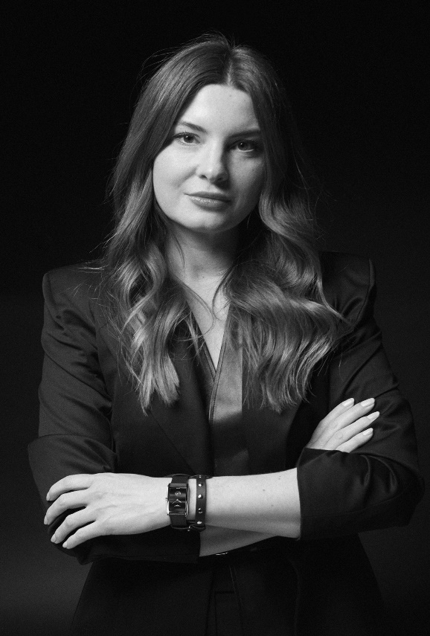

Yvonne Yvonne Reichmuth was born in Switzerland in 1986. After graduating in fashion design in Zurich in 2008, she started her career as a womenswear designer. A strong and growing passion for leather took her to Florence, where she mastered the processes for treating and transforming this noble material.  
Over the decade that followed, Yvonne Reichmuth gained a wealth of additional experience as a fashion designer. She has provided pieces for editorial and commercial shoots,designed costumes for films and made numerous one-of-a-kind pieces. As a guest speaker, Yvonne has also shared her experiences with various schools and organisations. In 2016, she founded her own company in the centre of Zurich, naming it YVY after the short version of her first name. She has been invited to collaborate on fashion shows in Paris, Milan, Beijing, Berlin, Copenhagen and Dubai and has received several distinctions and prizes from the fashion world (Swiss Textile Prize for Young Fashion Entrepreneurs, Premium Young Talent Award). Her designs are worn by celebrities like Billie Eilish, Cardi B, Taylor Swift, Kristen Stewart, Monica Bellucci, Kylie Jenner, Gwen Stefani and Janet Jackson, as well as by a young and trendy audience.

Her strength lies in the timelessness of her collections, which are independent of the seasons and are often inspired by the equestrian world so dear to Longines. The affinities between the two companies were obvious and the resulting collaboration with the winged hourglass brand has redefined the look of a selection of models from the Longines DolceVita collection.

*Longines has been based at Saint-Imier in Switzerland since 1832. Its watchmaking expertise reflects a strong devotion to tradition, elegance and performance. With many years of experience as a timekeeper for world championships in sport and as a partner of international sports federations, Longines has forged solid and lasting links with the world of sport over the years. Known for the elegance of its timepieces, Longines is a member of the Swatch Group Ltd, the World’s leading manufacturer of horological products. With the winged hourglass as its emblem, the brand has outlets in over 150 countries.*