

November 3, 2023

For immediate release

Contact Jason Silverman, jason@upstatefilms.org

845-876-2515

Upstate Films Announces “The Mark”

State-of-the-art screening room at The Orpheum in Saugerties to open in January

[Upstate Films](https://www.upstatefilms.org/) has begun construction on a project that seems destined to become a local favorite. The Mark, a film and video screening room located at the Orpheum Theatre in Saugerties, will be an intimate 99-seat space with outstanding sightlines, comfortable seats and state-of-the-art audio.

The Mark is scheduled to open in early 2024. A campaign, **Support the Mark**, is currently underway to complete funding for the project. A [promo video](http://vimeo.com/user155510369/) and a [slideshow](https://docs.google.com/presentation/d/e/2PACX-1vS-pUXzvwgHg1_gUKr3zSx_PZQ4rCqPo7lXy3XcXa61WtfusmDftUL5jezighMXtCdvepehW82UBio8/pub?start=false&loop=false&delayms=3000) describing the project are available to share or embed. Details can be found at [www.upstatefilms.org/](http://www.upstatefilms.org/)the-mark

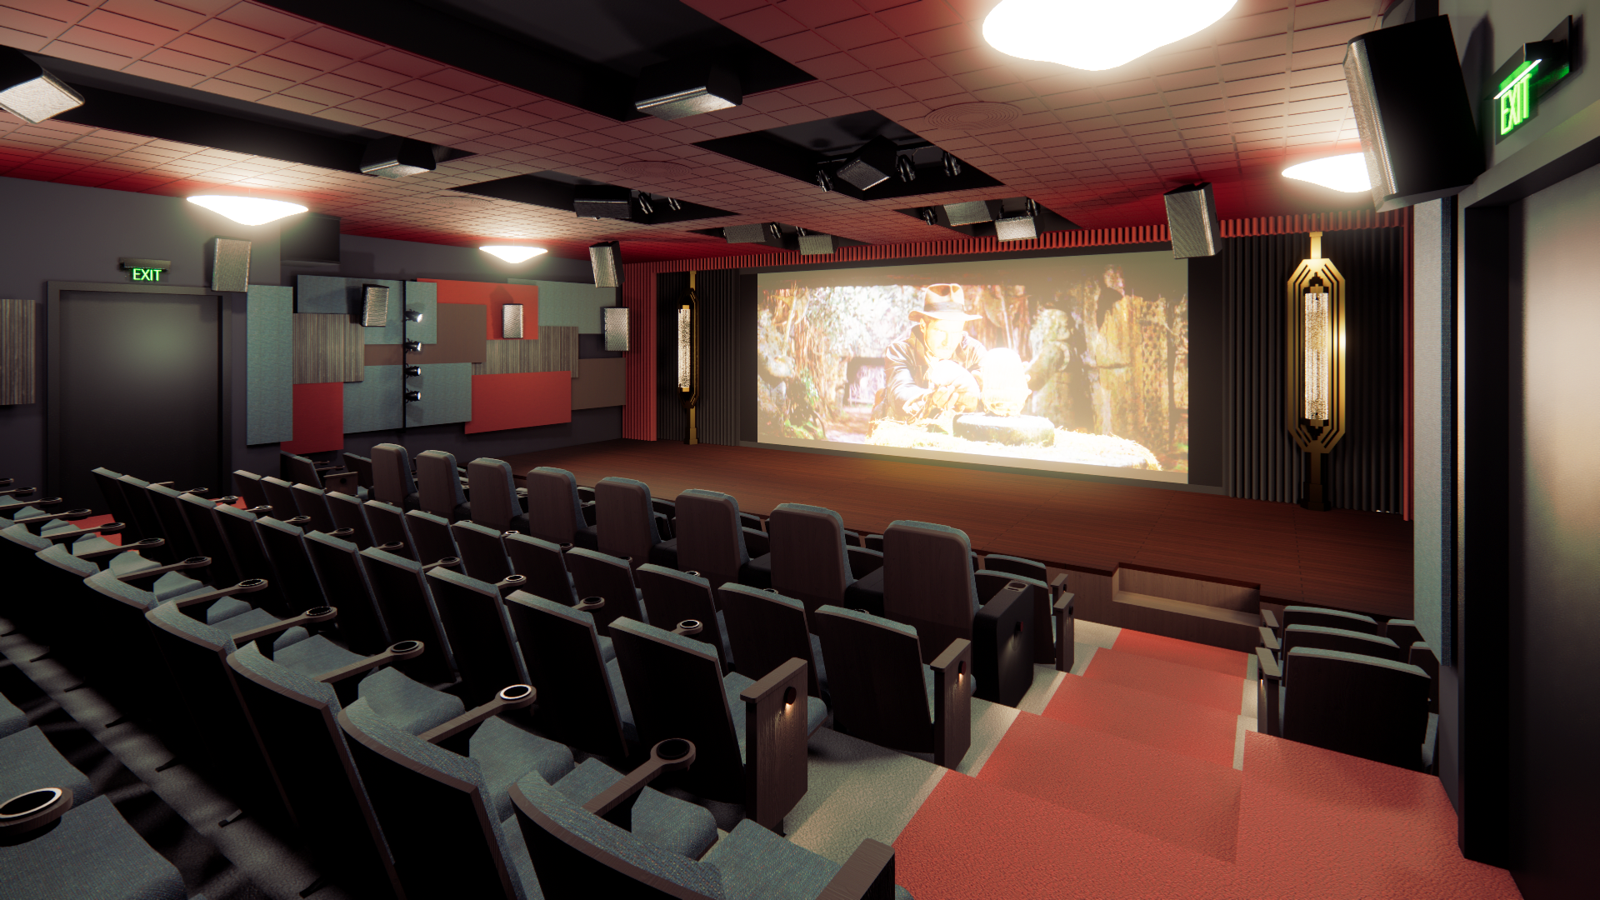

The theater is named in honor of the late [Mark Braunstein](https://www.hudsonvalleyfilmcommission.org/newsinfo/https//www.hudsonvalleyfilmcommission.org/2021924), the visionary founder of Markertek, beloved member of the mid-Hudson Valley arts community and generous philanthropist. The Mark features design by the award-winning architectural acoustics design firm [WSDG](https://wsdg.com/), led by [John Storyk](https://wsdg.com/company/people/john-storyk/). The firm’s previous projects include venues and studios for Bruce Springsteen, UCLA, Lincoln Center, Spotify, Jay-Z, MTV, Alicia Keys, NYU and, at the beginning of Storyk’s career, Jimi Hendrix.

‘We are immensely proud to be part of this project,” said Storyk. “Communities need theaters more than ever, and this theater will rival professional executive screening rooms anywhere in the nation. This is a project that my dear friend Mark Braunstein would have loved to have supported—he understood the importance of gathering together to celebrate the arts and culture. It is an honor to dedicate our work to Mark.”

The Orpheum, a central feature of the [Main-Partition Streets National Historic District](https://www.livingplaces.com/NY/Ulster_County/Saugerties_Village/Main-Partition_Streets_Historic_District.html), was built in 1908 as a roller rink, vaudeville house and community center. It was converted into a movie theater in 1918, and, under several generations of ownership by the Thornton family, served for 100 years as the center of communal life for Saugerties Village, hosting first-dates, double features and decades of entertainment.

Upstate Films, a not-for-profit organization, purchased The Orpheum in 2021. It completed its first phase of renovations, including technical, safety and environmental updates, a new lobby and a spectacular new audio system in its large theater, in 2022. The Mark, located upstairs, will feature new top-of-the-line seats, meticulously designed acoustics, a state-of-the-art [Dolby ATMOS](https://youtu.be/kaaoL0rcwHs) system—the first in the region—and lighting and audio for flexible usage, including seminars and small music recitals.

“Every community deserves a great gathering place,” said Jason Silverman, co-Executive Director of Upstate Films. “The Orpheum has inspired generations of people from our region. The Mark will make a great space even better—we think it’ll be one of the best and most exciting venues to fully experience a movie anywhere. Working with WSDG and John and honoring Mark Braunstein, who was an extraordinarily generous man, has given this project a lot of soul.”

Upstate Films was founded in 1972 in Rhinebeck, New York. In the 51 years since, it has provided millions of filmgoers with life-altering, inspiring and connective experiences. It remains one of the nation’s most prominent rural art-house cinemas. In addition to the Orpheum Theatre, Upstate Films operates the Starr Cinema in Rhinebeck Village and also programs shows at the Community Theatre in Catskill, the Old Dutch Church in Kingston and, through its traveling Hudson Valley Picture Show, in outdoor venues throughout the region. The leadership team includes co-Executive Directors Paul Sturtz and Jason Silverman.

WSDG (the Walters-Storyk Design Group) is at the forefront of the field of architectural acoustic design and analysis. The firm delivers cutting-edge technology, ergonomic and stylish interiors and environmentally conscious solutions. WSDG has created more than 3,000 audio/video production, performance, education, corporate, house of worship and residential projects around the globe. Co-founder John Storyk began his career in 1968 with designs including Electric Lady, Jimi Hendrix’s first studio. He and Beth Walters formed WSDG in 1987, with the late Nancy Flannery joining to serve as CFO. The company expanded with offices in Latin America, Switzerland, Berlin and Miami. The firm’s accolades include 12 NAMM TEC Awards, and awards from AIA, and feature articles in *The New York Times, Vanity Fair* and *The Washington Post.*

Interviews with Jason Silverman, Paul Sturtz and John Storyk are available upon request. Renders of the space and other photos can be found [here](https://www.dropbox.com/scl/fo/2bfsgwb2ggzlg23vj19ps/h?rlkey=upul10jhujvj3mmgmo7mloynm&dl=0).

***