For more information, please contact Marta de Paco
On +34 670 780 664 or email press@comunicahair.com

Important:
These images are only available for editorial content.
Credits must be included.
Notification of their publication is expected.

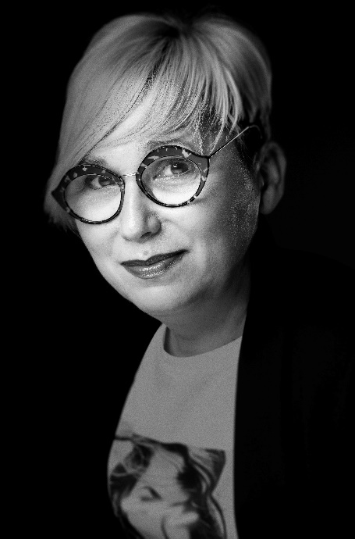
OLGA GARCÍA
THE WORLD Collection

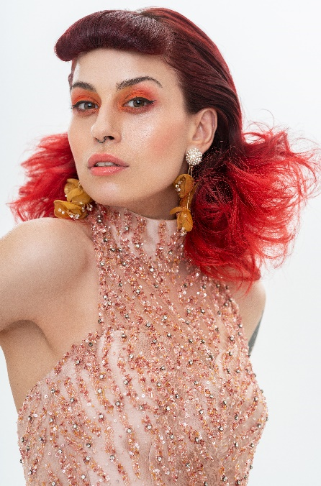
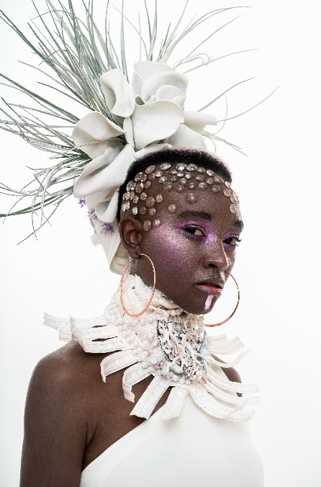

Hair: Olga García Estilistas @peluqueriaolgagarcia
Photographer: David Arnal @davidarnalteam
MUA: Jose Luis Blasco @josele.makeup
Styling: Visori @visorifashionartstudio

OLGA GARCÍA
THE WORLD Collection

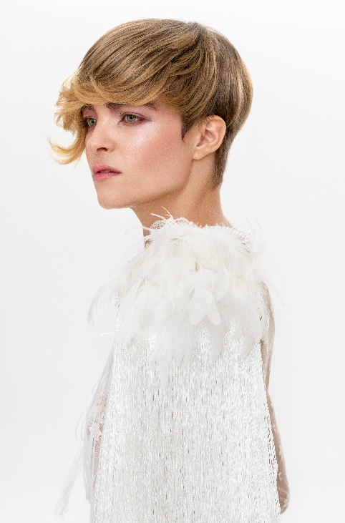

The World embraces the diversity of women in the world and their different ways of becoming brides. That makes it a fresh, versatile and creative collection when it comes to playing the bride. The looks convey comfort as a desire not to be corseted, but to let personality flow. Therefore, neither extensions nor fillers are used, but hair is expressed through its textures, with a romantic and racial touch.
The bangs are the main axis, the protagonists in each hairstyle. Since when placed close to the face they are always visible, they were chosen as the focal point of the look. These are not collected, and go unnoticed by being on the nape, where they are more difficult to see.
The collection is a tribute to the women of the world with different bridal models, with a unique personality, more confident, so that their day is very special and they can enjoy the moment in its fullness.

