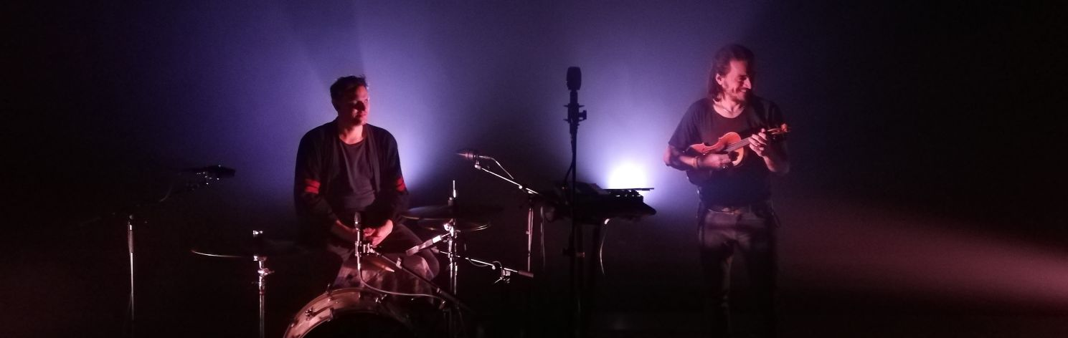

Solid State Logic joins Sennheiser’s ‘AMBEO for VR’ partnership program
Sennheiser AMBEO VR Mic works seamlessly with SSL’s System T broadcast audio platform

Wedemark/Las Vegas, April 8, 2019 – At NAB, Sennheiser and Solid State Logic (SSL) have announced their cooperation within the framework of the AMBEO for VR partnership program. Solid State Logic’s S500, S300 and TCR System T broadcast mixing consoles will now feature onboard AMBEO A-B conversion for the Sennheiser AMBEO VR Mic.

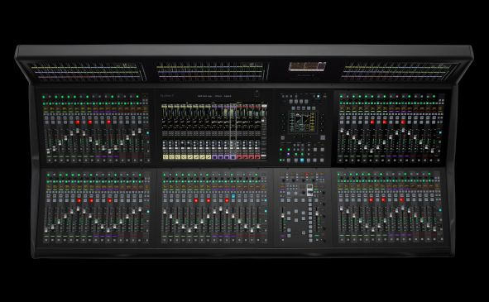 | System T, the new generation of broadcast audio production systems from Solid State Logic, now features AMBEO A-B conversion for accepting direct input from the AMBEO VR Mic

“We are extremely happy to welcome Solid State Logic to our partnership program,” said Véronique Larcher, AMBEO Immersive Audio co-director at Sennheiser. “Our AMBEO VR Mic and SSL’s System T consoles are trailblazers in immersive audio broadcasting. “With this partnership, we are making the workflows for the creation of immersive formats far easier.”

“The partnership with Sennheiser AMBEO expands our growing functionality to provide processing for multiple audio formats for immersive and three-dimensional audio; channel-based, objects, Ambisonics and binaural,” commented Tom Knowles, SSL Broadcast Product Manager. “System T now provides on-board A-B format conversion support for the AMBEO VR Mic, with a 360 transcoder to render to a wide range of multi-channel outputs from 4.0 to 7.1.4. This allows our clients to use the AMBEO VR Mic to add ambient sound to a live immersive production or provide decoding for a live VR mix.”

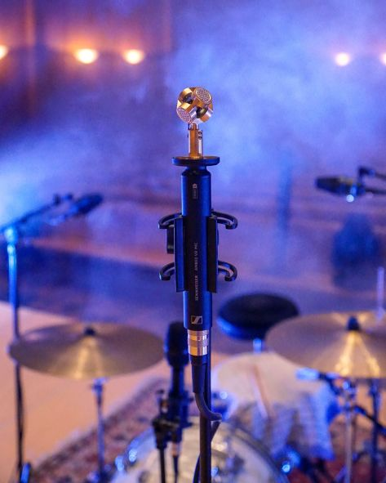 | The AMBEO VR Mic – pictured without the mic basket – is an ideal tool for providing the 3D audio basis in immersive audio productions. The signals from the Ambisonics microphone can now directly be fed into SSL’s System T consoles

Direct conversion for easy workflows
The AMBEO A-B converter works hand in hand with SSL’s 360 transcoder. While the former provides the processing-ready B-format from the Ambisonics AMBEO VR Mic, the latter converts this signal to a broad range of output formats and loudspeaker arrangements, ranging from 4.0. to 5.1.4 and 7.1.4. Broadcast engineers will be able to record and process immersive content with far greater ease, and without the need for any additional physical equipment.

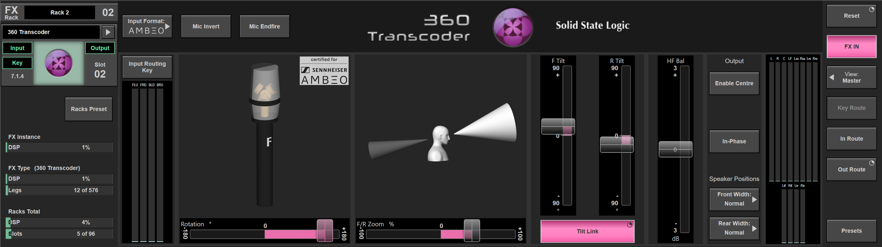
Graphical user interface of SSL’s 360 transcoder with AMBEO A-B converter

Visit Sennheiser and Neumann at NAB, Booth No. C1307.
Visit Solid State Logic at NAB, Booth No. 3026.

Background information: SSL System T consoles
System T is a new generation of dedicated broadcast audio production systems from Solid State Logic, designed to handle large-scale productions and multi-platform delivery. A range of hardware and software control interfaces can be placed anywhere on a network accessing Tempest processor cores and Network I/O audio interfaces. Dante, AES67 and ST 2110-30 AoIP connectivity provides complete interoperability. AoIP discovery, connection management and automatic stream creation are managed directly from the control surface, providing an intuitive audio-centric routing interface. Multiple consoles can be used on a single network, with the ability to re-configure control interfaces and processing resources to suit production requirements.

Background information: Sennheiser AMBEO 3D Audio
AMBEO is Sennheiser’s initiative for truly immersive 3D audio, designed to create sound experiences with an incredibly high emotional impact. The program encompasses products, technologies, software and workflows for the entire immersive audio signal chain, from capture and mixing to processing and reproduction. It includes hardware such as the AMBEO VR Mic, AMBEO Smart Headset, AMBEO AR One, and the AMBEO Soundbar as well as software/expertise such as the AMBEO Blueprints, AMBEO A-B converter, the AMBEO binaural panner (Orbit) and further DAW plug-ins. The AMBEO for VR partnership program was created in 2017 to ensure seamless workflows for VR and AR productions. AMBEO products are consistently developed with the early involvement of users, producers, content providers and technology partners across the globe, creating tools that not only match their demands but also shape the future of audio.

About Solid State Logic
Solid State Logic is the world’s leading manufacturer of analogue and digital audio consoles and provider of creative tools for music, broadcast, live and post production professionals. For more information about our award-winning products, please visit www.solidstatelogic.com.

About Sennheiser
Shaping the future of audio and creating unique sound experiences for customers – this aim unites Sennheiser employees and partners worldwide. Founded in 1945, Sennheiser is one of the world’s leading manufacturers of headphones, microphones and wireless transmission systems. With 21 sales subsidiaries and long-established trading partners, the company is active in more than 50 countries and operates its own production facilities in Germany, Ireland, Romania and the USA. Since 2013, Sennheiser has been managed by Daniel Sennheiser and Dr. Andreas Sennheiser, the third generation of the family to run the company. In 2017, the Sennheiser Group generated turnover totaling €667.7 million. www.sennheiser.com

Local press contact Global press contact

Jeff Touzeau Stephanie Schmidt
jeff@hummingbirdmedia.com stephanie.schmidt@sennheiser.com
+1 (914) 602-2913 +49 (5130) 600 – 1275

