World Diabetes Day 2020
Patient Testimonials, Zimbabwe

All photos should be credited to Tsvangirayi Mukwazhi.

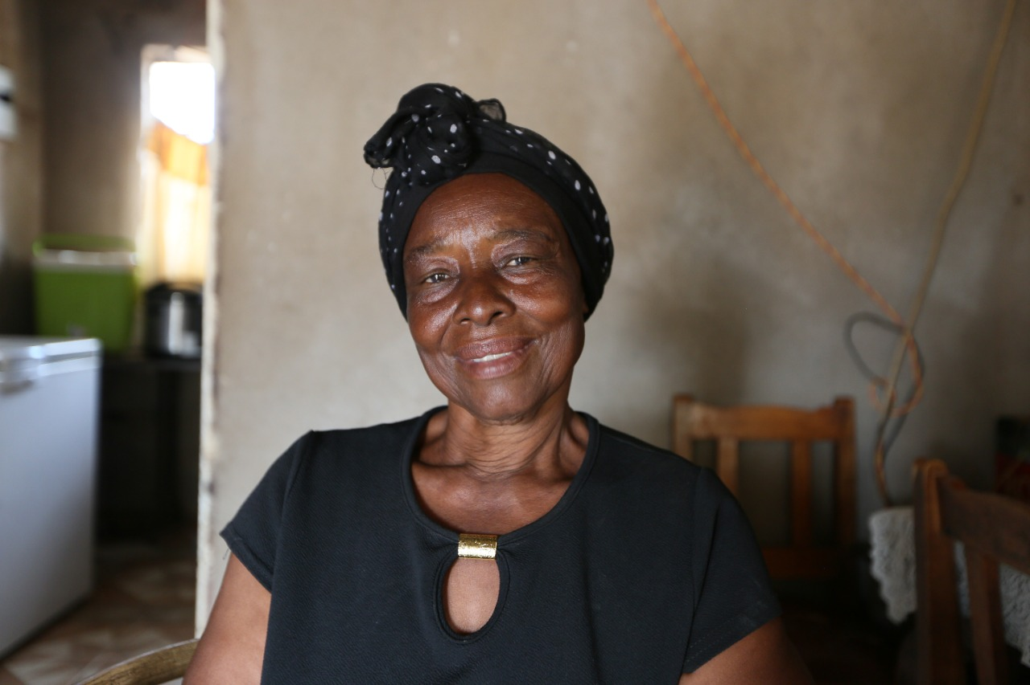
Mavis Dube
My name is Mavis Dube. I live in Chibuwe village. I got diagnosed with hypertension in 1990, and I have been living with it for the last 30 years. I also got diagnosed with diabetes in 2011, making it 9 years surviving with sugar diabetes. In 2016, I started working with MSF, who were providing me with free medication and consultation. They helped us a lot. We stopped walking long distances to get medication.

They helped train us, and I am one of the NCD expert patients at Chibuwe, and I am now able to offer counselling to other patients suffering from hypertension and other diseases. I would like to thank MSF for providing us with free drugs without having to walk long distances. If possible, MSF should also make such services available to other locations across the country.

Being diagnosed with hypertension or diabetes is not a death sentence, and one should accept their condition and get help and training on how to manage it from people who know the disease. I would like to thank MSF for doing a wonderful job in our community in Chibuwe.

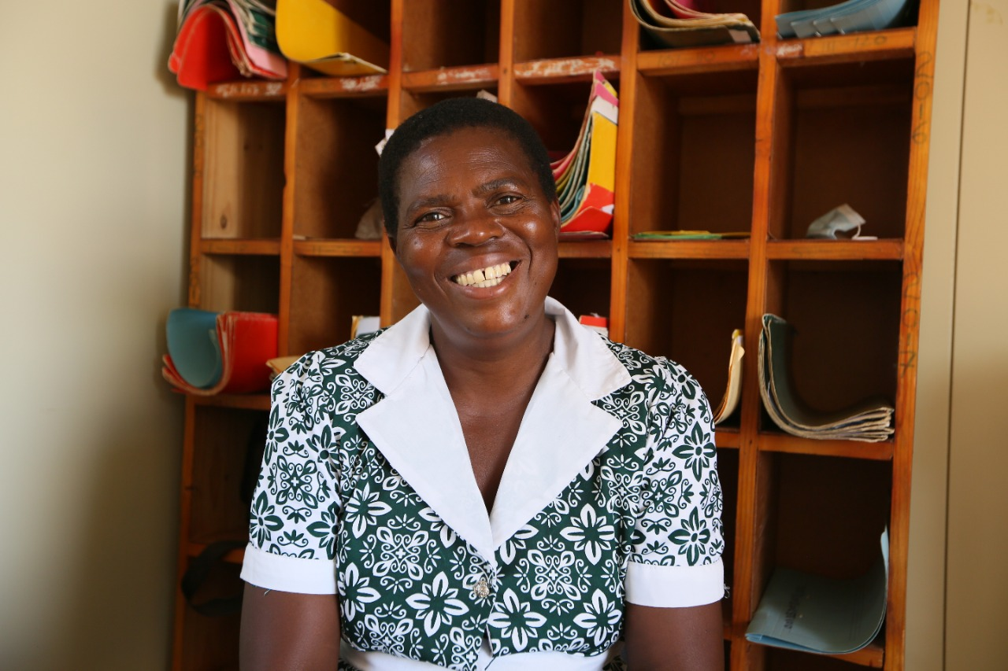
Mavis Geregere
My name is Mavis Geregere. I live in Rimbi in Chipinge district. I am a diabetic patient and have been living with this condition for the last two years. I would like to thank MSF for providing free medication as well as knowledge and training on the type of foods we are supposed to eat. Through the support given by MSF, we have been able to offer counselling and support within our community, and this has helped us to live a happy and stress-free life.

We are saddened within the community due to the fact that MSF will be leaving, and our greatest fear is that there won’t be enough medication and people offering us counselling. We were so much looking forward to their continued support, in particular with transport, as well as medical support.

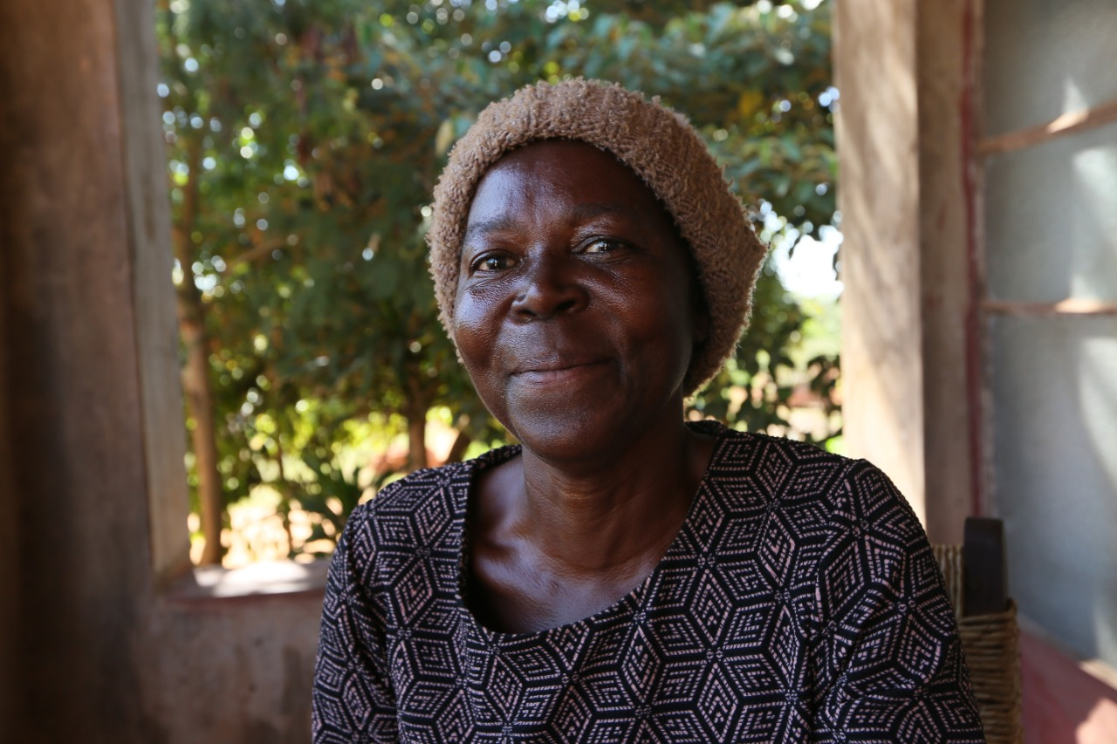
Renica Mapombere
My name is Renica Mapombere. I am 52 years old. I am a diabetes and hypertension patient. I have been living with diabetes for over two years now. I was assisted by MSF, who cared for my medical needs by providing medication each and every month. Nurses and doctors monitor our condition monthly and treat us well.

Cedric Mapombere
My name is Cedric Mapombere. I live in Chipinge and would like to thank MSF for providing support and medication to my wife after she had a stroke two years ago. The relationship between MSF and patients is commendable, and it is our hope that it may continue. I would like to thank MSF for the help they offer to hypertension and diabetes patients.

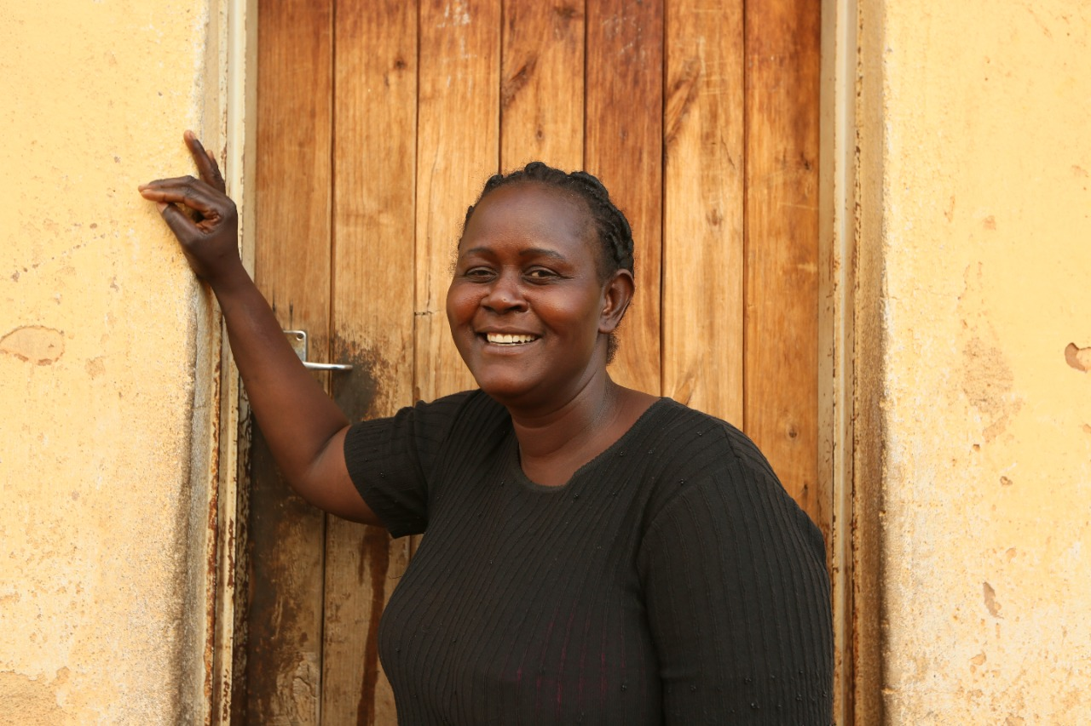
Thamari Gwenzi
My name is Thamari Gwenzi. I reside in Manesa Sarura village. I am 45 years old. I am an expert patient for diabetes and hypertension. I got diagnosed with diabetes in 2016. I live with my mother, who is also a diabetic patient. When she used to check her diabetes, I would also use the machine on myself and that’s when I realized I was diabetic.

It was easy for me to accept my condition, as I was used to seeing my mother managing it. I live a normal life with diabetes. I would like to thank MSF for assisting us since 2016, with free medication, knowledge and training.

People in our community now know how to manage and treat people with hypertension and diabetes thanks largely to the intervention offered by MSF. They have also offered training on our dietary needs, as well as the need for weight management and the need to exercise.

Our health and well-being has improved immensely. To those people who died in the past of hypertension and diabetes, it was mainly because MSF was not present in our community. Our biggest challenge is the type of food we are supposed to eat, which is very difficult to find. We are praying for someone to assist us with our food requirements.

It is our wish that free medication continues to be available, as we cannot afford to buy it. There is hunger in our community, as we are small-scale farmers and rather poor. Due to lack of water, we are unable to produce much food.

I have a small garden where I try to plant a few of the required foods for my condition. We are grateful to God, and it is our hope that someone will come in to assist us after MSF leaves.
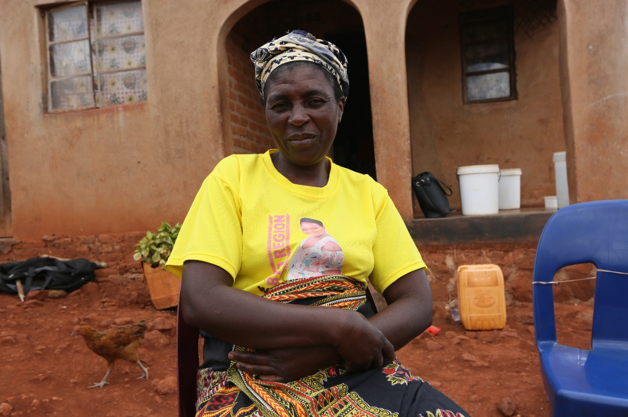
Auxilia Muungani
My name is Auxilia Muungani. I live at Zamchiya Clinic. I am 49 years old. I started taking my hypertension medication in 2019. I am a hypertension patient at Zamchiya clinic

One of the things I am grateful to have learnt is how to take my medication. Previously we didn’t know how to take our medication, and when we started going to the clinic, we were taught how and welcomed the lessons.

When I started taking the hypertension medication, my life changed and my health improved due to frequent testing and monitoring. I am now able to teach other people how to take their medication, and I am grateful to MSF for the knowledge and training they imparted on us.

We were also taught about the right foods to eat as well as what not to eat if one has hypertension.

We now fear that, when MSF leaves, whoever takes their place will not be able to provide us with medication, and so we are appealing to the government for assistance. Our greatest fear is that people are going to start to die, as they will not be able to afford medication and transport costs.

We are appealing for medication to be available for free within our communities so it lessens the burden of travelling long distances.

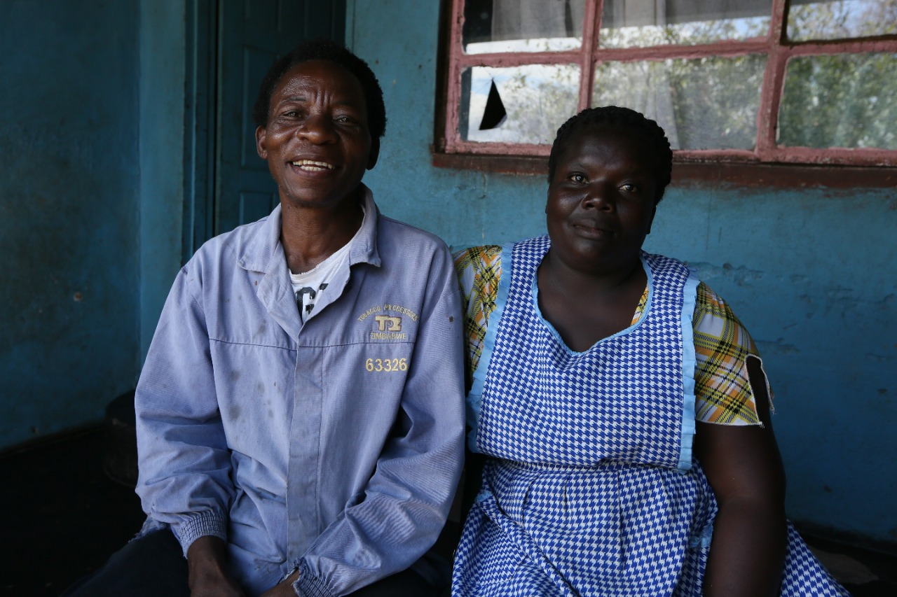
Emmanuel Matabuka
My name is Emmanuel Matabuka. I am 56 years old. I was diagnosed with diabetes in 2010 and joined the MSF programme in 2017. Since 2017 to present day, we have been assisted with free medication and training through MSF.

This has helped us a lot in that we are no longer having to travel to South Africa to look for medication, because it was cheaper to buy there than in Zimbabwe. MSF has taught us the right foods to eat, which has improved our health.

The challenges that we face, as diabetic patients, is that our children find it difficult to adjust to our dietary needs, but we are hopeful over time they will learn. Within our community, people have accepted us despite our condition.

Some of the challenges we face are that there is no way of identifying if someone is diabetic or not, especially if they collapse. A band or some of necklace would help.

There is no other donor or organisation that has shown support for diabetic patients in Zimbabwe like MSF, and we are grateful for their support. We are appealing to the government to support diabetic patients across the country.

Viola Makore
My name is Viola Makore. I am a 23-year-old diabetic patient. I was diagnosed with the disease in 2014. I am treated at Mutare General Hospital through the MSF programme. Before my condition was ‘hyper’, and I would frequent the hospital with my mother.

MSF managed to stabilize my condition, and the nurses were extremely helpful and offered counselling and support on my dietary needs. I used to love sweet things, but they helped me change my diet to suit my condition.

I used to buy medication, and it was burden, so I would reduce the required dosages due to costs. When I joined the MSF programme, I started getting medication and support for free, and I am truly grateful. Through the assistance and support offered by MSF, I was able to monitor my condition.

