Under embargo until September 26th, 2023, 00:00 CET
Introducing ACCENTUM Wireless
The sound and stamina to play by your own rules

Wedemark, Germany, September 26th, 2023 – The all-new Sennheiser ACCENTUM Wireless headphones offer standout features and world-class sound at an impressive value.

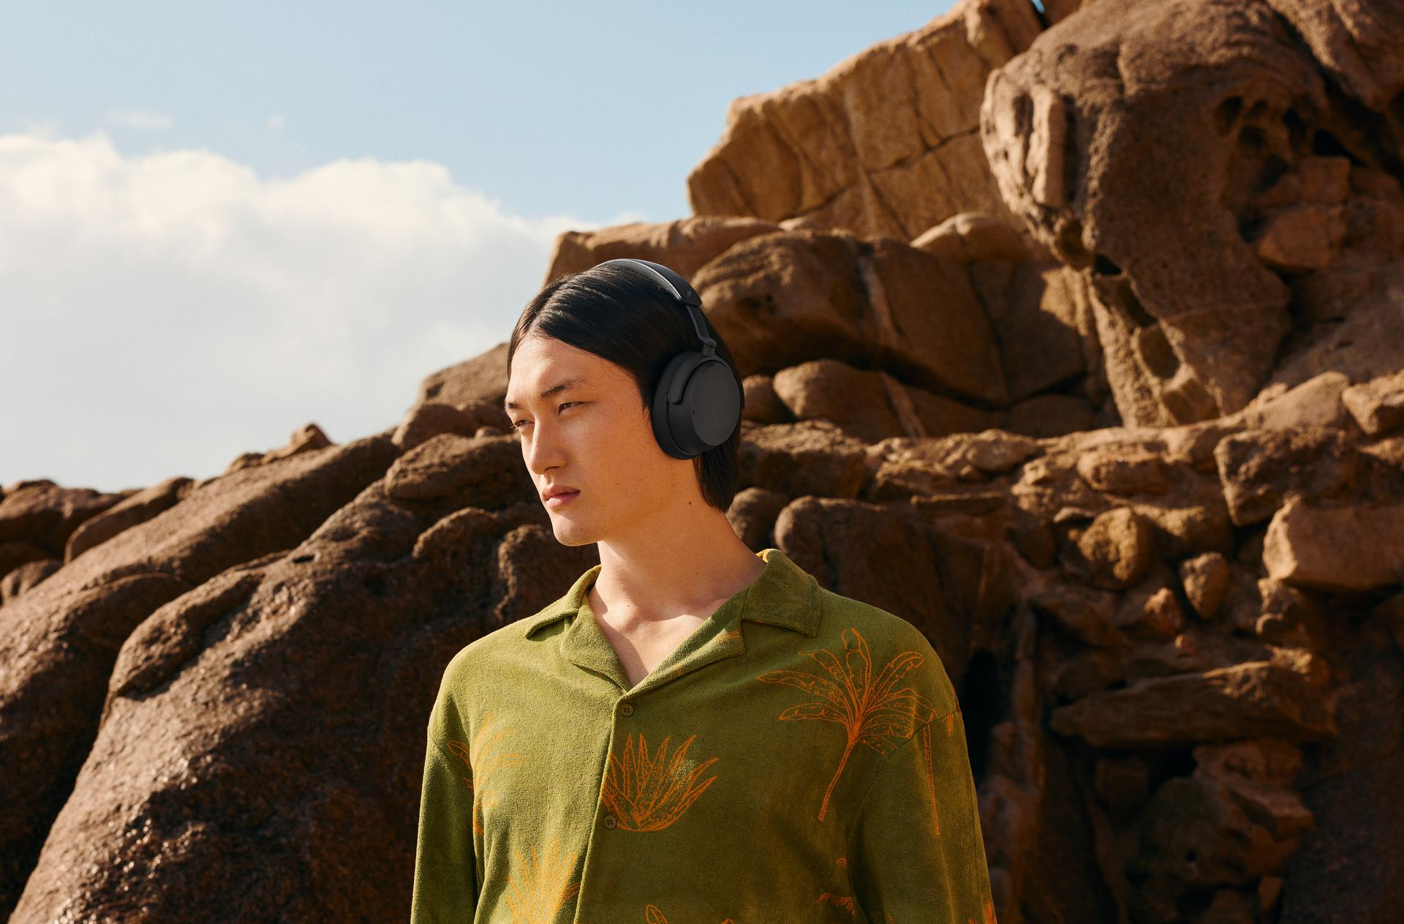

“ACCENTUM Wireless was developed to outperform their price tag, sharing much of the most desirable DNA of our award-winning MOMENTUM 4,” says Christian Ern, Sennheiser Principal Product Manager, “Consumers are getting breathtaking Sennheiser sound without sacrificing the battery life or wireless freedom that makes them so enjoyable to use all day long.”

The soundtrack to your life
Boasting larger-than-life Sennheiser acoustics and the serenity of Hybrid Active Noise Canceling technology, ACCENTUM Wireless is an easy recommendation for consumers that prioritize audio performance in a wireless headphone. Their 37mm dynamic transducers are tuned to provide exciting sound experiences with outstanding bass performance and striking clarity. Furthermore, the acoustics have been optimized for broad ANC performance, dramatically reducing cacophony from the outside world through a combination of passive isolation and covert microphones targeting both low and higher frequencies.

With more ways to consume content than ever, ACCENTUM keeps you in control using Bluetooth® 5.2 and multipoint connectivity. For exceptional sound quality, ACCENTUM supports the aptX™ HD codec, rivalling the sound of wired headphones with punchy output and robust wireless stability. AAC and SBC codecs are also onboard, perfect for catching up on shows or exploring a new album release on virtually any Bluetooth-enabled audio device.

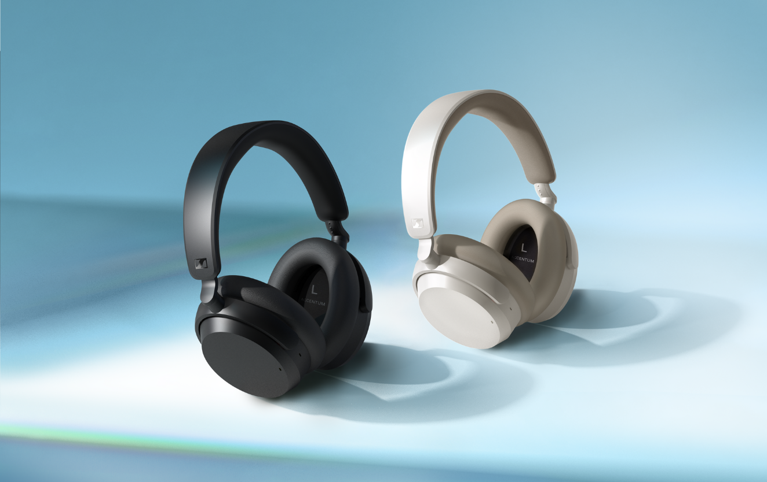

Big-time battery
In addition to operating up to 50 hours per charge, ACCENTUM can “quick charge” for up to 5 more hours of listening in just 10 minutes—about the time it takes to get up and make a fresh cup of coffee. The included USB-C charging cable can also transform the wireless headphones into a wired set for instances when Bluetooth is not permitted or enabled; simply plug the USB cable into a class-compliant device to use ACCENTUM as an audio interface for content consumption and voice communication. Their long-lasting battery has the added benefit of prolonging the amount of time it takes to reach the maximum number of charge cycles over the headphone’s lifespan, reducing e-waste along the way.

Calling the plays
ACCENTUM comes equipped for more than just content consumption—two built-in microphones and a dedicated wind-reduction mode make taking voice calls a breeze. Adjustable side-tone with advanced signal processing keeps conversations feeling natural and fatigue-free while minimizing background distractions. Multipoint seamlessly switches the active wireless connection from one Bluetooth device to another without the need for re-pairing the devices—a boon for people frequently jumping into VoIP calls on a computer but streaming a podcast on their mobile between meetings, for example.

Smart Control
Staying in command of ACCENTUM’s features is intuitive, thanks to the simplified 4-button layout and optional companion smartphone app. From managing Bluetooth connections and features to experimenting with the 5-band EQ, the Smart Control App enhances the headphone experience amidst a refreshingly simple visual user interface you can store in your pocket. Smart Control can store user presets and deliver updates, too, keeping ACCENTUM’s features operating smoothly when the devices they connect to evolve, too.

“The sleek and understated look of ACCENTUM Wireless is more than an extension of the latest generation MOMENTUM family,” says Ern, “They are arguably our most comfortable all-purpose wireless headphones yet with their balanced feel and luxurious padding. Your ears can stay in the sweet spot for hours.”

Sound design
The extended listening time from ACCENTUM’s battery is equally matched by its long-term wearing comfort. The earcup and headband padding contact points effortlessly conform to the wearer’s shape, with a gentle touch that always feels secure and natural. Their identity indeed echoes the compact fold-flat design of the MOMENTUM 4 Wireless, giving the entire headphone lineup a cohesive look that is serious about both sound and ergonomics.

Pricing and availability
ACCENTUM Wireless will be available in black and in white with sandstone accents. Pre-orders for the black colorway begin on September 26, 2023 and will start shipping October 4th. The white version begins shipping in late November—both models will be available at select retailers and at sennheiser-hearing.com. The new ACCENTUM Wireless will have an MSRP of 179.95 USD/179.90 EUR.

About the Sennheiser brand
We live and breathe audio. We are driven by the passion to create audio solutions that make a difference. Building the future of audio and bringing remarkable sound experiences to our customers – this is what the Sennheiser brand has represented for more than 75 years. While professional audio solutions such as microphones, meeting solutions, streaming technologies, and monitoring systems are part of the business of Sennheiser electronic GmbH & Co. KG, the business with consumer devices such as headphones, soundbars and speech-enhanced hearables became part of the Sonova Holding AG group of companies in 2022, who have licensed the Sennheiser trademark for this purpose.

www.sennheiser.com
www.sennheiser-hearing.com

About Sonova Consumer Hearing
Sonova Consumer Hearing offers premium headphones and hearables – primarily in the true wireless segment – as well as audiophile headphones, hearing solutions and soundbars under the Sennheiser brand. The business is part of the Sonova Group, a global leader in innovative hearing care solutions with headquarters in Switzerland and more than 17,000 employees worldwide.

Press contact
Sonova Consumer Hearing GmbH
Paul Hughes
Head of PR and Influencers, Sennheiser Headphone and Soundbars
T +49 (0) 162 2921 861
paul.hughes@sonova.com

