Neumann Monitors For Immersive Audio
At mediaHYPERIUM / California

Rolling Hills Estates, California, July 2021 — As the coronavirus pandemic took hold in Southern California in early 2020, spatial audio pioneer Herbert Waltl relocated his mediaHyperium operation to a disused music school, where he has outfitted a former recital room with an 18-speaker Neumann KH Line studio monitor system. The system flexibly switches between Dolby Atmos and Sony 360 Reality Audio immersive music formats without the need to reposition any speakers by combining a 7.1 layout with nine height and three floor-level speakers.

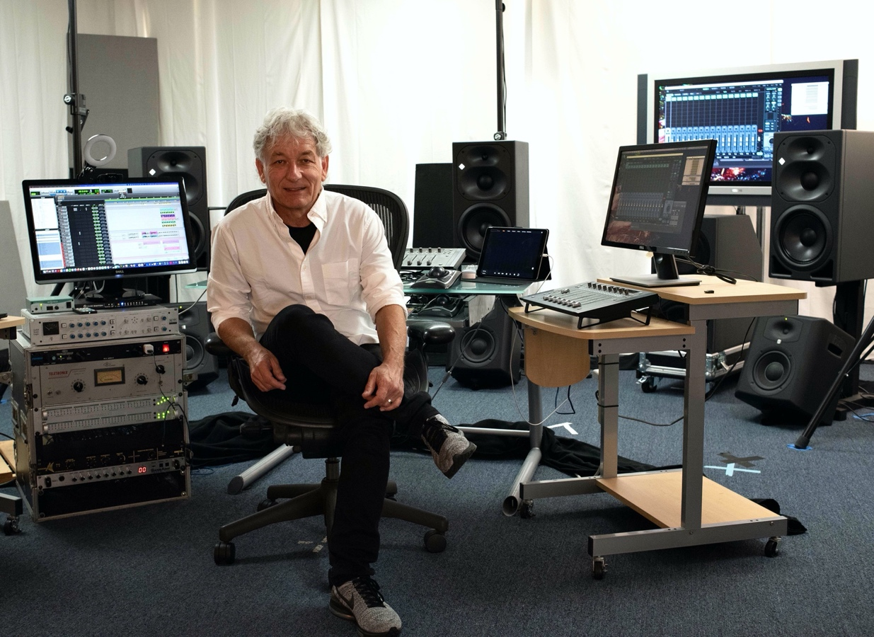
Herbert Waltl at the reimagined mediaHyperium studios.

Waltl, an award-winning producer, musician and technology evangelist who founded mediaHyperium in 1996, had been planning to build a new studio before the pandemic. For years he had mostly been working at Skywalker Sound in the Bay Area, for the last five years in partnership with Eric Schilling, a recording engineer and broadcast audio mixer with a long list of Grammy and Emmy Awards to his name. But when the new virus forced everyone into lockdown and the music school closed, “We said, the best thing, the safest thing, because of the pandemic, is to work out of here,” says Waltl.
NEUMANN PERFECTION IN 7.1
The 7.1 monitor setup comprises seven Neumann KH 420 tri-amplified midfield mains plus a pair of Neumann KH 870 bass-managed subwoofers. Five Neumann KH 310 tri-amped near field monitors on stands – three across the front plus left and right height channels – support the overhead channels of Sony’s object-based 360 Reality Audio. Hanging from the ceiling, and positioned slightly closer to the mix position per the recommendations of Dolby Laboratories, four Neumann KH 120 bi-amped near field speakers deliver the overhead zone for Dolby Atmos mixes.

Waltl made something of an informed leap of faith in selecting the Neumann system at mediaHyperium, although he has logged plenty of hours with one particular model working on various projects. “I had already heard the KH 310s at Skywalker and other studios, where I have used them. I was very impressed with them,” he says.

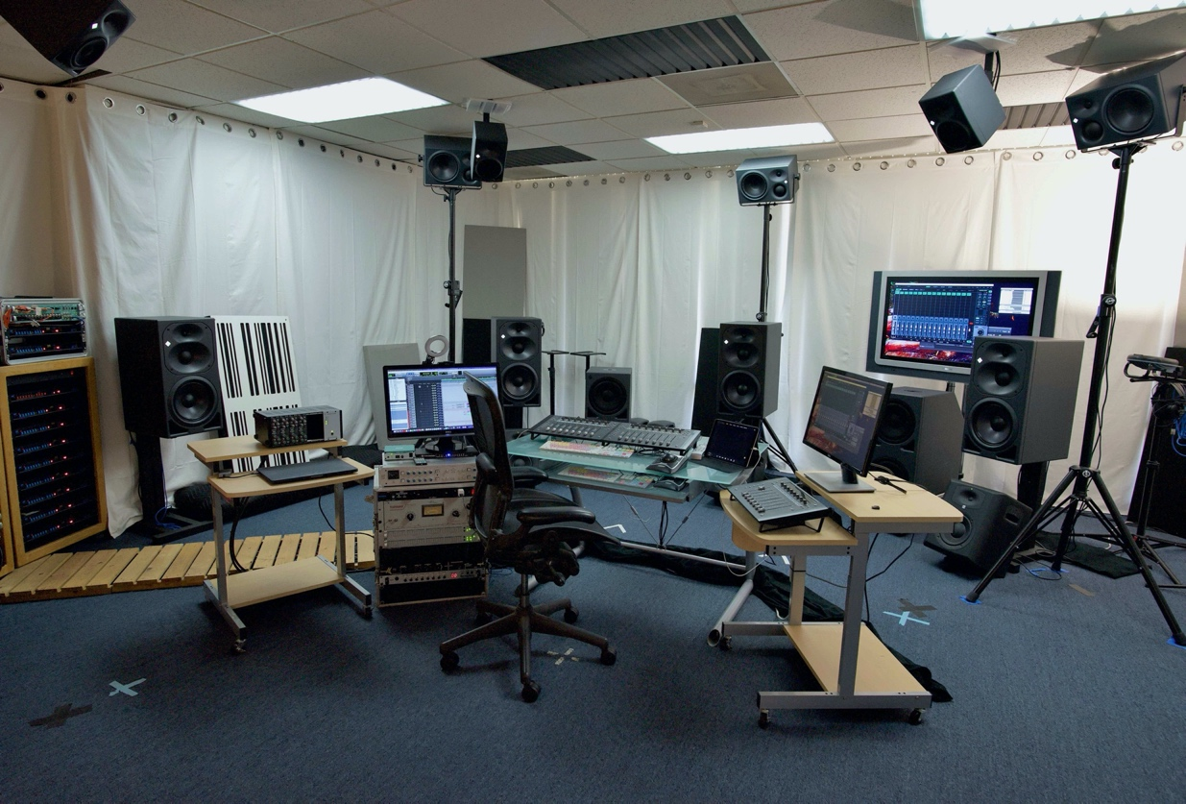
Neumann KH 420, 870, 310 and 120 monitors adorn the studio.

“I had never used the larger ones, the KH 420s,” says Schilling. Like Waltl, he says, “I only used the 310s before. In this room I’m probably eight feet away from the speakers. What I like is that the system has a lot of detail and you don’t have to play it loud to hear that. I work at a pretty moderate gain for most of the day, or I’d get too tired. I’m probably running this system at 20% of what it will do, in terms of volume, so it’s got a lot of headroom. And it’s nice having two subs, because the low end is a little more consistent. So it’s a very non-tiring system with a lot of detail.”
AUTHENTIC SONIC TRANSLATION
Previous initiatives to introduce formats beyond stereo have largely failed commercially due to the unwillingness or inability of consumers to install a large number of speakers in their homes. Now, though, manufacturers offer simple and cost-effective solutions such as soundbars and smart speakers that support immersive playback. As a result, says Waltl, “We have a second room, a listening room, where we put a Sennheiser AMBEO Soundbar. We can hear how the sound translates to a soundbar.”

And while Sony’s immersive format, based on Fraunhofer’s MPEG-H technology, was initially intended to deliver 3D music to headphones, “Sony 360 can now go to the Sennheiser AMBEO Soundbar and there are receivers that will send it out to a speaker system,” Schilling reports.

As Waltl also points out, “The Sony format asks for three speakers on the floor at the front. But there’s no way you can get an accurate and honest presentation if you have furniture or a console in front of you. So we built the room specifically for immersive,” he explains, with minimal furniture to support the mix controllers and Pro Tools display screens.

“Mixing immersive music in a stereo control room is challenging, because you have a big console that sits in the way of the sub,” agrees Schilling. “It’s not that it can’t be done, you just really have to work out where you’re going to place things. So this room is more like what I would find in a mastering room, where the footprint of my controller is very small.”

Schilling also comments, “We toyed around with whether we put in a system with bars where we could move the overhead speakers. But it’s more efficient and faster to have separate sets of speakers.” Schilling has set up templates to quickly route and switch between Dolby and Sony’s immersive formats in mediaHyperium’s mix room.

The room was virtually move-in ready, Waltl says. “The walls and ceiling were acoustically treated, because it was a recital room.” That said, Schilling recommended some additional standalone treatment, including bass traps. Now, says Waltl, “The room sounds wonderful.”

FROM ALICIA KEYS TO VICTOR MANUELLE
Schilling has been remixing Alicia Keys’ catalog into the Sony 360 Reality Audio format and Dolby Atmos format, in conjunction with producer and engineer George Massenburg with Ann Mincieli at the helm, Alicia's longtime engineer. “I’ve done close to 30 songs for them in this room,” Schilling reports. “We started with her newest one, ALICIA, and we’re going backwards. We did the complete album HERE, from 2016; that just got mastered. The next project was SONGS IN A MINOR, but we had to finish that first, because it was the 20th anniversary of its release in June.”

Schilling continues, “For Alicia Keys’ first album, I used some outboard gear for certain sounds I couldn’t get in-the-box. I had to use outboard compressors. A plug-in is great, but it doesn’t really work the same way. But between the two of us we have a fair amount of gear that I can use when I need it, so it’s a bit of a hybrid room.”

According to Waltl, some of the other Sony 360 Reality Audio highlights to come out of mediaHyperium include Victor Manuelle’s 2018 Grammy Award-winning salsa album 25/7, two albums with organ works by Bach and HAUSER PLAYS MORRICONE, an album of film composer Ennio Morricone’s work transcribed for cello and orchestra performed by Stjepan Hauser.

“We always want to be authentic to the original stereo release,” says Waltl, who has been remixing music into surround and immersive formats for the past 20 years. “Our credo has been that we want it to feel like the stereo mix. I don’t want it to be a shock; it’s not a DJ remix. However, we should be using the opportunities of the space and I don’t want to be too conservative in my immersive concepts. We have a creative set of tools on hand and extend on the original vision. Therefore, the immersive mix should be a true alternative listening experience to the stereo version. So, you have to be open-minded and really explore. This is something we all should embrace.”

About Neumann
Georg Neumann GmbH, known as “Neumann.Berlin”, is one of the world’s leading manufacturers of studio-grade audio equipment and the creator of recording microphone legends including the U 47, M 49, U 67 and U 87. Founded in 1928, the company has been recognized with numerous international awards for its technological innovations. Since 2010, Neumann.Berlin has expanded its expertise in electro-acoustic transducer design to also include the studio monitor market, mainly targeting TV and radio broadcasting, recording, and audio production. The first Neumann studio headphone was introduced at the beginning of 2019. Georg Neumann GmbH has been part of the Sennheiser Group since 1991, and is represented worldwide by the Sennheiser network of subsidiaries and long-standing trading partners. www.neumann.com

Local press contacts USA:
Jeff Touzeau Daniella Kohan
jeff@hummingbirdmedia.com daniella.kohan@sennheiser.com
+1 (914) 602-2913 +1 (860) 222-4226

Global press contact:
Andreas Sablotny
andreas.sablotny@neumann.com
T +49 (030) 417724-19

