Reveal the truth in your music
Sennheiser introduces HD 560S headphones for analytical listening sessions

Wedemark, September 24, 2020 – Today’s audiophiles spend hours enjoying or analyzing music, whether listening to another artist’s work or assessing their own recordings. Sennheiser’s new HD 560S headphones offer just what is required for analytical listening sessions at an accessible price point: natural and accurate reference sound that divulges every detail, complemented by an outstanding low-frequency extension, while providing a “barely there” experience on the head and ears.

The HD 560S is tailor-made for listeners who need to understand a tune in all its details, from the recording studio to the sound file. It aims to show how a track is intended to be heard, rather than delivering an interpretation offered up by a headphone’s sound design, The HD 560S’ transducers are specifically tuned for accuracy, offering dependable A/B comparisons of mixes, sources, and media formats. Its open-back earcups facilitate a natural expansion of sound waves, while their angled alignment recreates the optimal triangular listening position of loudspeakers for a wide, articulate soundstage — without the need for room treatment.

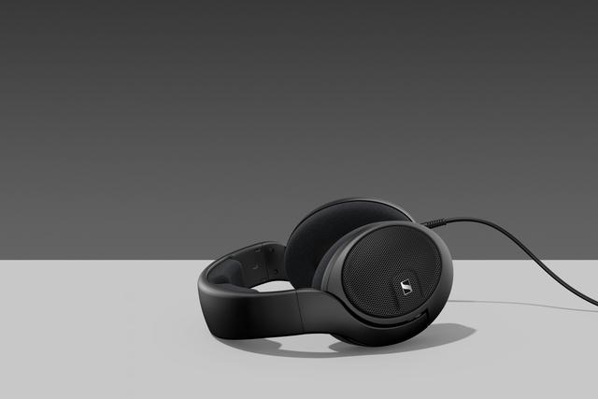

Sennheiser’s new HD 560S headphones offer natural and accurate reference sound that divulges every detail, complemented by an outstanding low-frequency extension

Offering a frequency response of 6 Hz – 38 Hz, the HD 560S reproduces the entire frequency range with honesty, complemented by gratifying and smooth low-frequency extension. As a result, the headphones effortlessly reproduce the complex bass sounds found in modern music. At the same time, a high 110 dB/1V sensitivity and an extraordinarily low THD (<0.05% at 90 dB) offer an expressive dynamic range and clarity, even at a high SPL.

“We are excited to introduce the entry-level audiophile HD 560S headphones. In terms of bass response and value for money, this product represents a paradigm shift for open, dynamic headphones,” said Jermo Köhnke, Product Manager at Sennheiser. “With linear acoustics tailored to critical listening sessions, we have designed the HD 560S for audiophiles who evaluate a recording’s entire journey through the audio path.”

Headphones that are barely there
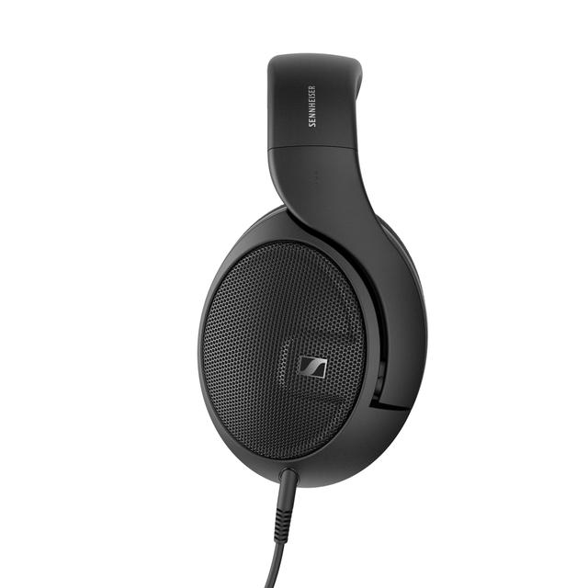
Extensive listening sessions require headphones that are extremely comfortable, or better yet, feel like they are not even there. The HD 560S uses an ultralight chassis for distraction-free listening. The open, around-the-ear design offers benefits beyond natural sound — the ventilated cup remains cool without touching the wearer’s ears. Even the velour earpads have been carefully considered to keep all contact points soft to the touch for comfortable long-term listening.

The HD 560S uses an ultralight chassis to provide a “barely there” experience on the head and ears

Because audiophiles frequent a variety of sources, the voice coil was specifically developed to provide an exceptional experience regardless of the playback system, while the 120 Ω impedance allows the HD 560S to be used with virtually any audio source. For maximum versatility, the HD 560S is equipped with a detachable 3-meter cable, 6.3mm jack and a 3.5mm adapter with a flexible 15cm lead.

The Sennheiser HD 560S will be available from September 29 for 199 EUR (MSRP).

About Sennheiser
Founded in 1945, Sennheiser is celebrating its 75th anniversary this year. Shaping the future of audio and creating unique sound experiences for customers – this aim unites Sennheiser employees and partners worldwide. The independent family company, which is managed in the third generation by Dr. Andreas Sennheiser and Daniel Sennheiser, is today one of the world’s leading manufacturers of headphones, loudspeakers, microphones and wireless transmission systems. In 2019, the Sennheiser Group generated turnover totaling €756.7 million. www.sennheiser.com

Global Press Contact
Sennheiser electronic GmbH & Co. KG
Jacqueline Gusmag
Communications Manager Consumer
T: +49 (0)5130 600-1540
jacqueline.gusmag@sennheiser.com

