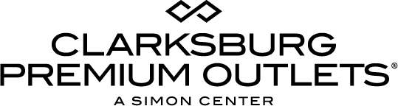

For more information:
Becca Meyer
BRAVE Public Relations, 404.233.3993
bmeyer@bravepublicrelations.com/

**MEDIA ADVISORY**

Clarksburg Premium Outlets to celebrate Labor Day Weekend with Clearance Event, September 1-4
Enormous savings destination offers additional savings on unmatched selection of stores and brands!

CLARKSBURG, Md. (August 29, 2017) – Clarksburg Premium Outlets is sending the season off in style with Summer’s Last Hurrah - Labor Day Weekend Clearance Event, complete with premium deals for the whole family! From Friday, September 1 – Monday, September 4, shoppers can find additional deals on already reduced prices at sought-after outlet retailers! Fashionistas will enjoy extended hours throughout the weekend as they shop their favorite brands, including Ugg, Banana Republic, Michael Kors, Gap, Under Amour, kate spade new york, Tory Burch, Salvatore Ferragamo and more.

WHAT: Summer’s Last Hurrah - Labor Day Weekend Clearance Event
Shoppers can find additional deals on top of the enormous savings up to 65 percent off every day!

WHEN: Friday, September 1 – Monday, September 4

Extended Hours:
Friday – Saturday: 10 a.m.-9 p.m.
Sunday: 10 a.m.-8 p.m.
Monday: 10 a.m.-9p.m,

WHERE: Clarksburg Premium Outlets
22705 Clarksburg Rd
Clarksburg, MD 20871

MORE INFO: For more information on this event, please visit premiumoutlets.com/clarksburg or connect with Clarksburg Premium Outlets on Facebook, Twitter and Instagram.

###

