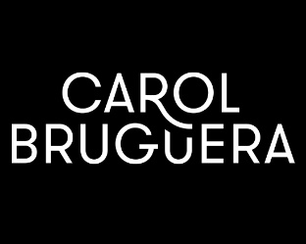
CAROL BRUGUERA

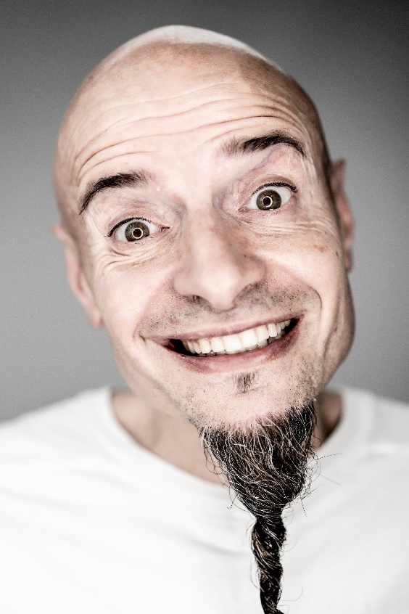
It all started in 1962, when Dolors Bruguera decided to open a small hairdressing salon in Vic. 10 years later her husband Jacint Carol joined the team. That was when Carol Bruguera was formed. A few years later, some of the couple's children joined the team, who began the expansion. We currently have 15 salons and we are a team of more than 120 professionals.
Mia Carol – Hairdressing Director

Our main lines of work are: taking the hairdressing one step further as to creativity, taking maximum care of our clients, being as sustainable as possible, and getting better organized internally through technology so that our team can feel more valued and fulfilled.

During all this time, we have managed to be present in all the environments in which we talk about hairdressing: fashion and hairdressing magazines (national and international); we have collaborated with the best brands in the sector on workshops, demonstrations for hairdressers, and even fashion shows, TV, cinema and theater; we have won some of the most prestigious awards in the industry: Hairbrained video awards, Global Salon Business, AIPP, Laus, among others.

