For immediate distribution

Command and Control: Powersoft to Highlight New Duecanali Amplifier Models and Updated M-Force Transducer at InfoComm 2018
— Powersoft to host special InfoComm demonstrations of Armonìa DSP and Control Software —

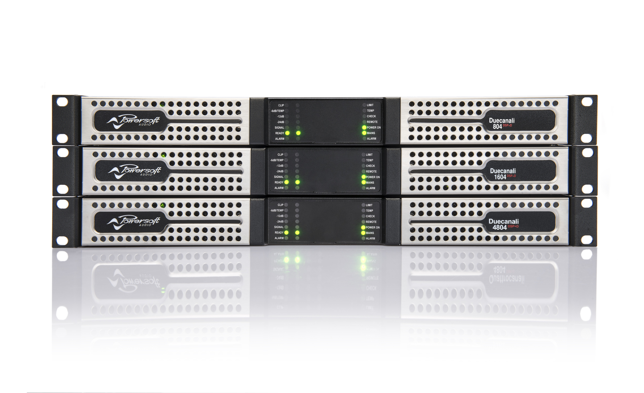
Las Vegas, May xx, 2018 – Powersoft [InfoComm booth C628], the world leader in lightweight, energy-efficient amplifier platforms, is launching several new products targeted at the fixed installation and OEM markets at this year’s InfoComm exhibition. New products include a significant extension of its successful two-channel amplifier platform, Duecanali, as well as its renowned M-Force transducer, which brings unprecedented power and integration possibilities to an increasing number of OEM partners.

The Duecanali 804 and 4804 — which are now launching in the U.S. market — are the latest additions in the Duecanali platform, which is perfectly suited for retail, leisure and hospitality fixed installations that require both pristine and reliable sound. The Duecanali 804 offers 2 x 400W and represents a lower total power solution for installations in retail, as well as bars and restaurants where a single two-channel amplifier is required — without the need for additional channels or power. The range is completed by the existing Duecanali 1604 launched last year, which sits between the two new products in the Duecanali range.

A Duecanali in your future
The newly completed Duecanali range, which boasts an unmatched power to size ratio, is able to drive low impedance loads (2/4/8 Ohm) and 70V/100V distributed lines selectable per channel. It also provides more than 16 different possible output configurations per channel. The Duecanali range also delivers on control and interoperability with DSP onboard, third-party plug-ins, networking and remote control.

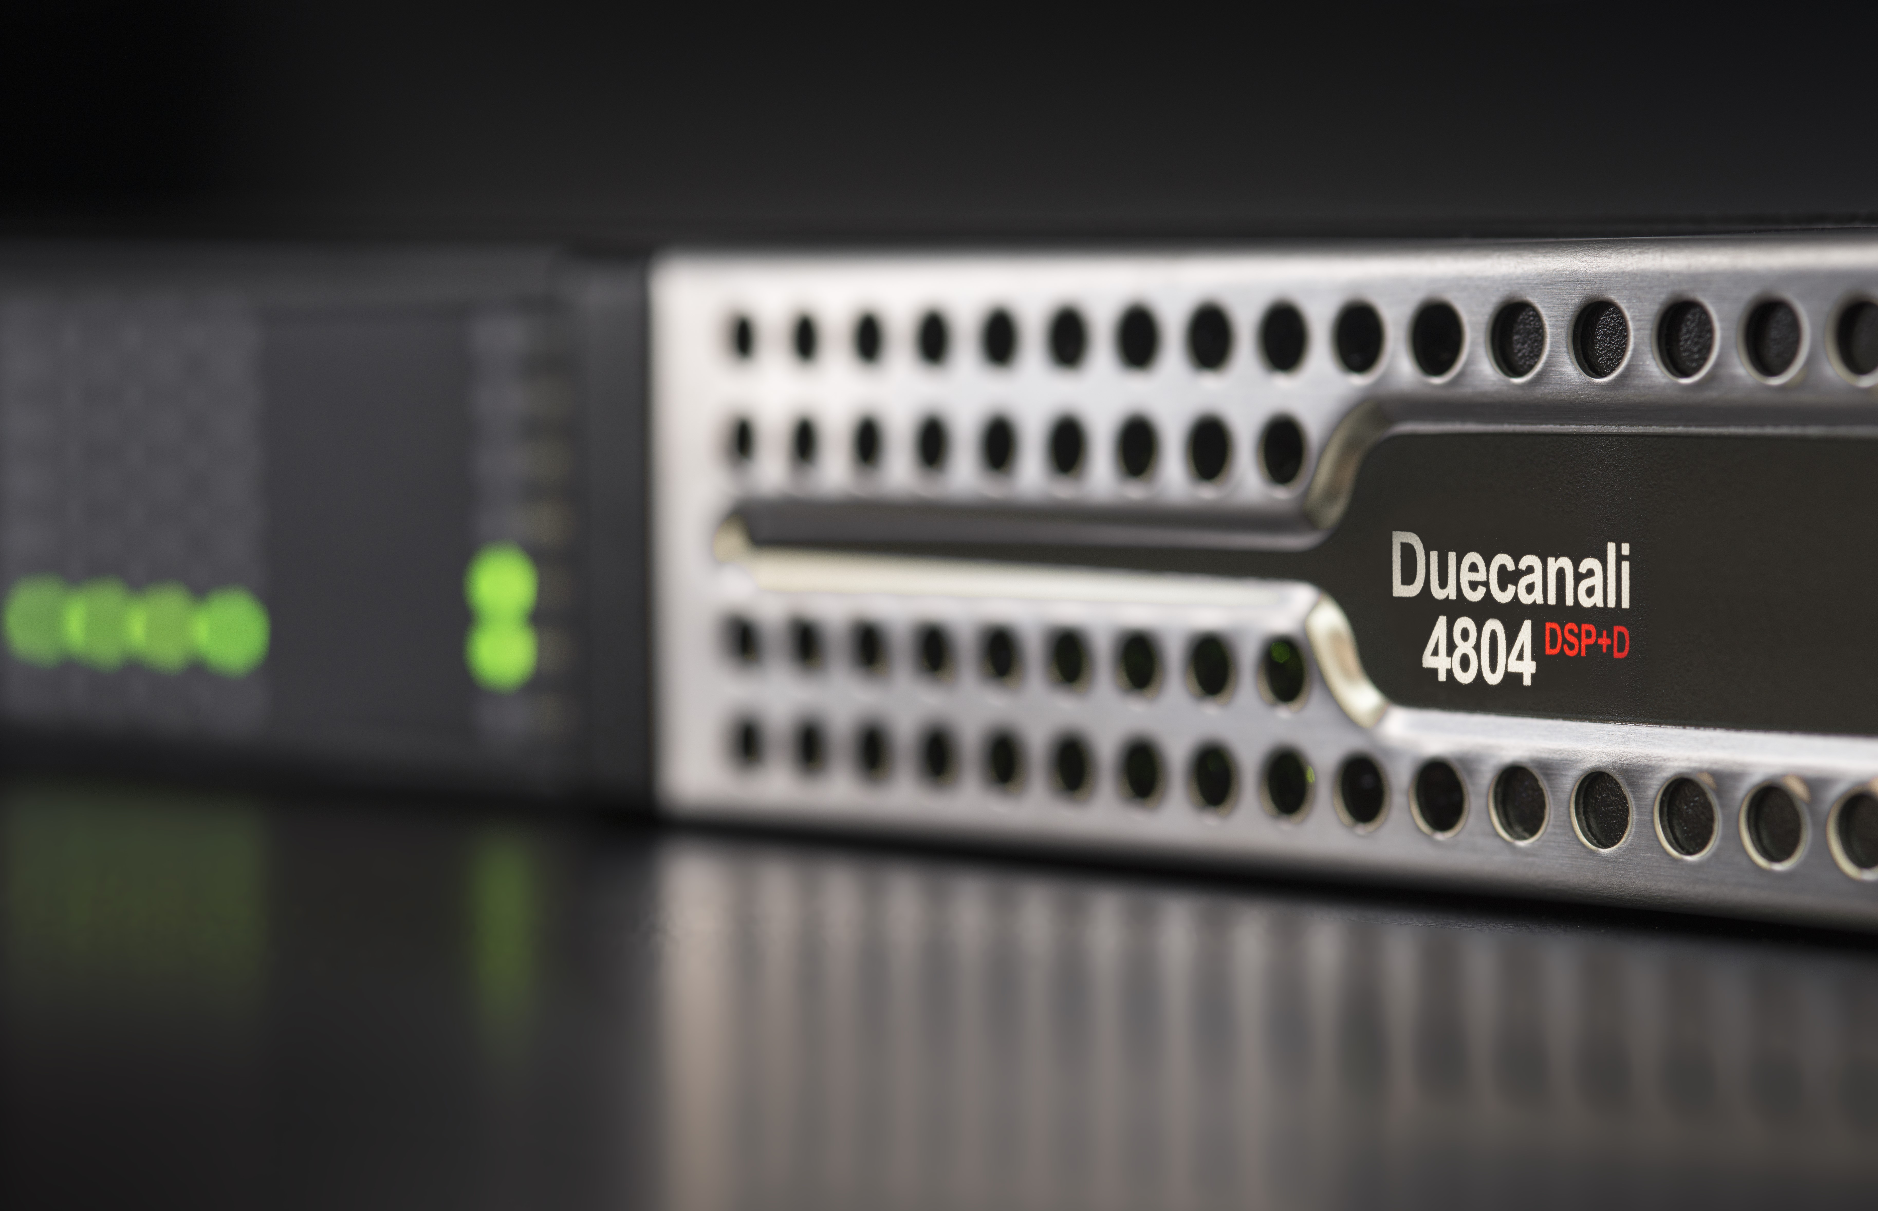
“With DSP onboard, interoperability created via third-party plug-ins, networking and remote control, Powersoft amplifiers have been converted into smart controllers of the future,” says Francesco Fanicchi, Powersoft’s Brand and Communication Director. “This has great bearing on integrators involved in multiple disciplines like audio, video, ETH cabling, power distribution and UPS provision, meaning that the future becomes a whole lot easier.”

Diving in the deep end with M-Force
Powersoft also continues to explore new chapters of innovation in the realm of infra bass, with its patented M-Force technology. Recently announced at this year’s Prolight & Sound, the new M-force 301P01 has been updated with a series of additional features to simplify the workload for Powersoft’s growing community of OEM partners.

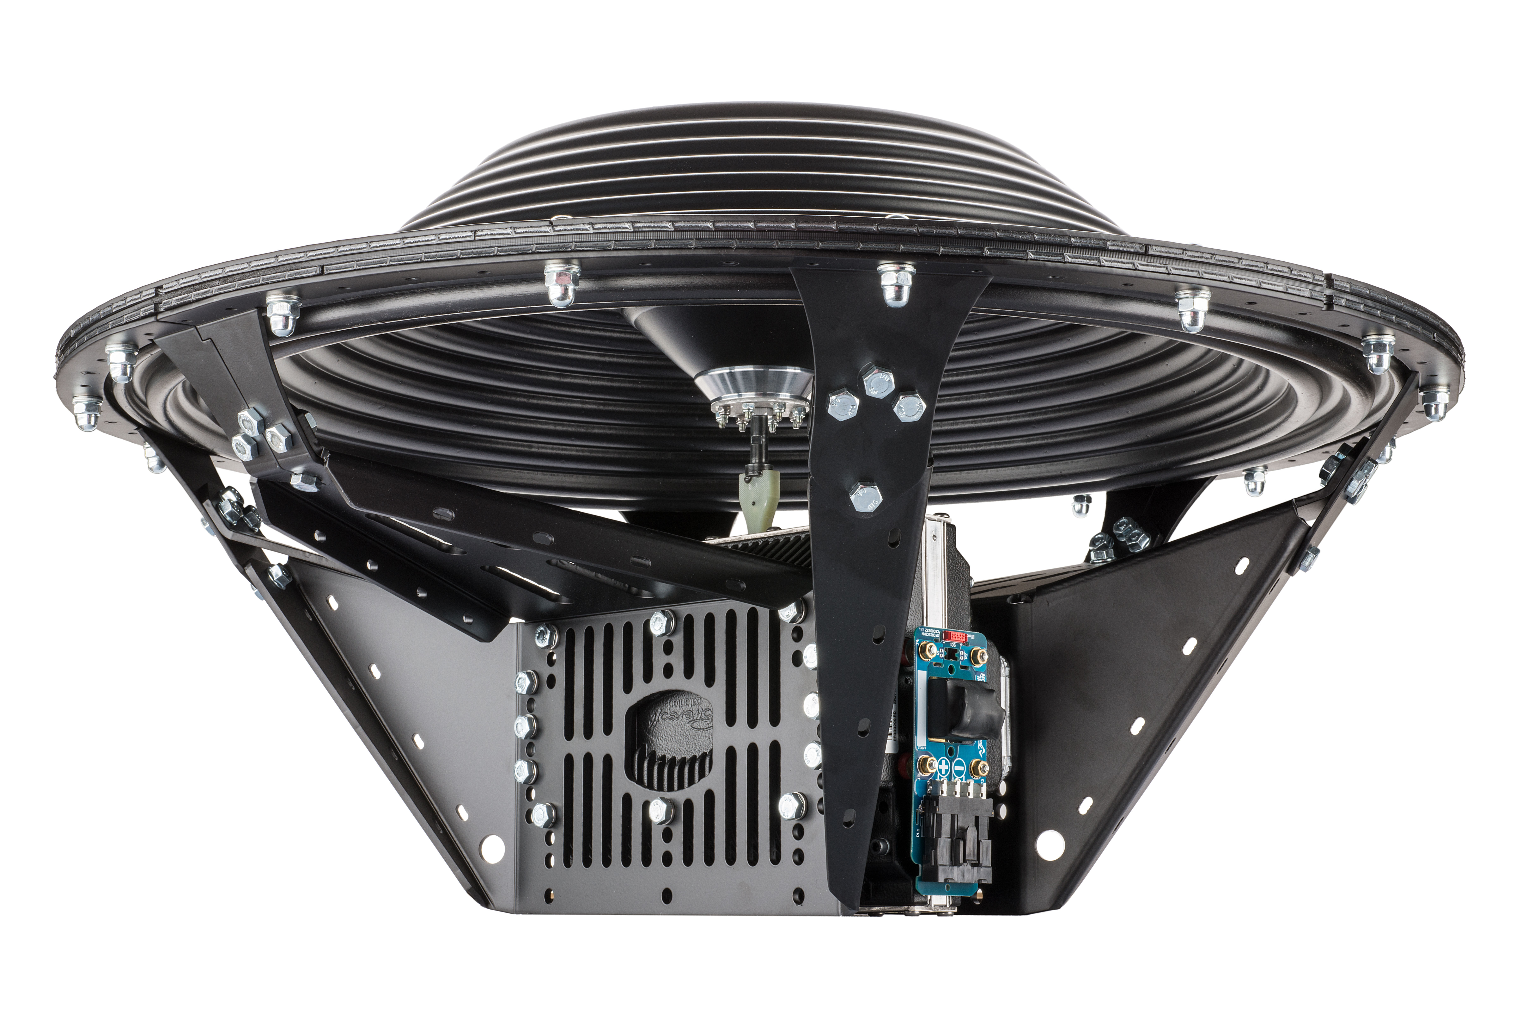
Now, M-force is available in either the M-force 01 long throw linear motor (for infra sub applications) or the M-force 02 short throw linear motor (for high acceleration applications). With longer linear displacement, M-Force 01 is the perfect tool for direct radiation and bandpass applications, enabling manufacturers to keep cabinet sizes to a minimum while allowing for flawless infra-bass reproduction. M-Force 02 meantime, is designed to handle reliability under extreme loads — such as bandpass applications and loaded horn configurations.

Visitors to InfoComm 2018 will appreciate the developments to M-Force 301P01, which is engineered in a robust, factory assembled package, greatly simplifying implementation. The motor is matched to a purpose-built diaphragm through a newly designed coupling and a lightweight chassis, which also improves thermal dissipation. The need for an external spring has also been removed, since magnetic spring action from linear movement is delivered by motor and magnets.

“I’ve always considered power amplification, signal processing, and transducer design in loudspeaker to be one single entity in the pursuit of performance,” said Claudio Lastrucci, Powersoft’s R&D Director. “There’s no division between one domain and another because this would limit the evolution of the products to small changes that don’t add up.”

Armonía Pro Audio Suite™ Demonstrations
In conjunction with InfoComm, Powersoft will also host demonstrations on Armonía Pro Audio Suite, its innovative audio management and DSP software solution. Half-hour sessions will be held twice a day between June 6-8 at 11:00 a.m. and 2:00 p.m. at Powersoft Booth C628, hosted by Powersoft’s Gino Pellicano, Market Development & Applications, North America. Each session is capped with insights and explorations into system monitoring and advanced remote-control functions, with emphasis on Armonía Operator View and advanced Webapp functionality.
Each session is free and open to the public
Armonía Pro Audio Suite™ is a control and monitoring software platform for the full range of Powersoft products, making sound system setup and tuning easy through its highly intuitive user interface. The system offers unique features to make sound systems safer and better sounding, especially in combination with Powersoft’s DSP technology.

For further information, contact:
Jeff Touzeau (media contact)  Hummingbird Media  Tel : +1 (914) 602 2913  Email: jeff@hummingbirdmedia.com | Francesco Fanicchi  Powersoft (Florence, Italy)  Tel: +39 346 9719798  Email: francesco.fanicchi@powersoft.it

Or visit www.powersoft-audio.com

About Powersoft:
Powersoft is the world leader in lightweight, high power, single rack space, energy efficient amplifiers for the professional audio market. Founded in Italy in 1995, headquartered in Florence, Italy, with offices in Kearny, NJ, Powersoft couples the experience and precision of its production department with exceptional components to deliver products with perfect audio response and high performance reliability. Its state-of-the-art amplifiers can be found in an array of markets, ranging from stadiums, sporting arenas, theme parks, performance venues and airports to convention centres, churches and clubs, and are used by the world's leading tour sound companies. For more information, visit the Powersoft website @ www.powersoft-audio.com

