Major Firmware 2.0 Update for Neumann MT 48
New plugins, immersive broadcast tools, advanced monitoring features, and scalable Dante connectivity 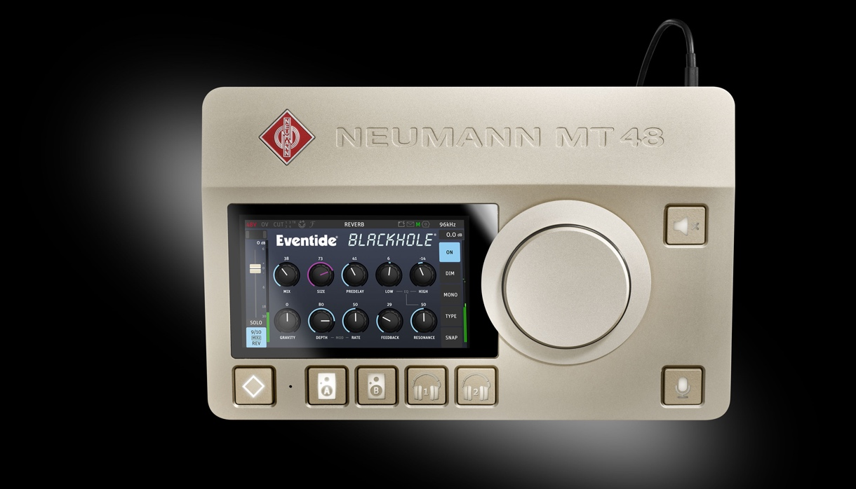

Berlin, Germany, June 15th, 2026 - Neumann.Berlin announced the release of firmware version 2.0 for its MT 48 audio interface, marking a significant evolution of the platform with expanded creative tools, deeper broadcast integration, and enhanced workflow flexibility for professional users.

Building on its reputation for best-in-class audio fidelity and control, the MT 48 continues to evolve as a central hub for recording, mixing, and broadcast production - combining pristine sound quality with increasingly powerful DSP-based processing and monitoring capabilities.

Plugin Ecosystem for Creative Processing
Firmware 2.0 introduces compatibility with premium plugins previously available for the Anubis platform. Users of the MT 48 can now install:

- Eventide Blackhole Reverb, renowned for its expansive, otherworldly spatial effects, enables engineers and producers to craft rich ambient textures and cinematic soundscapes
- Merging+Deesser, a transparent and highly precise tool for controlling vocal sibilance during both tracking and mixing
By enabling the embedding of these tools into MT 48’s real-time processing environment, Neumann reduces reliance on external plugins while maintaining ultra-low-latency workflows - an essential advantage for both recording and live production scenarios.

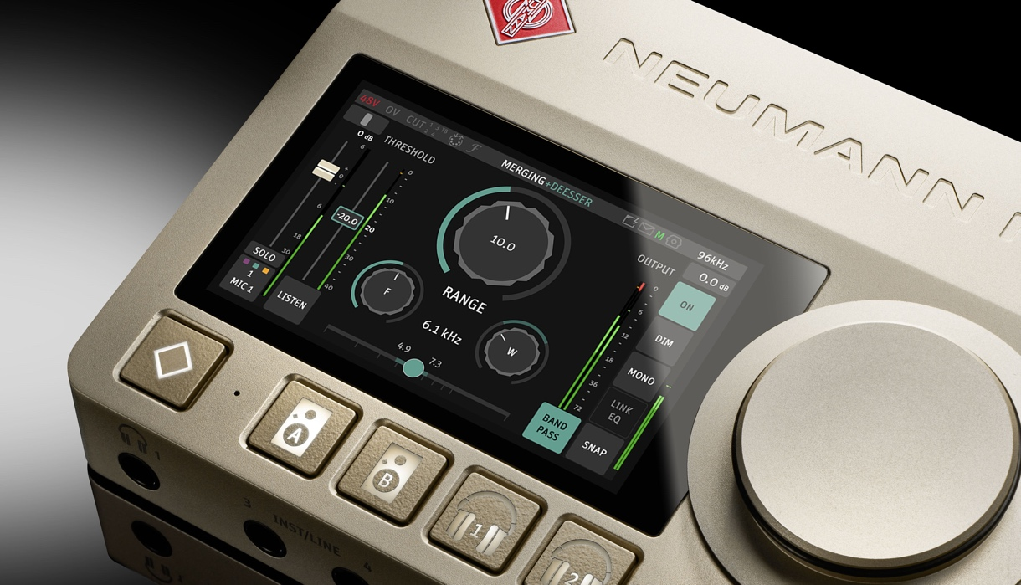

Scalable Dante Networking for Any Production Size
Recognizing the diverse needs of modern audio professionals, Neumann MT 48, as well as Merging Anubis and Hapi Mk III, now support 8x8, 16x16, 32x32, and 64x64 Dante Ready plans.
This increased flexibility ensures that users can align their investment with their current needs while retaining the option to expand seamlessly as projects grow. Such scalability makes the MT 48 suitable for a wide range of applications - from compact project studios to networked broadcast facilities and multi-room production environments.

AMBEO 2 Channels Live Broadcast Encoder
MT 48 now supports the AMBEO 2 Channels Live Broadcast Encoder, enabling broadcasters to encode their live immersive content in a 2-channel mix that consumers can enjoy at home on their stereo speakers while preserving the immersive feel of the original mix.
The encoder is available through the AMBEO program. Interested broadcasters should contact their local Sennheiser representative.
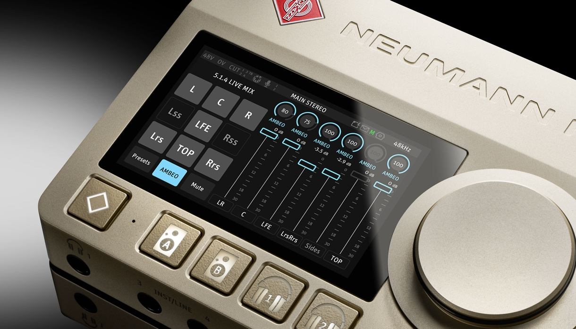

Refined User Experience and Broadcast Integration
Firmware 2.0 introduces a redesigned Advanced Pages interface, featuring updated visuals, improved navigation, and access to deeper levels of control. The new interface enhances usability while maintaining the precision required by professional engineers working under time pressure.
Further strengthening its broadcast credentials, the MT 48 now supports LAWO HOME Management Platform. This interoperability significantly broadens the device’s application in professional media environments.

Workflow Enhancements for Music and Monitor Mission
The update introduces a series of practical features designed to streamline day-to-day production tasks:

Music Mission Improvements:
- N-1 mixing is now possible, which is particularly useful for broadcast
- Talkback Dim allows automatic attenuation of monitoring levels during talkback, improving clarity in studio communication
Monitor Mission Enhancements:
- Speaker and source grouping for faster comparisons and more efficient navigation
- L/R flip function for quick validation of stereo imaging and phase issues
- Custom downmix rules, enabling users to adapt monitoring behavior to specific formats and workflows

Together, these features reinforce the MT 48’s role not only as an interface, but as a comprehensive monitoring controller for complex modern audio environments.

Performance, Stability, and Ecosystem Integration
In addition to new features, firmware 2.0 delivers numerous bug fixes, performance optimizations, and enhanced USB compatibility, including support for the latest macOS systems.
These improvements ensure stability in mission-critical workflows and reflect Neumann’s ongoing commitment to long-term product support.

Availability and Pricing
Firmware 2.0 for the Neumann MT 48 will be available as a free update starting June 15th.

Plug-ins:
- Merging+Deesser: MSRP DE EUR 209.00/ UK GBP 179.00 / US USD 209.00
- Eventide Blackhole: MSRP DE EUR 209.00/ UK GBP 179.00 / US USD 209.00
For Dante pricing, please see Audinate's website. (How it works: 1. Connect your Dante Ready device, 2. Open the Dante Activator tool from Dante Controller, 3. Add options to your cart, check out at Audinate, then your device will be activated.)

For more information, visit: www.neumann.com

About Neumann
Georg Neumann GmbH, known as “Neumann.Berlin”, is one of the world’s leading manufacturers of studio-grade audio equipment and the creator of recording microphone legends such as the U 47, M 49, U 67, and U 87. Founded in 1928, the company has been recognized with numerous international awards for its technological innovations. Since 2010, Neumann.Berlin has expanded its expertise in electro-acoustic transducer design to also include the studio monitor market, building upon the legacy of the legendary loudspeaker innovator Klein + Hummel. The first Neumann studio headphones were introduced in 2019, and since 2022, the company has increased its focus on reference solutions for live audio. With the introduction of the first audio interface MT 48, and its revolutionary converter technology, Neumann now offers all the necessary technologies needed to capture and deliver sound at the highest level. Georg Neumann GmbH has been part of the Sennheiser Group since 1991 and is represented worldwide by the Sennheiser network of subsidiaries and long-standing trading partners. www.neumann.

Stay up to date and follow us on: FACEBOOK I INSTAGRAM I YOUTUBE

Press Contact Neumann:
Neumann Newsroom
newsroom@neumann.com
+49 (0) 30417724-0

