For immediate distribution

Grammy-Winning Recording Engineer Eduardo del Aguila Streamlines Workflow with Flock Audio’s PATCH System
Flock’s digital controlled patchbay routing system has streamlined del Aguila’s workflow as he quickly moves from project to project

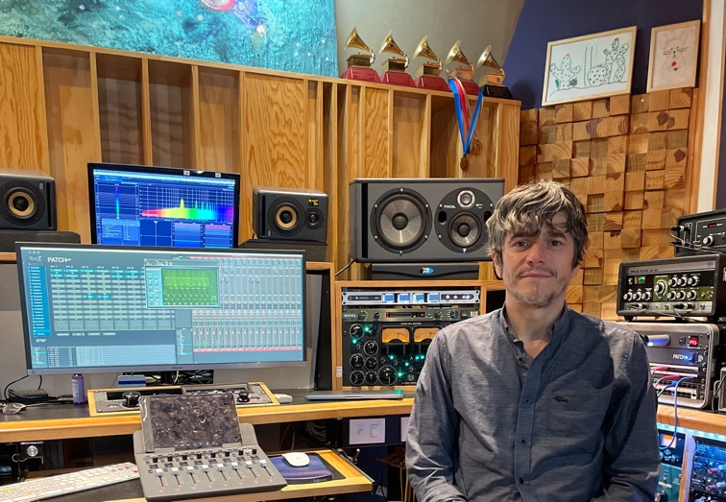
Mexico City, Mexico – September 9, 2021 – Four-time Latin Grammy-winning recording engineer Eduardo del Aguila’s mixing and mastering ‘dance card’ has been full these days. Working on multiple projects at a time for some of Mexico’s biggest artists, including members of rock band Molotov, Mon Laferte, and many others, del Aguila needed a patchbay solution that allowed him to switch as easily from one project to the next as swiftly as he did. So, eight months ago, he employed Flock Audio’s revolutionary digitally controlled patchbay routing solution the PATCH System — and the difference he’s seen in his workflow has been unmatched.
“I first got the PATCH System right before the pandemic hit, so unfortunately, I couldn’t use it right away, but over the last eight months of using the System, I’ve been completely amazed,” del Aguila said. “I’ve been in this business for 22 years, and the PATCH has really blown my mind.”
Keeping the Workflow Flowing
Del Aguila regularly finds himself jumping between his projects in the span of the day — mixing an artist in the morning and mastering a classical saxophone quartet’s album in the afternoon. Having the PATCH System at the ready has helped del Aguila streamline his projects and easily transition from one project to the next.
“Every day when I turn on my equipment, all I have to do is queue up the PATCH APP on my computer and everything is ready to go,” he explained. “This is huge because I’m switching projects all the time, so the PATCH System is a really great thing to have.”
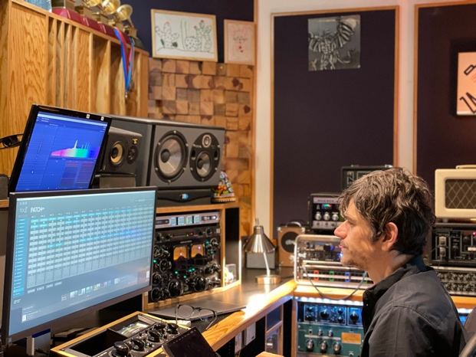
Additionally, del Aguila said the ability to “cut the cables” has been key to systematizing his workflow.
“I’m really happy to have it because I really hated the cables that come with regular patchbays,” del Aguila said. “It’s something I’ve been working with for many, many years. When I was an assistant, I was doing a lot of patching, and now as an engineer, I still hate it. Also, I wear glasses, and I like the PATCH APP because it’s intuitive and, contrary to patchbays where everything is really small, I can see everything with the PATCH APP clearly right in front of me and check that everything is in the right place very easily.”
Recording with PATCH
Aside from mixing and mastering, del Aguila recently recorded an EP with a member of Mexican rock band Molotov. To record the session, del Aguila turned to the PATCH System for the first time.
“It was my first recording session using the PATCH System, and I was surprised by how was amazingly easy it was to work with,” del Aguila said. “Before, I had to patch manually, but the PATCH makes everything much more simple and speedier — and it’s just as easy as using it for mixing and mastering.”
For more about Flock Audio, visit: flockaudio.com.

About Flock Audio
Flock Audio Inc. is a pro-audio manufacturer based in Kelowna, Canada, founded in 2017. The company is best known for its PATCH System Series, which is a digitally controlled, 100% analog patchbay routing solution for professional audio environments. For more information on Flock Audio and its products, please visit the company website at: http://www.flockaudio.com.
Media Contact
Jeff Touzeau
Public Relations
Hummingbird Media
+1 (914) 602 2913
jeff@hummingbirdmedia.com

