March 30, 2018
Toyota Motor Corporation
GAZOO Racing Company

Rally France (Tour de Corse) : Preview
Island asphalt challenge awaits TOYOTA GAZOO Racing

The twisting asphalt roads of Corsica lie ahead of the TOYOTA GAZOO Racing World Rally Team on round four of the 2018 FIA World Rally Championship season. The classic Tour de Corse is the first pure asphalt event of the year, but drivers Jari-Matti Latvala, Ott Tänak and Esapekka Lappi will take confidence from the performance of the Toyota Yaris WRC on the partly ice-covered roads of Rallye Monte-Carlo, where the team celebrated a double podium finish.

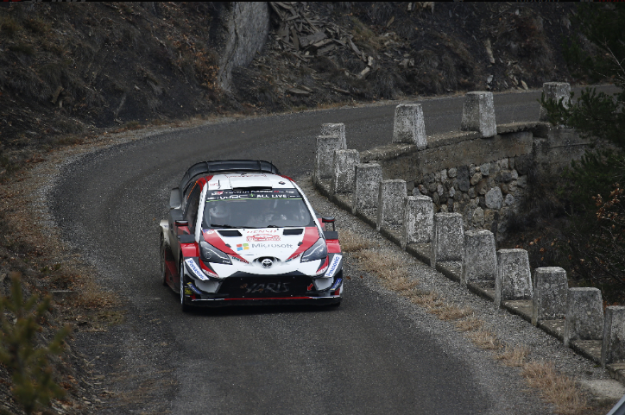

Yaris WRC #7

Serving as France’s round of the WRC, the Tour de Corse is famed for its narrow and winding mountainous stages, which are often lined by rock faces on one side and steep drops on the other. Abrasive asphalt and long stages also mean that tyre wear is a factor.

The rally is based at Bastia Airport on the eastern side of the island, where the action begins on Friday with two loops of two stages – one of which, La Porta-Valle di Rostino is 49.03 kilometres long. Saturday consists of two loops of three stages, focused on the northern coast and totalling 136.9 kilometres. On the final day, the action moves to the island’s capital Ajaccio on the western side of the island: The mammoth 55.17-kilometre Vero-Sarrola-Carcopino test – the longest on the rally since 1986 – is followed by 16.25-kilometre Pénitencier de Coti-Chiavari Power Stage.

Quotes:
Tommi Mäkinen (Team Principal)
“I think that Corsica should be a good rally for us. Our car has been working quite well on asphalt and we have had some really good pre-event testing. Our test driver Juho Hänninen was working on the suspension, and he did a very good job to improve the car, and I think that Jari-Matti, Ott and Esapekka are all happy with the feeling. Everybody in the team seems to be well prepared, so I feel pretty confident that everything will go well.”

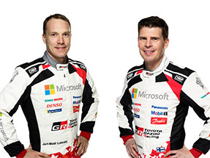
Jari-Matti Latvala (Driver car 7)
“I have some good memories of Corsica from my win there in 2015. It is certainly an asphalt rally that I like. There’s a reason they call it the Rally of 10,000 Corners: if you find any straight that is longer than 100 metres, you know you are on the wrong island! You cannot really cut the corners so much and there is not so much gravel on the road, which makes it really enjoyable as you can just focus on the corners and the lines. We had a very, very positive pre-event test. The feeling was extremely good and I am very confident with the car. All of the teams should be quick in Corsica, but I really hope we are up there fighting for the podium places.”
Jari-Matti Latvala and Miikka Anttila

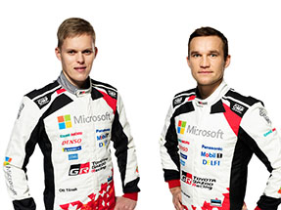
Ott Tänak (Driver car 8)
“We have been competitive on every surface so far this season. The team is working really hard to make sure that we can be reliable too. Now we just need to start taking some points back from our rivals. Last year my feeling in Corsica was quite good, so I want to have a strong result this time. The conditions on Rallye Monte-Carlo were very specific so it was difficult to take a lot, but we still went into our pre-Corsica test with some kind of idea which way we want to go. We had a proper two-day test and I think we went in the right direction: It feels like the car is performing well.”
Ott Tänak and Martin Järveoja

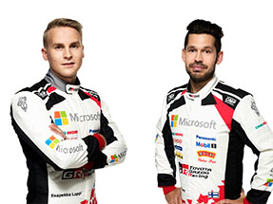
Esapekka Lappi (Driver car 9)
“I have done Corsica a couple of times in the past in other categories, and I would say that it is completely different to any other rally. It is just corner after corner, without many straights to give us a rest. The schedule is also unique as we don’t have as many stages, but they are quite long. This will be my first time in Corsica in a World Rally Car, but I take confidence from the speed we showed in Monte Carlo. In fact, I am actually more confident this time because we managed to find a better set-up in the pre-event test. We tested in both damp and fully dry conditions so we should be ready whatever the weather.”
Esapekka Lappi and Janne Ferm

The statistics (Tour de Corse):
Year | Jari-Matti Latvala | Ott Tänak | Esapekka Lappi
2017 | 4 | 11 | -
2016 | 4 | 10 | -
2015 | 1 | 10 | 14

What happened last year?
The Toyota Yaris WRC came close to the podium on its Corsica debut last year, with Jari-Matti Latvala finishing fourth overall after a thrilling finish. Victory on the the Power Stage allowed him to claim fourth place at the end of the rally by just 0.1 seconds.
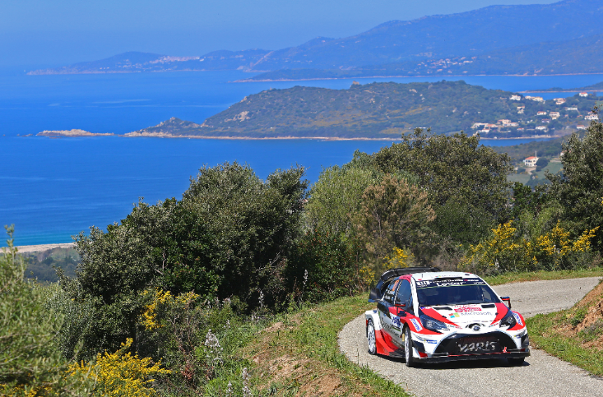

Yaris WRC Tour de Course 2017

Press release
URL:

Pictures will be uploaded here during the event
URL: https://www.tgr-dam.com

Follow us!
Follow TOYOTA GAZOO Racing WRT:
∇Facebook: https://www.facebook.com/TOYOTAGAZOORacingWRC
∇Twitter: https://www.twitter.com/TGR_WRC (@TGR_WRC)
∇Instagram: https://www.instagram.com/tgr_wrc/ (@TGR_WRC)
∇YouTube: https://www.youtube.com/channel/UCCtALHup92q5xIFb7n9UXVg

Contact

TOYOTA GAZOO Racing PR Office
Email: tgr_pr@tgr-dam.com

TOYOTA GAZOO Racing official website:
http://toyotagazooracing.com/

TOYOTA GAZOO Racing World Rally Team is supported by following partners:
