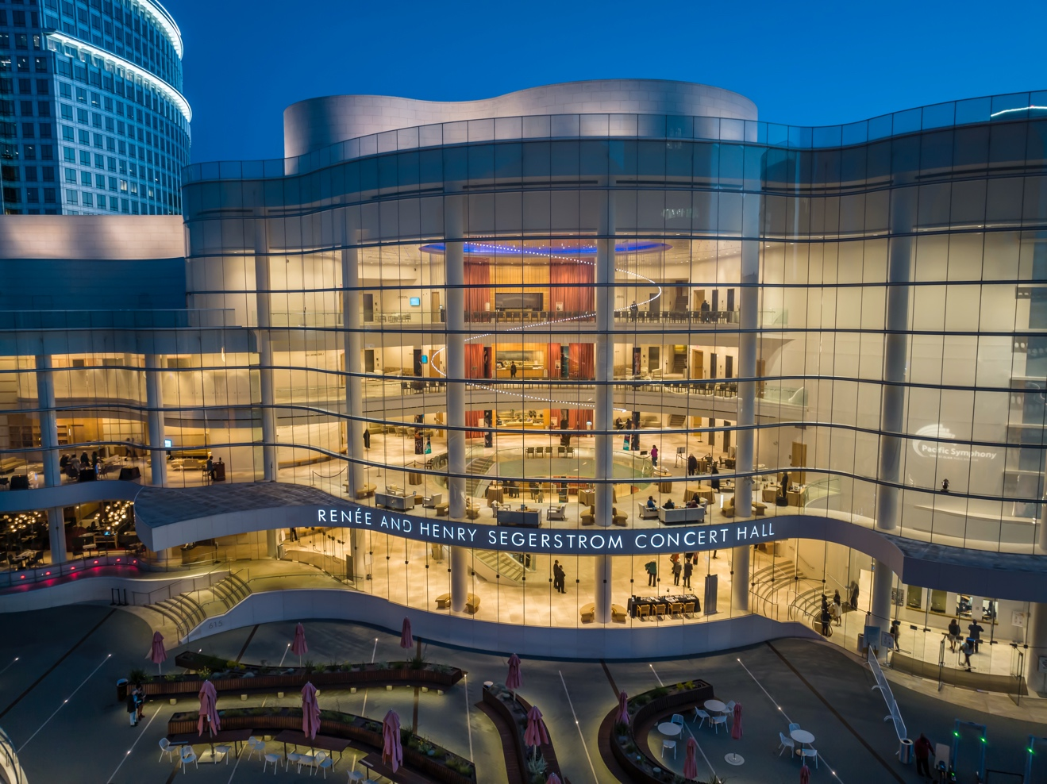
Pacific Symphony Saddles Up its Orchestral Performances with 40 Neumann Miniature Clip Mics
After testing the MCM 114 Acoustic Instrument Sets, "everybody loved them right out of the gate, so it was a real easy decision to make,” for the largest U.S. orchestra formed in the last 50 years.

Costa Mesa, California, January 14, 2025 — Pacific Symphony chalked up a couple of firsts at its 2024 Fourth of July Spectacular when the orchestra opened a new summer home with a set of brand new Neumann MCM Miniature Clip Microphones. The five-concert summer series at Great Park Live in Irvine, California, marked the live debut of Pacific Symphony’s 40 Neumann MCM 114 Acoustic Instrument Sets, which all feature KK 14 cardioid capsules.
With Pacific Symphony about to settle into a new outdoor amphitheatre for the summer series with new equipment provider, Apex Audio, the organization decided to acquire new instrument microphones, reports John Downey, Head Audio Engineer for the orchestra at the Renée and Henry Segerstrom Concert Hall. Renowned orchestral scoring and concert mixer Shawn Murphy, who mixes Pacific Symphony’s summer outdoor program every year, recommended that the orchestra consider Neumann’s MCM 114 set.
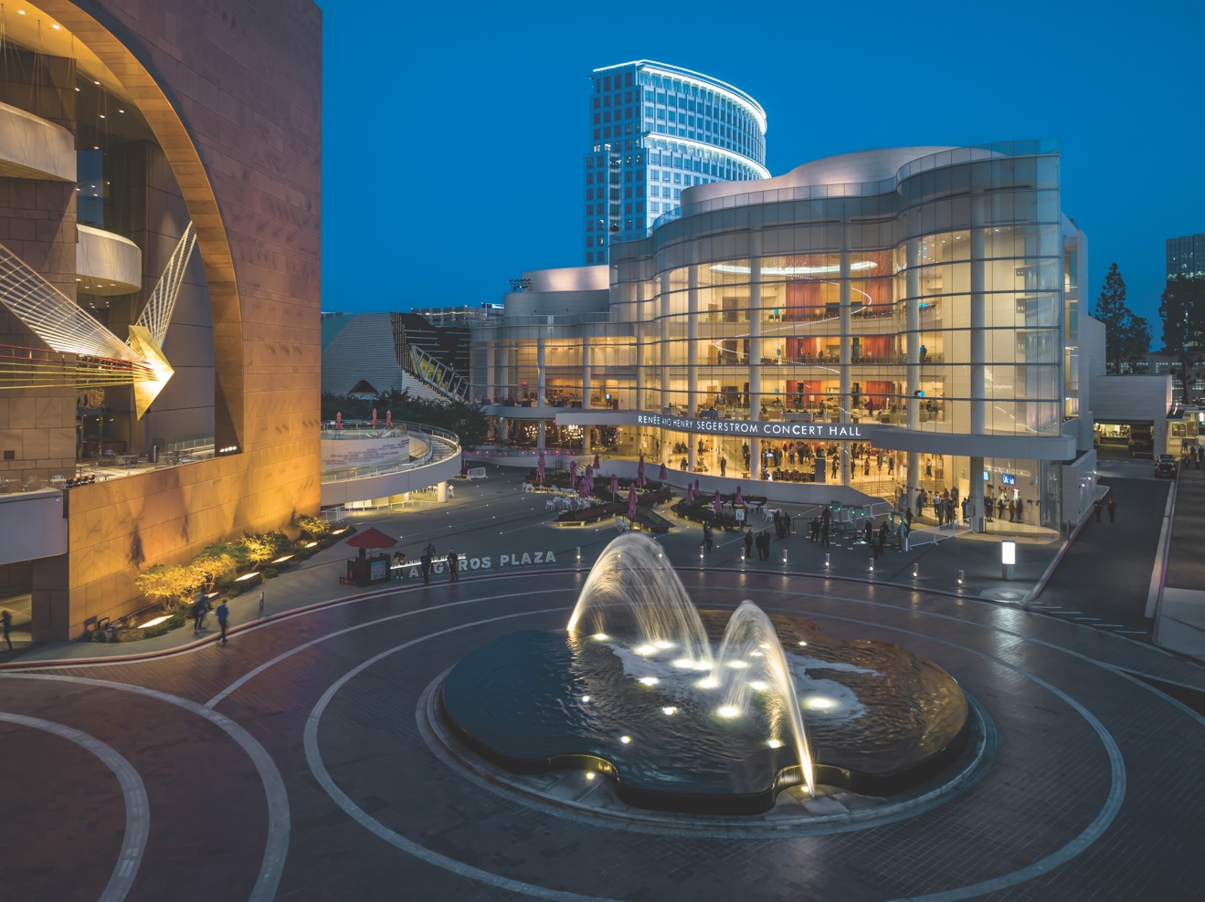
Renée and Henry Segerstrom Concert Hall, Courtesy of Pacific Symphony

Founded in 1978, Pacific Symphony is the largest orchestra formed in the U.S. in the last 50 years and has been the resident orchestra of Segerstrom Center for the Arts (formerly The Orange County Performing Arts Center) in Costa Mesa, California since 1986. In 2006, the Symphony moved into the Renée and Henry Segerstrom Concert Hall, celebrated for its world-class acoustics. The orchestra presents more than 100 concerts and events each year.
“We got a demo package from our vendor, Apex Audio, in Huntington Beach, and had a few of the musicians test them out and see how they felt about the MCM 114,” Downey recalls. He has worked at the Segerstrom Center for just over 25 years and has been the head sound engineer and the orchestra’s principal mixer since 2014. “Everybody loved them right out of the gate, so it was a real easy decision to make.”
There are a few Neumann microphones at the Segerstrom Concert Hall, he continues, and Pacific Symphony purchased some Sennheiser MD 421 dynamic mics years ago. But this was the orchestra’s largest acquisition of Neumann products so far. “We ended up buying 40 MCM 114s with various mounts. We've got them across our entire string section.” Typically, the orchestra’s string section comprises 12 first violins, 10 second violin, eight violas, six cellos and four double basses.
The KK 14 capsule was designed for close-miking and, with its high sound pressure level (SPL) handling and low self-noise, is suited for acoustic instruments of all kinds. “It's linear, clean and crisp where it needs to be, and low and full where it needs to be,” Downey says. “It's very predictable and it's really transparent, so out of the box, you need to do almost nothing and it’s going to sound great. We put a high pass filter on, but there isn't a lot you have to do, which makes the workflow smooth and fast. It sounds great and lives up to every expectation of the Neumann brand.”
Pacific Symphony’s program at the Fourth of July Spectacular at the 3,500-capacity Great Park Live included patriotic tunes, a salute to the Armed Forces, and a couple of pieces by John Williams, as well as a firework finale. Williams, who is friends with Music Director Carl St.Clair, now in his 35th season with Pacific Symphony, has even conducted the orchestra on a couple of occasions. Shawn Murphy, who mixed the concert, is also John Williams’ live sound engineer. “Shawn had nothing but great things to say about the Neumann mics afterwards,” Downey reports. “We had been discussing the purchase via email previously. He'd had some experience with the mics, which is why he recommended that we investigate the MCMs.”
At the end of Pacific Symphony’s SummerFest 2024, members of the orchestra were also happy to share their opinions on the microphones, Downey shares. “At every one of the five concerts, I had several musicians come up and tell me how much they liked the mics. We don’t usually get that kind of feedback from them.”
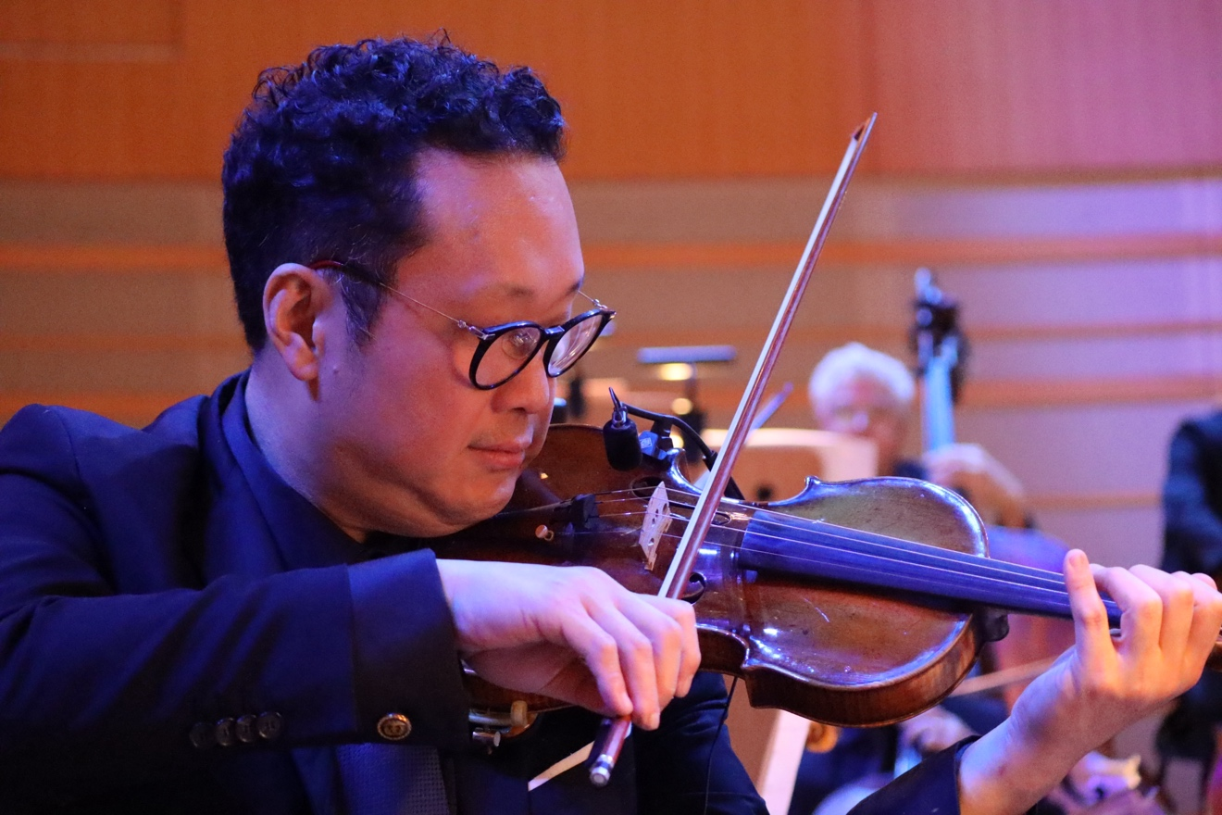
Pacific Symphony Concertmaster Dennis Kim, Courtesy of Pacific Symphony

Downey also included some of the musicians in the initial evaluation process to get their opinions on mounting and unmounting the microphones on their instruments. “Before we pulled the trigger on the purchase we took the demo kit out to the stage to the section leaders, and to a few other people in the sections, and had them try the mic on. I said, ‘How do you like this? How does it feel? Do you think that this is going to be better or worse?’ They all said, ‘This is great, way better than the previous mics.’”
Downey and his crew built a rack for easy teardown at each event. “We pick the mics up and hang them on the rack then take them off stage, where we can wrap them up and put them into their packages to take them away. I bought some padded mailing envelopes, and we put one mic in each of those, then 10 padded mailers to a strong box. It all goes very smoothly and packages up nice and cleanly.” The Neumann MCM microphones come with a quality soft case for convenient storage and transport and are built to be robust, so they easily handle frequent use as seen at the Pacific Symphony.
The design of the MCM mic set offers additional peace of mind, he says. “The fact that the MCM 114 is quite robust and modular, and the fact that it doesn't really cost that much to replace a cable if it does get shredded, is a huge factor.”

About Neumann
Georg Neumann GmbH, known as “Neumann.Berlin”, is one of the world’s leading manufacturers of studio-grade audio equipment and the creator of recording microphone legends such as the U 47, M 49, U 67, and U 87. Founded in 1928, the company has been recognized with numerous international awards for its technological innovations. Since 2010, Neumann.Berlin has expanded its expertise in electro-acoustic transducer design to also include the studio monitor market, building upon the legacy of the legendary loudspeaker innovator Klein + Hummel. The first Neumann studio headphones were introduced in 2019, and since 2022, the company has increased its focus on reference solutions for live audio. With the introduction of the first audio interface MT 48, and its revolutionary converter technology, Neumann now offers all the necessary technologies needed to capture and deliver sound at the highest level. Georg Neumann GmbH has been part of the Sennheiser Group since 1991 and is represented worldwide by the Sennheiser network of subsidiaries and long-standing trading partners. www.neumann.com
Stay up to date and follow us on: FACEBOOK I INSTAGRAM I YOUTUBE

Local Press Contact:
Daniella Kohan
daniella.kohan@sennheiser.com
+1 (860) 227-2235

Press Contact Neumann:
Dr. Andreas Hau
andreas-hau@neumann.com
+49 (030) 417724-15

