Mission Critical Performance: Williamson County Emergency Operations Center Relies on myMix for Crisis Communications
The versatile myMix system plays a crucial role in delivering critical information to key county officials in central Tennessee
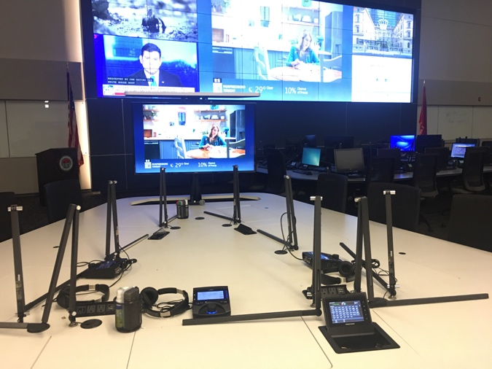
Franklin, TN, February 27, 2019 — While originally designed as a personal monitor mixer and recording system for musical performances, Williamson County Tennessee’s Office of Public Safety relies on the myMix system to assist important county officials during an emergency or large event within its county.

Located just south of Nashville, Williamson County has numerous tables set up in its Emergency Operations Center (EOC) which serves as a space for police chiefs, fire chiefs and mayors to gather critical information during a disaster or county event. Each table features nine chairs and three myMix units. The EOC room features a wall of televisions that display various feeds where the myMix units supply audio to individual headsets.

“The myMixes allow someone in the EOC to easily listen to what’s on one news channel by just grabbing the headset and not disturbing the whole room,” said Sean Cothron, IT Systems Administrator for the Emergency Management Agency in Williamson County. Cothron added that as of last month, the delivery of radio traffic from law enforcement and fire protection has also been added into the network. “It’s great because I can turn those radios to whatever frequency I need for a specific event.”

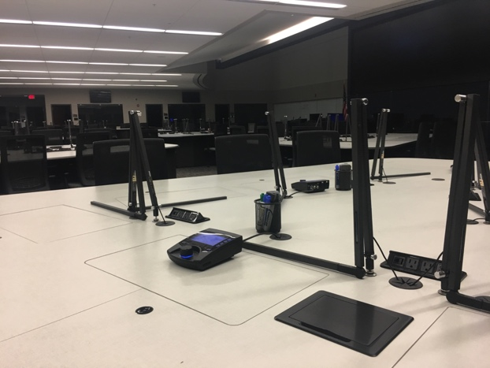
A Reliable Solution When it Counts
The Williamson County EOC’s AV metrics includes 16 feeds for both computer and televisions. Three stations with nine chairs are set up in the Emergency Operations Center and each station features one myMix unit.

“The ability for the user sitting in the chair to get the resources that they require and help them respond to the public’s needs is critical,” Cothron said. “It’s great because we’ve never had any type of system like this before we installed the myMix units.”

The myMix units were put to the test last summer when tornadoes tore through Williamson County.

“We had a lot of upper-level command people, like the police chief, fire chief and mayors here,” Cothron explained. “They were running the event from that room and communicating and taking communications from people in the field and sharing that information with the room so everyone had situational awareness about what was happening.”

The myMix is essential to delivering radio feeds to key personnel in the EOC as Williamson County’s Office of Public Safety building is constructed to withstand a direct strike from an F5 tornado or large earthquake. As a result, radio signals cannot penetrate the structure, so Cothron said without the myMix it would be nearly impossible to get the signals into the room.

According to Cothron, the myMix units are used during “any big event that’s affecting the community in a positive or negative way.” As a result, the myMix system played a key role during this year’s annual Williamson County Fair, which is held for 9 days each August. As the second largest county fair in the state, the myMix delivers critical radio communications to the Emergency Operation Center’s tables, providing situational awareness and interoperability direct to key decision makers.

“The myMixes provided them with the information that gave them the ability to direct resources as they became needed,” Cothron said. “This could have been more personnel or more equipment.”

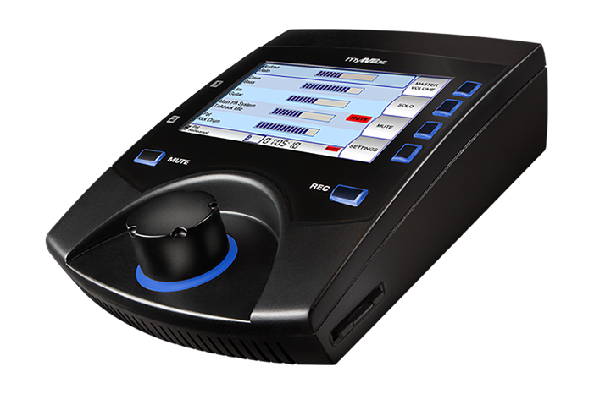
A ‘Critical Component’
In addition to installing myMix units in the Emergency Operations Center, Cothron has placed three units in the county’s policy conference room.

“It’s helpful to have units in this room because depending on how large an event is, there could potentially be users in this room as well,” Cothron explained. “Thanks to the location of the policy conference room, they can see the wall and listen into radio traffic even when they aren’t in the EOC.”

Additionally, the county’s Auxillary Communcations group — a group of HAM radio operators that volunteer during emergencies providing communications in case the public safety radio system fails — have also begun using myMix units at their communications table. Cothron said he can’t imagine working without the myMix.

“I’m blown away by the capabilities of these boxes,” he said. “It’s very cool what you can do with it. And while we aren’t using it for its designed application, it’s still a critical component for us at the EOC.”

For more information, visit mymixaudio.com.

About myMix
Part of the Synthax family, the North American distributor for RME, myMix is a personal monitor mixing and recording system featuring local network inputs and can operate either self-contained or integrated with any analog or digital mixing consoles. Thanks to its ease of use, the myMix is ideal for on-stage performances, studio monitoring as well as installed applications such as houses of worship.

Media Contacts:
Katie Kailus
Public Relations
Hummingbird Media
+1 (630) 319-5226
katie@hummingbirdmedia.com

Jeff Touzeau
Public Relations
Hummingbird Media
+1 (914) 602 2913
jeff@hummingbirdmedia.com

