Embargoed until 1 July 2020, 10 a.m. CEST

Anniversary offer

Raise Your Voice with the XSW 1-835 Vocal Set

Wedemark, 1 July 2020 – Sennheiser’s July anniversary deal brings you the XS Wireless 1-835 Vocal Set at a special price. An easy-to-use wireless microphone system for singers and presenters, this vocal system operates in the professional UHF band. To celebrate the audio specialist’s 75-year anniversary, the XSW 1-835 Vocal Set is available for EUR 199 instead of EUR 299 throughout the months of July and August. Please visit www.sennheiser.com/special-deals for a list of dealers offering this promotion. Still on special offer this month are the Memory Mic (extended until 31 August) and the HD 280 PRO headphones (extended until 31 July).

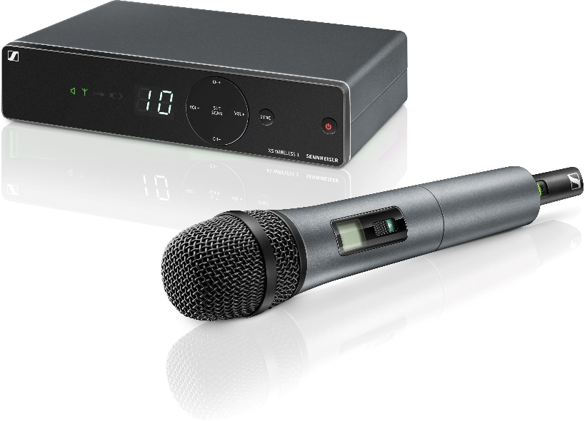 | The XSW 1-835 brings you a vocal set with the renowned evolution e 835 capsule, operating in the professional UHF band
Looking for ease of use, fast set-up and reliable transmission? Then the XSW 1-835 is for you. Offering excellent live sound and a stunning design, this radio microphone system has you ready to perform within seconds, thanks to automatic frequency management with one-touch synchronization and intuitive, icon-based controls.

The handheld transmitter is fitted with the renowned Sennheiser evolution e 835 capsule; the receiver provides balanced XLR and unbalanced jack outputs and employs antenna switching diversity for reliable reception. The system offers up to ten compatible, preset channels in eight frequency banks, and is available in a number of ranges across the UHF spectrum.

The XS Wireless 1-835 set comes complete with receiver, handheld transmitter with microphone capsule, power supply unit, microphone clamp and batteries.

The images accompanying this press release can be downloaded at https://sennheiser-brandzone.com/c/181/954muDtP.

About Sennheiser
Founded in 1945, Sennheiser is celebrating its 75th anniversary this year. Shaping the future of audio and creating unique sound experiences for customers – this aim unites Sennheiser employees and partners worldwide. The independent family company, which is managed in the third generation by Dr. Andreas Sennheiser and Daniel Sennheiser, is today one of the world’s leading manufacturers of headphones, loudspeakers, microphones and wireless transmission systems. In 2018, the Sennheiser Group generated turnover totaling €710.7 million. www.sennheiser.com

Global Press Contact

Stephanie Schmidt
Stephanie.schmidt@sennheiser.com
+49 (5130) 600 – 1275

