**For immediate release**

**First-class comfort from head to toe**

**Two iconic German brands team up to provide a sublime inflight entertainment experience.**

***Wedemark, November 7, 2024* – The Sennheiser brand and Lufthansa today announce an in-flight collaboration that brings the acclaimed MOMENTUM 4 Wireless to the newest Lufthansa Allegris First Class suites.**

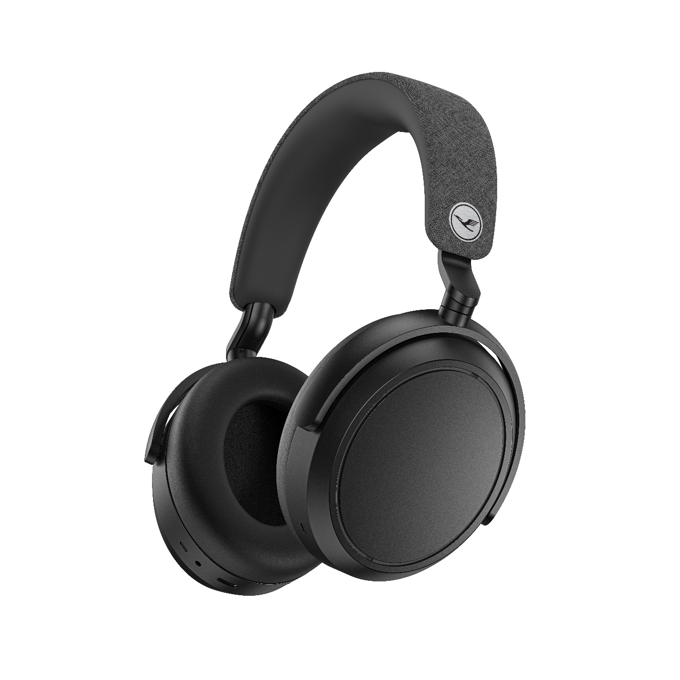  
**The sound of the skies**

In the coming weeks passengers on select Lufthansa Allegris First Class planes flying from Munich to Bangalore and Mumbai and back will be offered a special Lufthansa-branded edition of MOMENTUM 4 Wireless to use for the duration of the flight. The travel headphones boast remarkable sound, battery life, and first-class comfort. The collaboration aligns with both companies’ commitment to an exceptional customer experience, with more routes to be added in the future.

*‘When it comes to providing a luxurious sound experience for the inflight entertainment in Lufthansa Allegris First Class, one brand stood out for us*,’ said Kai Peters, Head of Customer Experience Design Lufthansa Group. ‘*Sennheiser is a long-established German premium audio brand that produces innovative sound experiences, with excellent reviews from experts and customers. In line with our motto, ‘Truly Like Home’, we are delighted to offer the Sennheiser MOMENTUM 4 headphones in our new* *First Class suites, as they enhance the flying experience with their excellent sound, comfort and active noise cancellation. Lufthansa is thus one of the first airlines to offer wireless headphones as part of the entertainment experience. Beyond that, the Bluetooth technology on board will also allow passengers in all travel classes to use their own private headphones.*’

MOMENTUM 4 is fully equipped to handle intercontinental flights with ease, thanks to relaxing Noise Cancellation and up to 60 hours of battery life per charge. Whether catching up on their favorite shows, crossing a must-see movie off their list, or settling into a curated playlist, the inflight entertainment has never sounded so good.

*“We could not have asked for a better partner than Lufthansa,”* says Christian Ern, Sennheiser Principal Product Manager, *“There is a genuine sense of pride we both get by offering excellence to our customers. Each can take a little piece of innovative technology based on the power of German engineering across the world, which is always a special way to start—or complete—a memorable journey.”*

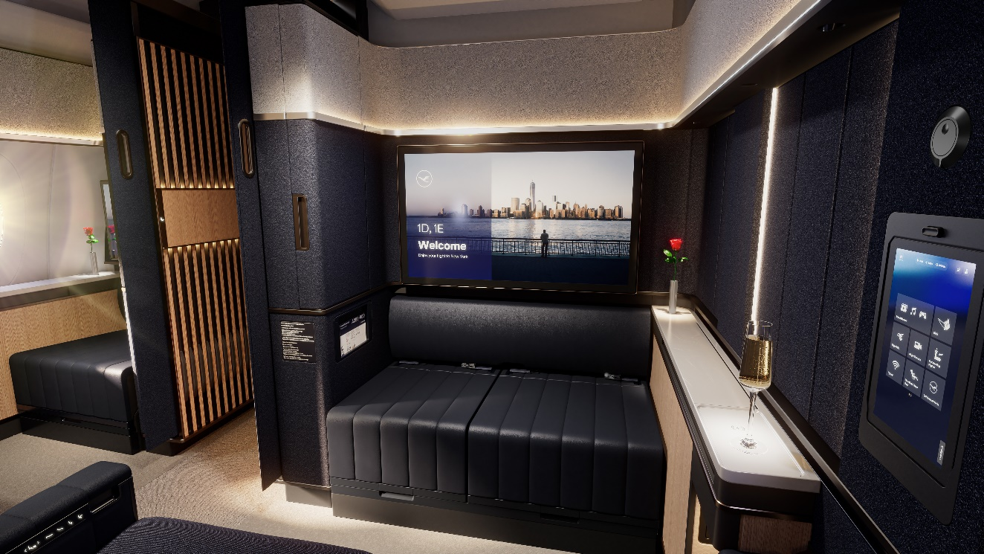

**Ready for takeoff**

Lufthansa’s new first-class entertainment option will be available soon. With its advanced comfort and performance, MOMENTUM 4 Wireless is equipped to connect to Lufthansa’s Inflight Entertainment system and stream via Bluetooth. Travelers looking for their own upgrade can purchase MOMENTUM 4 Wireless “Lufthansa Edition” in the Lufthansa Inflight Shopping, the Lufthansa First Class Terminal and from the end of November via worldshop.eu. The standard Sennheiser product is available at select retailers and sennheiser-hearing.com

**About the Lufthansa Group**  
The Lufthansa Group is an aviation group with operations worldwide. It plays a leading role in its European home market. With 96,677 employees, the Lufthansa Group generated revenue of EUR 35,442m in the financial year 2023.

The Lufthansa Group comprises the Passenger Airlines and Aviation Services segments.

The Passenger Airlines segment includes, on the one hand, the network airlines Lufthansa Airlines, SWISS, Austrian Airlines and Brussels Airlines. As part of the multi-hub strategy, they offer their passengers a broad range of flights from their global hubs in Frankfurt, Munich and Zurich as well as their national hubs in Vienna and Brussels. Lufthansa Airlines also has close relationships with the regional airlines Lufthansa CityLine, Lufthansa City Airlines and Air Dolomiti as well as Discover Airlines, the Lufthansa Group’s holiday airline. Edelweiss, the leading Swiss holiday airline, is a sister company of SWISS.

Furthermore, Eurowings also belongs to the Passenger Airlines segment. This airline provides a comprehensive range of direct connections for European short- and medium-haul destinations, in particular from German-speaking countries.

Aviation Services comprises the segments Logistics and MRO, as well as Additional Businesses, which in particular include Lufthansa Aviation Training and Lufthansa Systems. An agreement to sell AirPlus was signed in 2023. The Group Functions are also part of this segment.

**About the Sennheiser** **brand**

We live and breathe audio. We are driven by the passion to create audio solutions that make a difference. Building the future of audio and bringing remarkable sound experiences to our customers – this is what the Sennheiser brand has represented for more than 75 years. While professional audio solutions such as microphones, meeting solutions, streaming technologies and monitoring systems are part of the business of Sennheiser electronic GmbH & Co. KG, the business with consumer devices such as headphones, soundbars and speech-enhanced hearables became part of the Sonova Holding AG group of companies in 2022, who have licensed the Sennheiser trademark for this purpose.

[www.sennheiser.com](http://www.sennheiser.com/)

www.sennheiser-hearing.com

**About Sonova Consumer Hearing**  
Sonova Consumer Hearing offers premium headphones and hearables – primarily in the true wireless segment – as well as audiophile headphones, hearing solutions and soundbars under the Sennheiser brand. The business is part of the Sonova Group, a global leader in innovative hearing care solutions with headquarters in Switzerland and more than 17,000 employees worldwide.

**Press contact**

Sonova Consumer Hearing GmbH

Eric Palonen

PR and Influencer Manager | Americas  
Sennheiser Headphones and Soundbars

T +1 860 908 1210

eric.palonen@sonova.com