INTERPOL
MARAUDER

OUT AUGUST 24 ON MATADOR RECORDS

PRESS CONFERENCE STREAMING NOW
LIVE FROM MEXICO CITY – WATCH HERE

FIRST SINGLE ‘THE ROVER’ OUT NOW

PERFORMING LIVE ON THE LATE SHOW WITH STEPHEN COLBERT TOMORROW, JUNE 8

WORLD TOUR DATES ANNOUNCED INCLUDING HEADLINE STOPS AT MADISON SQUARE GARDEN, HOLLYWOOD BOWL, ROYAL ALBERT HALL AND MORE

UK FESTIVAL DATES INCLUDING BST HYDE PARK AND TRNSMT

“Marauder is a facet of myself. That’s the guy that fucks up friendships and does crazy shit. He taught me a lot, but it’s representative of a persona that’s best left in song. In a way, this album is like giving him a name and putting him to bed” -Paul Banks

But before he calls it a night, Marauder has a few tales to tell. Pull up a chair, because you’ll want to hear this…

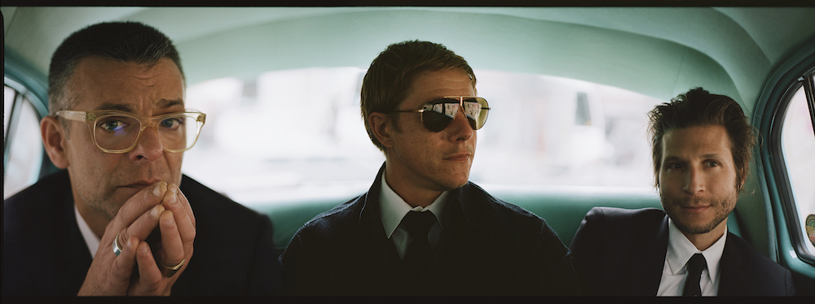
(Credit: Jamie-James Medina)

Months of speculation come to an end today as details of the new Interpol album can finally be confirmed: One of the most critically and commercially acclaimed bands of the last decade and a half will release their sixth album, Marauder, August 24th on Matador Records.

As you read this, Interpol is currently revealing all details (Themes! Making-of! Album art! Producer! Visuals!) to a convergence of their most fervent fans and media, live from General Prim 30 in Mexico City via a livestreamed press conference. Tune in HERE.

Marauder’s first single, ‘The Rover’, can be heard HERE, and will be performed live on The Late Show with Stephen Colbert tomorrow, June 8.

Interpol have also confirmed an initial run of worldwide tour dates, in addition to previously announced appearances at London’s BST Hyde Park with The Cure, Glasgow’s TRNSMT Festival, NYC’s House of Vans and Chicago’s Riot Fest. Fans that pre-order Marauder directly from the Interpol store will get first access to ticket pre-sales for the new shows, which include Royal Albert Hall, Madison Square Garden and Hollywood Bowl. The full list of tour dates can be found below.

(PRESS CONFERENCE PHOTO GOES HERE, WILL USE ONE FROM THE DRESS REHEARSAL)

It finally happened; somebody called the cops on Interpol.
The long arm of the law caught up with Daniel Kessler, Paul Banks, and Sam Fogarino in 2017, as they worked on a new album inside the Yeah Yeah Yeahs’ rehearsal space in Manhattan. Even in its infancy, Marauder was shaping up to be a beast; an early practice session was so vigorous, it resulted in Sam hitting the drums so hard that he busted his kick drum.
Eventually, the trio were playing with such force and volume, that a neighbor called the boys in blue on the boys in black, forcing them out of the practice space. “We ruined it for everyone,” reflects Daniel. “It seemed like you’re picking on the wrong rock band,” adds Sam with a laugh. “It’s not like we’re Mastodon. I mean, in certain circles, we’re considered wimps!”
If that was ever the case, the Interpol captured on their sixth album are nothing of the sort. While many fans took time over the last 18 months to read about the band’s vital part in New York City’s early 21st century rock renaissance or bask in the glory of their hugely successful 15th anniversary tour celebrating the seminal 2002 debut Turn On the Bright Lights, the trio have been quietly (sorry, LOUDLY) working on making sure they’re not just a cultural timepiece for music historians to study. The result is Marauder: an album that sways as well as it seduces, that pounds as well as it pouts, and that batters as well as it broods.
They’ve had some help along the way. For the first time since 2007’s Our Love to Admire, Interpol have opened themselves up to the input of a producer. For two-week spells between December of 2017 to April of 2018, they travelled to upstate New York to work with Dave Fridmann – famed for recording with Mercury Rev, Flaming Lips, MGMT, Spoon, Mogwai, and countless more.
The New Yorkers arrived at his remote and frequently snowbound Tarbox Studios with most of Marauder tightly rehearsed and worked out. Fridmann made sure that their meticulous work in crafting a virile and visceral set of songs didn’t get flattened during recording. It was his suggestion to skip the Pro Tools, and record directly two-inch tape. It’s a decision that allows a leaner and more muscular Interpol to flex throughout the album.
In the run up to writing and recording, Sam found himself immersed in soul drummers such as Al Jackson Jr (Otis Redding’s drummer) and 80’s funk producers Jimmy Jam and Terry Lewis. “How can I make shit swing?” was the question Sam repeatedly asked himself, and the answer is in the striding gallop of opener “If You Really Love Nothing,” the embellished skip ‘n’ bounce of “Stay in Touch” and the R&B swagger of closer “It Probably Matters.” Interpol have always been world-beaters at creating a feeling, but Marauder is where the feel is just as crucial.
Helping to achieve that is the band’s fast-learning bassist. “On El Pintor, we were riding on the novelty aspect of Paul playing bass, and enjoying what a good job he was doing,” says Sam, referring to the 2014 album the band recorded without original bassist Carlos Dengler. “But this time, it was a case of ‘you’re the bass player.’ I think now he felt comfortable to explore. He’s not just jumping into save the day, he’s applying himself and his voice as a bassist.”
Paul may have stepped out of the shadows as a bassist, but he’s stepping into an even brighter light as a songwriter. During Interpol’s previous albums, the singer largely kept himself out of his own work, preferring to fill his lyrics with detached thoughts, characters, and observations, often phrased in abstract. But more than 20 years on since forming at NYU, the frontman is finally allowing himself to play a role in his own stories.

“This record is where I feel touching on real things that have happened to me are exciting and evocative to write about,” he explains. “I think in the past, I always felt autobiography was too small a thing for me to reference. I feel like now, I’m able to romanticize parts of my own life.”

It’s an attitude that’s also reflected in the album’s cover; a shot of Attorney General Elliot Richardson, who in 1973, dramatically resigned after refusing President Nixon’s orders to fire special prosecutor Archibald Cox, who was then leading an investigation into the growing Watergate scandal. Richardson cuts a lonely, isolated figure, naked to scrutiny in a spare and artificial looking room. “A lot of being accountable has to do with being honest,” says Paul, referring to both his lyrics, and the cover. A sense of reckoning is inextricably part of the album as a whole.
Like most, Paul has been many different people over the course of his life, and shades of them poke through throughout the album. Whether it’s the overly-curious narrator of “Now You See Me at Work, Dear,” the regretful soul looking back over a relationship in “Flight of Fancy,” or the rabble-rousing, magnet for trouble at the heart of “The Rover,” there are fascinating traces of a real person – past, present and future – entwined through many of the songs.

But it’s on “Stay in Touch” that the titular character comes closest to becoming flesh and blood. “Marauder chained of no real code/Marauder breaks bonds/Marauder stays long/Plays with the real face on,” croons Paul. You can almost feel, smell, and taste the danger associated with someone as headstrong and self-indulgent as this. But you want to be near it all the same.

Artwork
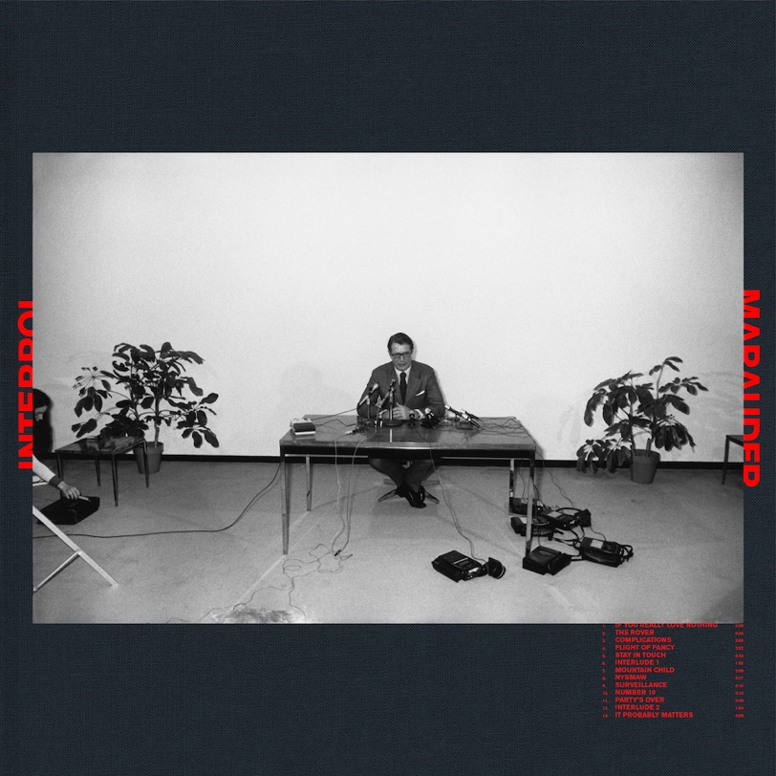

Marauder Tracklisting:

1. If You Really Love Nothing
2. The Rover
3. Complications
4. Flight of Fancy
5. Stay in Touch
6. Interlude 1
7. Mountain Child
8. NYSMAW
9. Surveillance
10. Number 10
11. Party's Over
12. Interlude 2
13. It Probably Matters

Worldwide Tour Dates:
25/6 – Wien, Austria – Arena Wien Open Air
26/6 – Sesta Al Reghena, Italy – Sexto Nplugged
27/6 – Zagreb, Croatia – INmusic Festival
1/7 – Glasgow, UK – TRNSMT festival
5/7 – Roskilde, Denmark – Roskilde Festival
7/7 – London, UK – Hyde Park – w/ The Cure
24/8 – Brooklyn, NY – House of Vans
14-16/9 – Chicago, IL – Riot Fest
4/10 – Los Angeles, CA – Hollywood Bowl – w/ The Kills, Sunflower Bean
6/10 – Berkeley, CA – Greek Theatre - w/ The Kills, Sunflower Bean
6/11 – Tokyo, Japan – Akasaka Blitz
14/11 – London, UK – Royal Albert Hall
24/11 – Copenhagen, Denmark – TAP1
29/11 – Paris, France – La Salle Pleyel
2/16 – New York, NY – Madison Square Garden – w/ Car Seat Headrest, Snail Mail

INTERPOL
Official Site / Facebook / Twitter / Instagram / YouTube / Store

