We are a PR Agency specialising in the hair sector. Creative Hairdressers are our clients.

For more information, please contact to Marta de Paco
On +34670780664 or email press@dreamscometrue.es

Important:
This images are only available for editorial content.
Is mandatory credits included.
Let us know if you give us coverage, would be very appreciated.

IVAN RODRIGUEZ
MÉXICO
DESIRE Collection

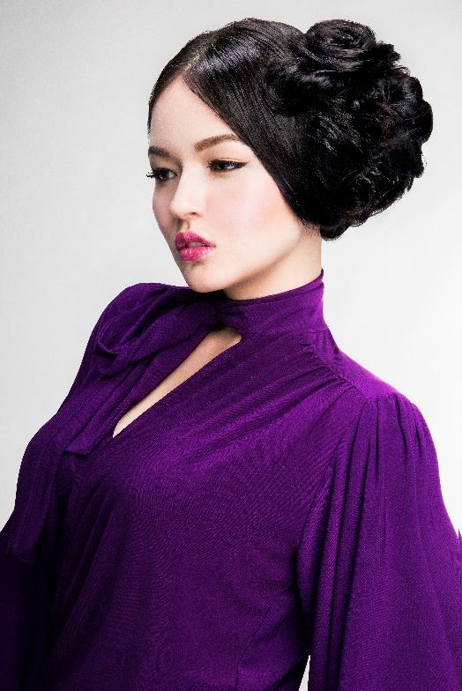
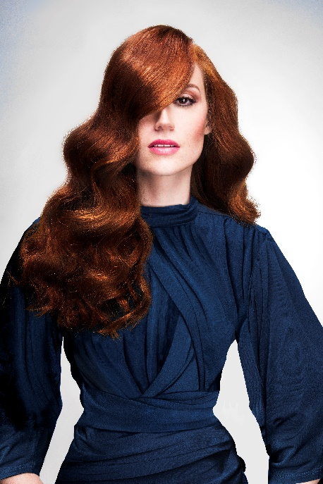
Hair: Ivan Rodriguez
Photographer: Jell Loya
MUA: Thessa Peralta & Ale Llamas

IVAN RODRIGUEZ
MÉXICO
DESIRE Collection

DESIRE captures the desire of every woman to always look and feel beautiful, regardless of the occasion.
The proposals of our collection include femininity, culture, texture, and most importantly: diversity. Whether through makeup, hair or fashion, each woman wants a unique way of expressing herself through her own style.
DESIRE is for everyone, regardless of nationality, skin color or hair texture. We are inspired by the diversity and multiculturalism of the metropolis where different ways of believing, thinking, loving, feeling and being converge.
So different, but so equal in the desire to look and feel good.

DESIRE COLLECTION 2018 - ISA - STEP BY STEP
STEP 1: Find the correct proportion with symmetry and volume of this African-American hair.
STEP 2: Take the section at the back of the neck up and secure with a large bobby pin.
STEP 3: Take a second section, make a twist and secure with a large bobby pin.
STEP 4: With your fingers create proportioned and uniform volume.
STEP 5: Take the lateral section and bring it up by applyingBioSilk Finishing Spray Natural Hold.
STEP 6: Select strands and twirl with your fingers and apply Biosilk Shine On.

DESIRE COLLECTION 2018 - SEUNG - STEP BY STEP
STEP 1: Divide the hair into three sections.
STEP 2: Create a side ponytail just behind the ear joining one side section.
STEP 3: Divide the ponytail into 2 sections. Take the first back section and hold it in the ponytail, with run your fingers up the ponytail to create soft twists and fan out for softness.
STEP 4: Take the second section and repeat the twist. Then begin to form twirls securing with bobby pins.
STEP 5: Take the last side section to create an unadjusted twist, then secure it with a pin.
STEP 6: create a smooth and glamorous style, and apply BioSilk Finishing Hair Spry Firm Hold + BioSilk Shine On.

DESIRE COLLECTION 2018 - SUSAN- STEP BY STEP
STEP 1: divide the hair into three sections and form a ponytail on one side, just behind the ear.
STEP 2: Take the opposite side section, comb in the direction of the ponytail and cover the hair band.
STEP 3: Take a section of the crown and divide it in two.
STEP 4: Smooth and gently brush the surface of the section.
STEP 5: Use a pin to control it near the ponytail.
STEP 6: Apply BioSilk Finishing Spray Natural Hold + BioSilk Shine on.

DESIRE COLLECTION 2018 - YAZMIN. STEP BY STEP
STEP 1: Divide the hair into two sections.
STEP 2: create a large twist in the crown section and leave the ends of the hair free.
STEP 3: Take the back section and hold it as if you were going to make a ponytail.
STEP 4: turn the section inward and lift it to the top of the crown.
STEP 5: make a second turn, hold it with a pin and leave the ends of the hair free.
STEP 6: Create a free style with the ends, creating body and volume at the top. Apply BioSilk Finishing Hair Spry Firm Hold + BioSilk Shine On.

