For immediate distribution

Inimitable Essence: BAE Audio Unveils the 500 Series Format 73EQL

73EQL sets a new standard for 500 series EQs with unparalleled audio performance and vintage sound

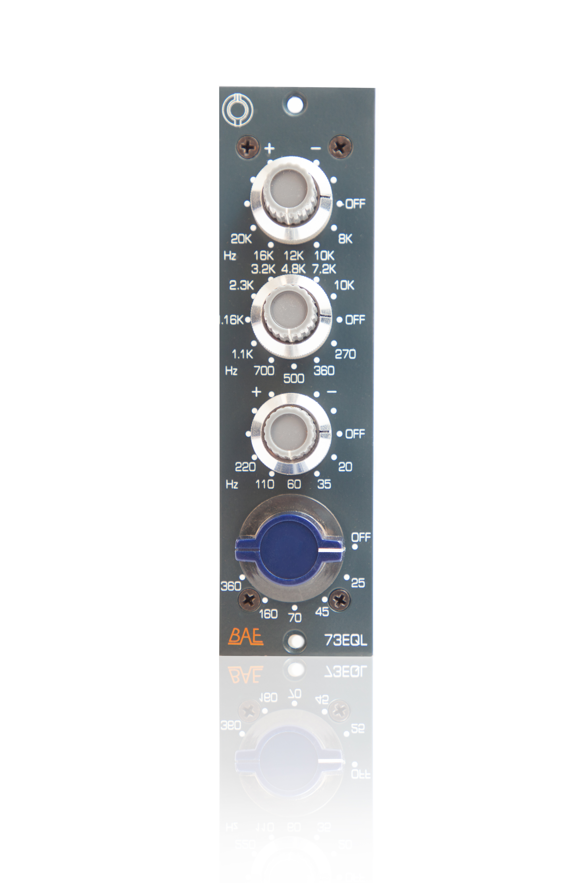
North Hollywood, CA, September 18, 2019 – With an unmatched track record of creating vintage equipment faithful to the original design specifications, BAE Audio announces the newest family member among its renowned 1073 series: the 73EQL 500 series equalizer. Featuring the same Carnhill/St Ives transformers, inductors and Elma switches as its 19” rack brethren, the new 73EQL delivers highly musical and authentic tone shaping capabilities using the same electronics and circuitry as its legendary 1073.
The 73EQL delivers impressive tonal shaping options into a diminutive size, making it the ultimate accompaniment to a BAE 1073MPL 500 series preamplifier or as a stand-alone EQ to complement just any other input source. With a 3-band EQ section and highpass filter controls, the 73EQL is able to shape nuances of sound sources while imparting the classic sound character of the 1073 — this makes it the ultimate companion for on-location, studio recording, mixing or mastering applications.
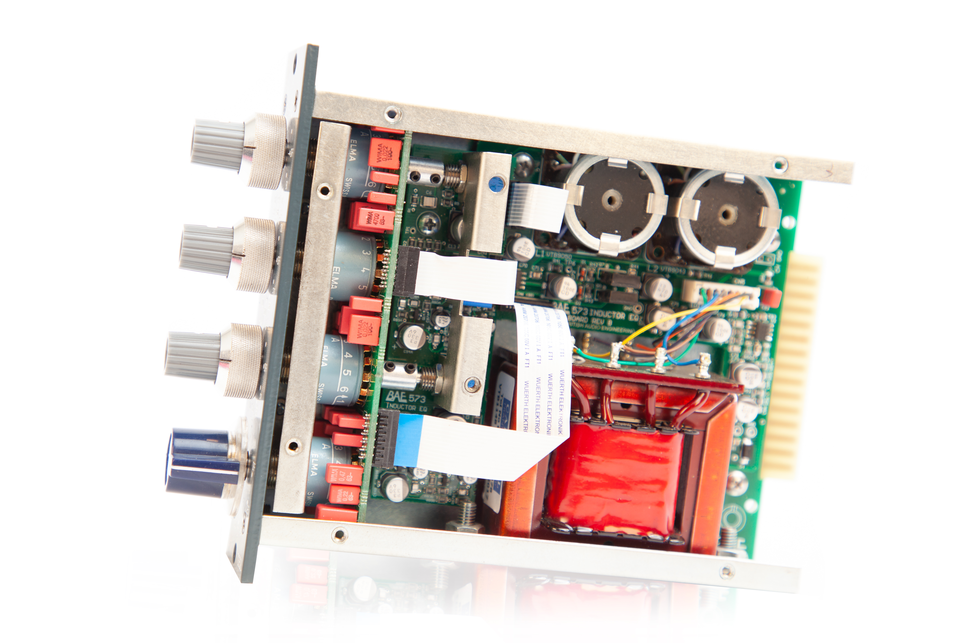
An instant classic with a shared legacy
“The 73EQL shares the same pedigree and workmanship of our classic 1073 lineup,” explained Mark Loughman, President of BAE Audio. “Achieving an authentic 1073 sound inside the 500 series format was a significant milestone for our company five years ago, and today we’ve managed to extend this capability into what we feel is the best sounding 500 series EQ on the market. With its extended control over all three frequency bands, the 73EQL delivers world class vintage BAE sound in a compact form factor.”
The highly anticipated 73EQL follows the success of the 1073MPL 500 series preamplifier, which was introduced four years ago and which was quickly adopted as a foundational element for many commercial and project studios around the globe. BAE Audio has been building the 1073 for two decades; consecutively longer than any other company in history. The company’s 500 series rendition of this classic circuitry is the result of many years of research and development, over which time the company strived to retain the authentic sound character of the 1073 in an impossibly small package — without compromising quality, materials or workmanship.
The 73EQL is available now at a price of $950 USD. For more information and detailed specifications, please visit http://www.baeaudio.com
Specifications:
- Extended high frequencies of 8 kHz, 10 kHz, 12 kHz, 16 kHz and 20kHz
- Extended mid-range of 270 Hz, 360 Hz, 500 Hz, 700 Hz, 1.1 kHz, 2.3 kHz, 3.2 kHz,
4.8 kHz, 7.2 kHz, 10 kHz
- Extended low frequency range of 20 Hz, 35 Hz, 60 Hz, 110 Hz and 220 Hz
- Extended highpass filter of 25 Hz, 45 Hz, 70 Hz, 160 Hz and 360 Hz.
About BAE Audio
BAE Audio is a U.S.-based manufacturer of high-end microphone preamp and equalizers, all of which are faithful to vintage designs of the seventies and before. The company is committed to the vintage philosophy of hand wiring and hand soldering all of its components to achieve a high quality and authentically vintage sound. For more information on BAE Audio, please visit our website at www.baeaudio.com.

Media contact
Jeff Touzeau
Public Relations
Hummingbird Media
+1 (914) 602 2913
jeff@hummingbirdmedia.com

