‘Tree of Knowledge’ Podcast Selects RME Babyface Pro Audio Interface for its Ease of Use, Versatility
With no audio background, podcast host Roy Rotstein found the USB interface ‘plug and play’ ready

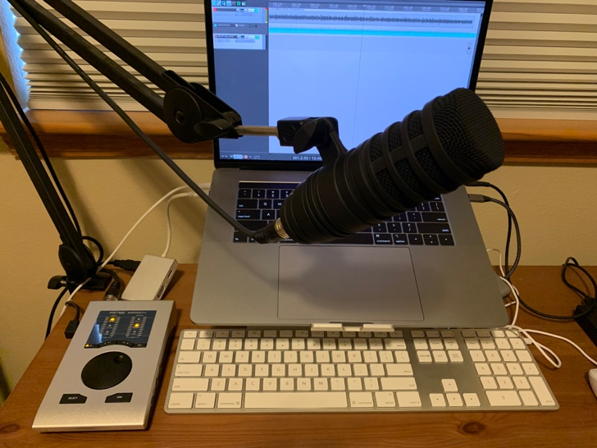
San Jose, August 25, 2020 – When Roy Rotstein started his science-themed podcast, Tree of Knowledge, which debuted in March, he had no audio engineering experience, but knew he needed an interface that could handle multiple channels to take his home studio to the next level. After seeing RME’s Babyface Pro 24-channel USB audio interface at last year’s PodFest Expo, he was sold.
“One of the things I liked best about the Babyface Pro is that you don’t need any audio background in order to operate it — you just plug it in and go,” Rotstein said. “I can use it for recoding solo episodes where I’m reading off a script, and I can use it when I conduct on-site interviews.”
Portability & Versatility
Available on Spotify and Apple Podcasts, Tree of Knowledge covers a wide range of topics, from vaccine development to neuroimaging, with new episodes released on a regular basis. According to Rotstein, he decided to start the podcast, and its correlating YouTube channel, to make scientific-related content “that’s available to the masses.” The podcast dives deeper into the topics covered on his Tree of Knowledge YouTube channel.
When conducting in-person interviews, Rotstein is able to fit his Babyface Pro, two mics with stands and his laptop all in one bag — making his audio setup versatile and portable.
“The portability of the Babyface Pro has been an enormous boon for me,” Rotstein said. “The fact that I have this little device which is just a little larger than my cell phone and is able to handle all the audio requirements that I need is huge.”

While doing Skype interviews, the Babyface allows Rotstein to record two channels independently. He said having the ability to have complete control over his podcast’s audio quality is key.
“I didn’t want the interviewees to have to record themselves,” he explained. “The Babyface Pro allows me to record two channels simultaneously and not have to rely on the second party. This was pretty important to me to be able to have that capability.”
Overall, Rotstein said the biggest benefit of the Babyface Pro was that even with his lack of engineering background, he was up and running on the interface in minutes.
“The Babyface Pro is so easy,” he said. “You literally just turn the dial, see what works and go.”

For more on RME, visit rme-usa.com

About Synthax, Incorporated
Synthax Inc. is the exclusive USA distributor for RME digital audio solutions, Digigram broadcast audio systems, Appsys digital audio tools, Ferrofish advanced audio applications, myMix personal monitoring systems and ALVA cableware. We supply a nationwide network of dealers with these products for professional audio, broadcast, music industry, commercial audio, theater, military and government applications. For additional information, visit the company online at http://www.synthax.com.

Media Contacts:
Katie Kailus
Public Relations
Hummingbird Media
+1 (630) 319-5226
katie@hummingbirdmedia.com

Jeff Touzeau
Public Relations
Hummingbird Media
+1 (914) 602 2913
jeff@hummingbirdmedia.com

