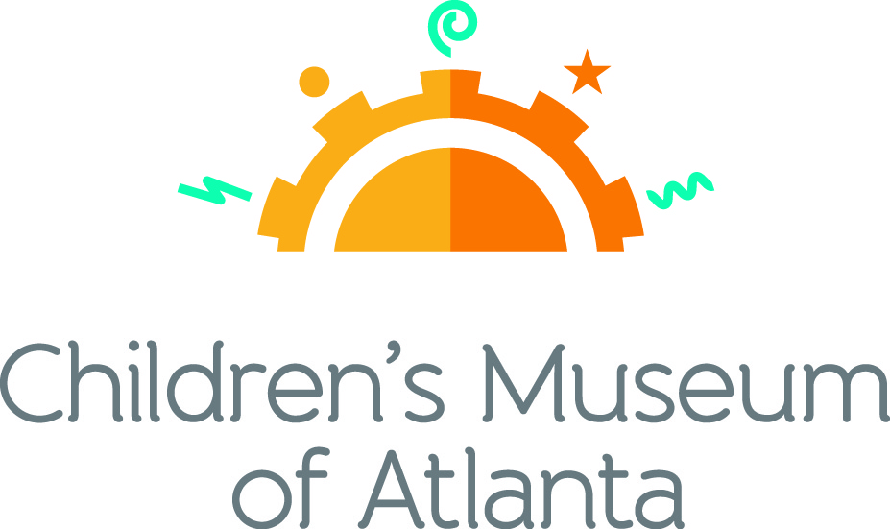

FOR MORE INFORMATION:
Becca Meyer/Jennifer Walker
BRAVE Public Relations, 404.233.3993
bmeyer@bravepublicrelations.com/
jwalker@bravepublicrelations.com

FOR IMMEDIATE RELEASE

Children’s Museum of Atlanta’s announces super-duper September programming
Families can enjoy inaugural TinyCON, explore newest traveling exhibit and more!

ATLANTA (August 14, 2017) – Although school may be starting, fun is always in session at Children’s Museum of Atlanta! Families are invited to participate in the Museum’s very own TinyCON--complete with Jedi training and Mario Kart racing experience a day in the life of Sid the Science with the newest feature exhibit, travel the world in 20 minutes, hear traditional music associated with Eid al Adha and more!

Feature Exhibit: Sid the Science Kid: The Super-Duper Exhibit!
September 16 – January 15, 2018
This thrilling new traveling exhibit brings the award-winning PBS KIDS TV series Sid the Science Kid to life. Kids will be able to step into Sid’s world and become “science kids” themselves as they discover and investigate everyday science questions around Sid’s home, at school in the Super Fab Lab and on the playground. Through fun, hands-on activities, kids will use scientific tools to learn about simple machines, the laws of motion, magnetism, air power and the five senses. It’s sure to be a super-duper-ooper-schmooper good time!

Themed daily programming during Sid the Science Kid: The Super-Duper Exhibit! will occur September 16 – January 15, 2018. Programming subject to change and may be altered during special events. All programs included with admission unless otherwise noted.

Mini-Musical: Hilarity Academy written by John Jenkins
Weekdays at 11 a.m. and noon; Weekends at noon and 2 p.m.
Congratulations and welcome to Hilarity Academy – a place where science and comedy collide! Children will join Professor Punchline as he teaches Jo King how to incorporate laughter in the world around him.

Story Time
Weekdays at 3 p.m.; Weekends at 1 p.m.
“Sid the Science Kid: The Trouble with Germs” by Jennifer Frantz
Sid’s dad has come down with a cold complete with sneezing and a runny nose! Little ones can gather around as the Imaginators share why it’s important for Sid to wash his hands and take other precautions to avoid the germs.

Music & Movement
Weekdays at 2 p.m.; Saturday at 11 a.m. and 3 p.m.; Sunday at 11 a.m.
Kids can join the Imaginators for some bone-ified fun, featuring a skeleton scavenger hunt and, of course, the Hokey Pokey!

Super Spectacular Science Show
Weekdays at 1 p.m. and Weekends at 4 p.m.
Professor Lab Coat and her assistants will lead a mesmerizing science demonstration for the entire Museum.
Eat A Georgia Rainbow
Sunday at 3 p.m.
Children will embark on a scavenger hunt and cold cooking activity with the Imaginators to learn more about fruits and veggies harvested in Georgia throughout the year.
Art Studio Projects
Weekdays 10:30 a.m. –3:30 p.m.; Weekends 11 a.m. –4 p.m.
Little ones can discover colors and explore artists from around the world through various crafts like creating 3D teeth models, examining X-Ray pictures, drafting secret messages using invisible ink and making an extra bouncy ball.
Build It Lab
Weekdays, 10:30 a.m. –3:30 p.m.; Weekends 11 a.m. –4 p.m.
Children will put their woodworking and creative tools to the test in this supervised space where they have access to real tools and materials. Encouraging inventions, this Build It Lab sparks creativity by allowing young innovators to build items such as a mini construction wrecking ball using simple machines.
Science Bar
Weekdays 10:30 a.m. –3:30 p.m.; Weekends 11 a.m. –3:30 p.m.
Science is everywhere, especially on the mezzanine at the Museum! Step Up to Science is the new STEM exhibit area and features interactive exhibits about light, robotics and how the human body works! Families can saddle up to the science bar for a full menu of fun activities, knowledge and have their questions turned into answers by one of the STEM educators.

September Special Programming

TinyCON
Saturday, September 2
Calling all tiny princesses, wizards and Jedi Knights! Families are invited to Children’s Museum of Atlanta’s very own Tiny Convention for a fun-filled day of comic book adventures, including a Hogwarts potions class, Jedi training session, Mario Kart racing and more!
- Mario Kart Races
11 a.m. and 2 p.m.
3…2…1…GO! Little ones can join Mario and Luigi for a very special Mario Kart race at the Children’s Museum of Atlanta Stage.
- Pokémon Hokey Pokey
Noon
Children will meet the Mario Brothers to dance and sing along to the Pokémon Hokey Pokey while catching as many common and rare Pokémon as possible!
- Star Wars Jedi Training Academy
1 p.m. and 3 p.m.
Kids can visit the Build It Lab to make a personalized lightsaber to prepare for training. Led by the Imaginators, tiny Jedis will learn to use the force and battle enemy ships and villains.
- Art Studio
11 a.m. – 4:30 p.m.
Comic book artists wanted! Little ones will let imaginations run wild and create comic books featuring favorite superheroes!
- Build It Lab
11 a.m. – 4:30 p.m.
Children will prepare for galactic adventure and Jedi Training Academy by crafting a custom lightsaber.
- Science Bar
11 a.m. – 3:30 p.m.
Small wizards and even mini muggles can explore the science behind favorite potions of Harry Potter’s wizarding world including Polyjuice and Felix Felicis.
- Super Spectacular Science Show
4 p.m.
Professor Labcoat has an extra spectacular science show in store fit for the finest of wizards, superheroes and princesses.

Around the World with Words
September 5 – 15
Children can embark on an imagination adventure around the world to learn new vocabulary words.
- Special Story Time
Weekdays 3 p.m.; Saturday 1 p.m.
“This Is How We Do It: One Day in the Lives of Seven Kids Around the World” by Matt Lamothe takes eager listeners through a day in the life of kids in Japan, Iran, Italy, India, Peru, Uganda and Russia. Although some traditions may differ, children will find similarities among each culture through the world that unite them.
- Special Music and Movement: Dance Around the World
Weekdays 2 p.m.; Saturday 11 a.m. and 3 p.m.
Little ones can travel the seven continents through dance with the Imaginators! Featured dances include the fan dance from Asia, the hat dance from the Americas, the polka from Europe and a traditional African dance.
- Mini-Musical: Around the World in 20 Minutes written by Marc Farley
Weekdays 11 a.m. and noon; Saturday noon and 2 p.m.
Master explorer Phineas Figg has accepted a challenge from the International Explorers League and needs help from as many kids as possible to travel the world and visit renowned landmarks in 20 minutes!
- Super Spectacular Science Show
Weekdays 1 p.m.; Saturday 4 p.m.
Professor Lab Coat and her assistants will lead a mesmerizing science demonstration for the entire Museum.
- Art Studio
Weekdays 10:30 a.m. – 3 p.m.; Saturday 11 a.m. – 4 p.m.
Children can channel inner creativity and make various projects while learning about colors and exploring artists from around the world!
- Build It Lab
Weekdays 10:30 a.m. – 3 p.m.; Saturday 11 a.m. – 4 p.m.
Little ones can build an African thumb piano to travel across the globe through music.
- Science Bar
Weekdays 11 a.m. – 3 p.m.; Saturday 11 a.m. – 3:30 p.m.
Science is everywhere, especially on the mezzanine at the Museum! Step Up to Science is the new STEM exhibit area and features interactive exhibits about light, robotics and how the human body works! Families can saddle up to the science bar for a full menu of fun activities, knowledge and have their questions turned into answers by one of the STEM educators.

Celebrate Eid al Adha: A Cultural Exploration
Sunday, September 10
Eid al Adha is the Islamic festival that commemorates the willingness of Ibrahim (also known as Abraham) to follow Allah's command to sacrifice his son. Ismaili Muslim Community volunteers will be at the Museum to share stories through music and crafts throughout the day.
- Special Music and Movement:
11 a.m.
Special visitors dressed in traditional clothing will teach kids dances to pieces from Tajikistan, India, Egypt and Morocco.
- Eid Mela-Henna Art
Noon and 2 p.m.
In honor of the holiday, visitors can receive all-natural henna designs on their skin or can create original henna works on paper.
- Ismaili Choir
1 p.m.
Volunteers from the Ismaili community will perform traditional Eid al Adha songs.
- Art Studio
11 a.m. – 4 p.m.
Children can craft Eid al Adha cards with various sun moon decorations to celebrate the holiday.
- Build-It Lab
11 a.m. – 4 p.m.
Little ones can use real tools and materials under supervision to build an African thumb piano and create music for an Eid al Adha celebration.

For more information on the April program offerings or to support Children's Museum of Atlanta, visit childrensmuseumatlanta.org or call 404.659.KIDS [5437].

About Children’s Museum of Atlanta:
Children’s Museum of Atlanta is the only educational venue of its kind in Atlanta, presenting educational programs and exhibits designed for young children ages 0-8. The Museum’s mission is to spark imagination and inspire discovery and learning for all children through the power of play. With six permanent learning zones consisting of bright, creative and hands-on exhibits, the Museum supports inventive play-based exploration and experiential learning focused on the whole child. Core competencies for literacy, math and science are promoted throughout all exhibits and programming in alignment with the state and national Core Performance Standards. The Children’s Museum of Atlanta also offers parties, memberships, field trips, summer camp and private events. For more information or to support Children's Museum of Atlanta, visit childrensmuseumatlanta.org or call 404.659.KIDS [5437].

Major support is provided by the Mayor’s Office of Cultural Affairs. Major funding for this organization is provided by the Fulton County Board of Commissioners.

Museum Admission: General Admission is $15.95 (plus tax) for anyone 1 – 100 years old. Babies and members are admitted for free. All daily programs are included in price of admission. Group rates and military discounts are available. For more information regarding ticket and membership options, visit childrensmuseumatlanta.org/plan-your-visit/faqs/.

Museum Hours: Monday, Tuesday, Thursday and Friday 10:00 a.m. – 4:00 p.m.; Saturday and Sunday 10:00 a.m. – 5:00 p.m.; Closed on Wednesdays. Please check the Museum website to confirm hours of operation.

Facebook: https://www.facebook.com/childrensmuseumatlanta
Twitter: https://twitter.com/ChildMuseumATL
Instagram: https://www.instagram.com/childrensmuseumatlanta
Pinterest: http://pinterest.com/cmatlanta
###

