In THE CAThedral OF SOUND: “The Pink Floyd Exhibition: Their Mortal Remains”

- After London and Rome, the interactive exhibition at the Dortmunder “U” Centre for Arts and Creativity looks back on the 50-year history of the British cult band
- The innovative Sennheiser audio guide and 360-degree audio installations provide a thrilling experience in sound and vision

Dortmund/Wedemark, 23 August 2018 – Higher and higher it climbs. The escalator in the Dortmunder “U" goes right up to the sixth floor. Having arrived at the top, visitors can also marvel at reaching a summit in audio-visual experience. From 15 September 2018, they can see – and of course hear – “The Pink Floyd Exhibition: Their Mortal Remains”. This interactive multimedia exhibition runs until 10 February 2019. After Rome and London, where the retrospective was very well received, Dortmund is the first and only venue in Germany. It presents a review of the British cult band’s creative work: fifty years of music history over an area of 1,000 square metres, illustrated chronologically on the basis of more than 350 exhibits, perfectly matched with innovative audio technology that allows the visitors to immerse themselves in the unmistakable sound of Pink Floyd. And Sennheiser is the audio partner responsible. Fascinating worlds of sound have been created, bringing the band’s career, its albums, its sound engineering and its performances to life in a stunning audio-visual display.

The Dortmunder U – Centre for Arts and Creativity is presenting the major Pink Floyd retrospective “The Pink Floyd Exhibition: Their Mortal Remains“ from 15 September 2018 to 10 February 2019.  (Photo: Dortmunder U, © Roland Baege) | 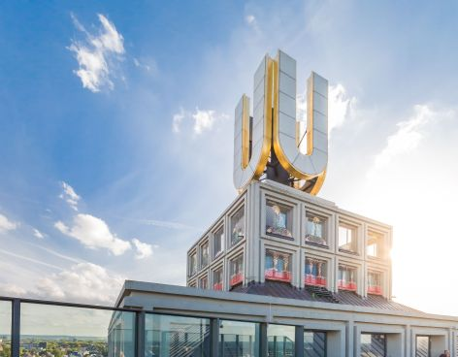

Immersive Performance Zone
One highlight that truly reflects the pioneering spirit of the British band with every sound is the immersive Performance Zone. The visitors find themselves right in the middle of the music and totally surrounded by the sound, enabling them to enjoy an exceptional 3D audio experience – while watching a huge, 24-square-metre video wall at the front showing David Gilmour, Nick Mason and Richard Wright together with former band member Roger Waters performing at the global Live 8 concert in 2005. Specially for this exhibition, part of that performance was produced using AMBEO 3D audio technology. A unique 17-channel remix of “Comfortably Numb” is reproduced through 18 Neumann KH 420 midfield monitor loudspeakers and seven KH 870 subwoofers. This immersive mix was created at London’s famous Abbey Road Studios as a cooperation between the producers Simon Rhodes and Simon Franglen and Pink Floyd’s sound engineer and partner Andy Jackson. Rhodes, one of the leading sound engineers at Abbey Road Studios, worked on productions for global blockbuster films such as “Avatar” and “Spectre”. The producer and composer Franglen is a Grammy winner and has also worked on some of the all-time greatest films, including “Avatar” und “Titanic”.

The highlight of the exhibition is the Performance Zone, which immerses the visitors in Pink Floyd’s final performance with its former band member Roger Waters. The audience at the Dortmunder U can experience a 24-square-metre video wall and a 17-channel AMBEO remix.

(Image courtesy of “The Pink Floyd Exhibition: Their Mortal Remains”)

Each instrument can breathe
A remix in 3D audio is fundamentally different from working in stereo or 5.1. The sound engineer needs to completely rethink, because the sound is everywhere in the room – above, to the side and even behind the visitors. This provides the opportunity to “open out” the mix, allowing the entire wealth of sound of the great original recordings to be experienced. The audience can walk around inside the music.

Simon Rhodes: “The special thing about the AMBEO remixes for Pink Floyd is that basically it has always been part of their DNA. The band pushed the boundaries of sound and are always looking forward to the next speaker configuration. And AMBEO is just so flexible, and is really the future in terms of its immersiveness in the sound and freeing you from traditional formats.”

Simon Franglen adds: “Anyone who has known and loved this music for many years will hear it as if for the first time. You simply pick up so many more details because each instrument is now able to ‘breathe’ – that is the great advantage of an immersive mix. What is more, the loudspeakers that we use can not only play the sound incredibly loud, but can also reproduce it with unbelievable precision. And you don’t normally get that when you listen to a live concert on a PA system. What we’ve got here is a studio mix, but live – and that is very rare.” And Rhodes enthuses: “You suddenly start paying attention to all kinds of exciting things, as if you are sitting in a huge cathedral and admiring all the details around you. It is like a cathedral of sound. Live music is particularly well suited for AMBEO, because the whole atmosphere is also recorded. The band usually directed twelve microphones into the audience, and if you can also use all of these microphones in the mix, you get the incredible feeling of really being there.”

900 audio guides and 40 videos
In addition to the Performance Zone, the audio guide is another key element of the interactive exhibition in Dortmund. Complete responsibility for installing the loudspeakers and programming the audio guide on behalf of Sennheiser was taken on by Robert Généreux, Business Director System Design. His job was to provide the visitors with a perfect audio experience. “We want to offer the visitors an audio experience that they have never had before,” says Généreux. “That applies not only to the Performance Zone, in which the spectacular AMBEO remix is played, but also for the sound in the entire exhibition.”

Sennheiser’s audio guide system is unique because it has the capability to play hundreds of individualised, automatically triggered stereo recordings simultaneously. A total of 900 receivers with HD 2.20 headphones accompany the visitors through the exhibition rooms. The audio information for the exhibits is played at each location at exactly the right time. When the visitors watch one of the 40 videos with Pink Floyd performances or interviews, they automatically hear the correct soundtrack through the headphones. The audio equipment required for this is cleverly concealed. Inconspicuous trigger units automatically play the individually correct soundtrack or the right music, while transmitters installed in the control room transmit both real-time audio and streamed audio via compact antenna units.

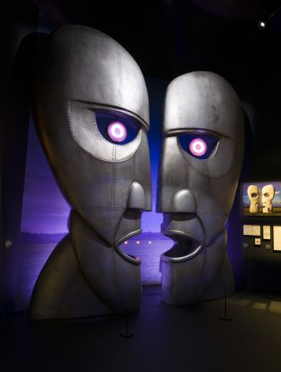  An audio guide from Sennheiser automatically plays information on the unique exhibits: metal heads from The Division Bell: 1994, Design by Storm Thorgerson and Keith Breeden, Pink Floyd Collection.  Photo Rupert Truman © Pink Floyd (1987) Ltd  (Image courtesy of “The Pink Floyd Exhibition: Their Mortal Remains”) | 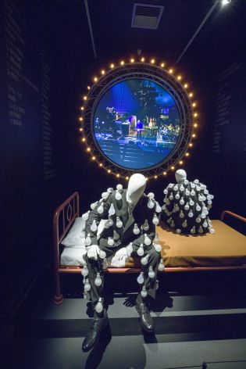  Lightbulb suits from the album artwork of Delicate Sound of Thunder: (replicas 2014), 1989 Design by Storm Thorgerson, Pink Floyd Collection.  Photo Rupert Truman © Pink Floyd (1987) Ltd  (Image courtesy of “The Pink Floyd Exhibition: Their Mortal Remains”)

“The result is a completely automatic but nevertheless absolutely individual tour that enables visitors to explore the exhibition in any sequence and at their own individual pace. The audio material is always played at the right place automatically and is gently faded in when the visitor enters an area of the exhibition and faded out again when they leave,” says Génereux. “But the system can also be used for conventional tours with a guide, for example for VIP tours. In this case, the audio material can be manually triggered and combined with the guide’s own commentary.”

Link to the interview with Simon Rhodes and Simon Franglen: https://www.youtube.com/watch?v=yMlFN8V4qW4

Exhibition partners
As the audio partner for the exhibition, Sennheiser provides unique sound experiences. The legendary music of Pink Floyd and interviews with the band members are automatically played to the visitors via an audio guide. The highlight is a 360° audio/video installation for which the song “Comfortably Numb” was remixed in innovative AMBEO 3D audio technology – a unique 17 channel remix played through 25 loudspeakers.

DSW21, Dortmund’s public utilities company, is the local presenting partner. Social commitment has a very high priority at DSW21, and promoting culture is a key aspect. DSW21 is supporting the Pink Floyd exhibition with a lot of energy, know-how and passion – fully in keeping with the motto of DSW21: “Mobility & Logistics – Energy & Water – Living Spaces – Data Networks. We make it easy!“

Press contact Dortmunder U Press contact Sennheiser

Hering Schuppener Stephanie Schmidt
Unternehmensberatung für Kommunikation GmbH PR Manager Professional Audio
theirmortalremains@heringschuppener.com stephanie.schmidt@sennheiser.com
+49 (211) 430 79-253 +49 (5130) 600 – 1275

