

Biuro prasowe better. gaming agency
bettergamingagency.prowly.com

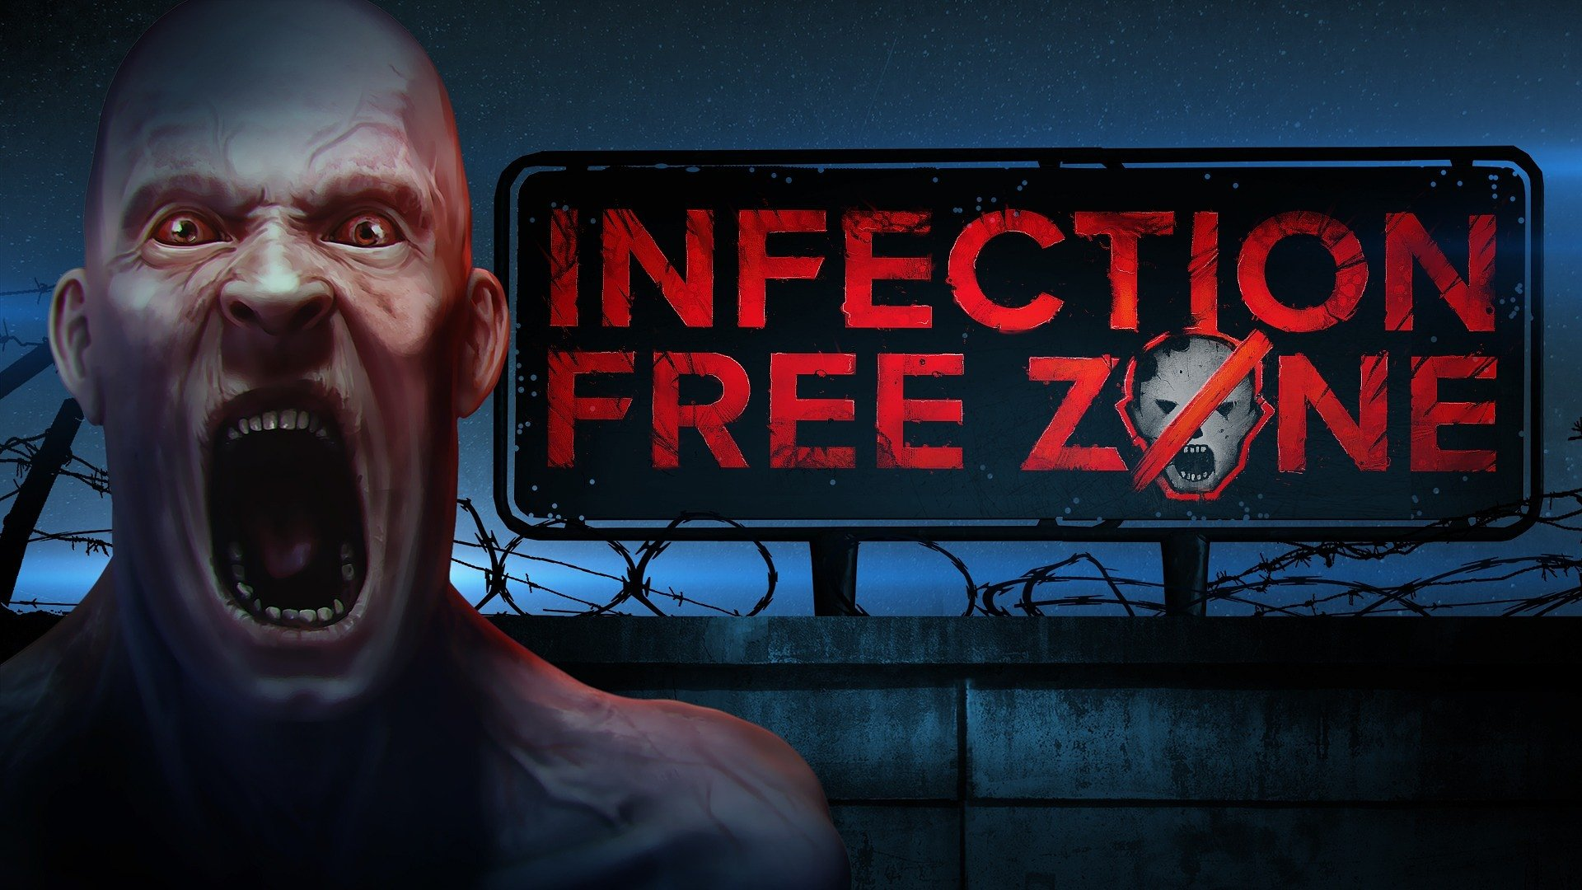

Package full of good news from Games Operators – Infection Free Zone demo, the launch of Delivery INC, two new games announcements – Hustlerix and Dust Raiders, and sales up to 90%.

The publishing team at Games Operators clearly has their hands full. The crew wishes to share some updates regarding the projects they are currently working on, and to the delight of gamers, there are quite a few of them.

Infection Free Zone – what’s new?

Infection Free Zone received a new demo, allowing players to learn more about mechanics that will be featured in the full version of the game. Among the added features are numerous innovations, including a research panel for technologies, significant changes in the building system, and new enemies - bandits. Within the demo version, players will be able to experience the first 8 days of adventure, giving them a taste of the unique atmosphere of Infection Free Zone.In the near future, Infection Free Zone will also receive a free prologue, which will unveil further aspects of the gameplay. The game card is already live on Steam, so we encourage you to visit the page for more info andadd it to your wishlist.

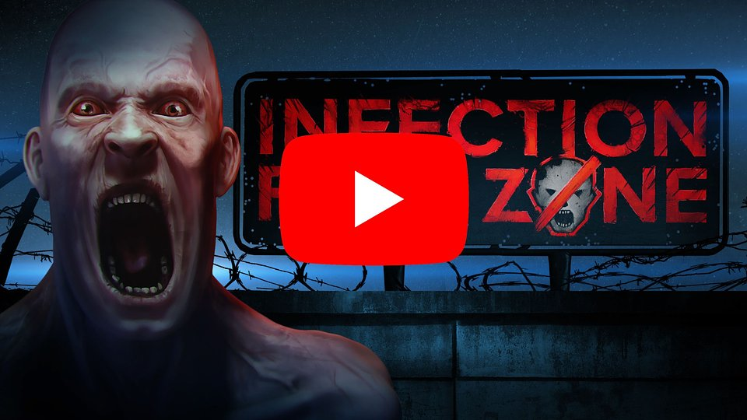
https://www.youtube.com/watch?v=woPktXgllaE

Delivery INC launches today!

Today also marks the launch of Delivery INC, a game where you will be tasked with running your own transportation company. Managing a fleet of vehicles and drivers in any city around the world, you will compete against time and deal with absurd customer demands. Searching for the shortest routes, combining orders, and solving mounting problems – all in real-time, where you must act wisely and fast.A flat tire, a passenger wanting to eat the delivery, a bomb in the trunk, or a police chase - your career will be full of unpredictable situations. No matter what happens, do not let anything stop you from completing the job. Choose any city in the world and build your empire.


https://www.youtube.com/watch?v=XwAJlctU1j0

Hustlerix – a new game announcement

In Hustlerix players will embark on an odyssey to the ancient world where, as a free Gaullish slave, you have only one goal - revenge on the senators.Fight with gladiators on the blood-stained sands of the Colosseum, compete in crazy chariot races, and throw massive menhirs at those who dare to oppose you. Confront historical villains, outsmart sly thieves or battle against legionnaires and mythical beasts known from ancient legends and myths. Then, when you find a moment to rest, engage in discussions with philosophers about the most burning issues of humanity. All of this is immersed in dynamic and action-packed gameplay.


https://www.youtube.com/watch?v=GbtT7qeVxrs

Dust Raiders – a new game announcement

Dust Raiders will throw players to the wastelands of a post-apocalyptic world, where they will take control of a group of survivors who managed to withstand the attack of a deadly faction known as Sawblade. As a result, they were left with nothing and now scavenge for scraps to construct a vehicle that will guarantee survival. Recruiting the best crew members, ready to sacrifice their lives for their comrades, will be just as important.Dust Raiders is a turn-based strategy game, where the core of gameplay will revolve around tactical battles involving heavily armed vehicles. Another significant aspect will be the modification of these vehicles using parts that can be found in the wastelands. However, the crew's actions will also attract ruthless invaders, requiring players to fend off successive brutal attacks.


https://www.youtube.com/watch?v=2ANfU67SdWM

Games Operators – Steam publisher sale

Games Operators has prepared a sale during which you can purchase their games with discounts reaching 90%. The event starts today, July 27th, and will last until August 3rd. The sale includes the publisher's entire portfolio, featuring highly acclaimed titles such as 911 Operator, 112 Operator, Rustler, Radio Commander, Aquarium Designer, Transport INC, and many more.


https://store.steampowered.com/sale/gamesoperatorspublishersale

Press kits:∘ Infection Free Zone∘ Delivery INC∘ Hustlerix∘ Dust Raiders

About Games Operators:Games Operators is a publishing company that invests in, releases, and promotes video games. The company helps develop innovative and unique video games like 911 Operator, Radio Commander, 112 Operator, BE-A Walker, and Transport INC. by getting involved in projects at various levels of progress – from the conceptual phase to nearly-finished products. For more information visit: www.gameops.pl.



Jakub Smolak
PR Specialist at better. gaming agency
jakub.smolak@bettergaming.pro
Twitter

