Strictly embargoed until 1 May 2020, 10 a.m. CEST

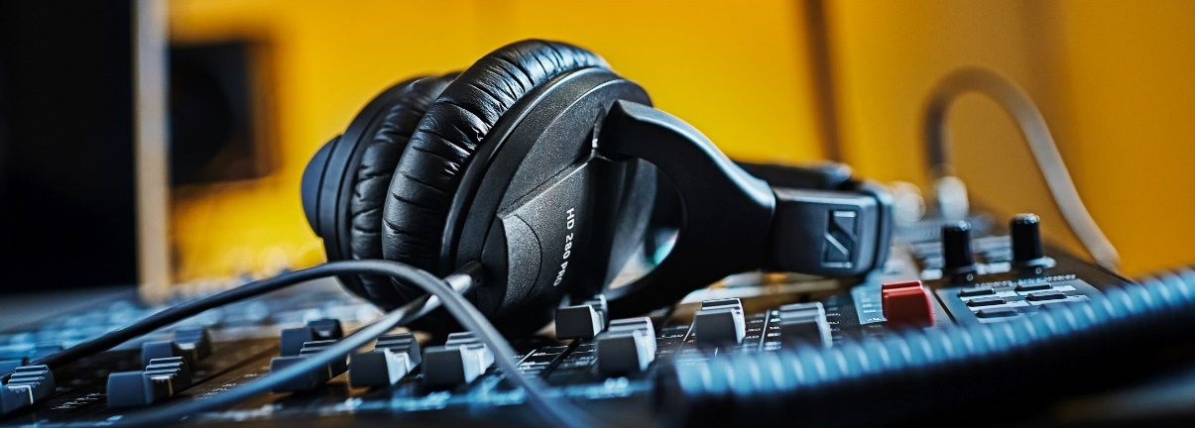Anniversary offer

The HD 280 PRO headphones for critical monitoring applications

Wedemark, 1 May 2020 – Looking for a pair of monitoring headphones that combine robust, modular design with accurate, detailed sound reproduction and good isolation? Then you’ll love Sennheiser’s anniversary deal for May: The audio specialist is offering the HD 280 PRO headphones for EUR79 (MRSP) instead of EUR99. Please visit www.sennheiser.com/special-deals for a list of dealers offering this special anniversary promotion.

The HD 280 PRO is Sennheiser’s special deal for the month of May | 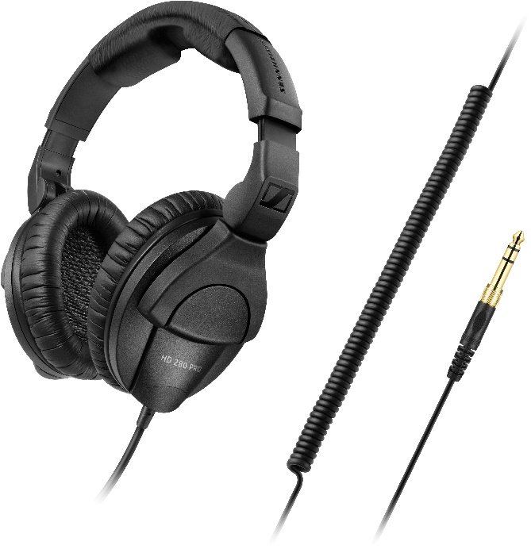

Firm favourites with musicians, DJs and engineers alike, the closed, around-the-ear HD 280 PRO headphones have been engineered for professional recording, mixing and monitoring applications. They offer high attenuation of ambient noise and a linear audio reproduction, enabling you to accurately monitor sound even in critical environments.

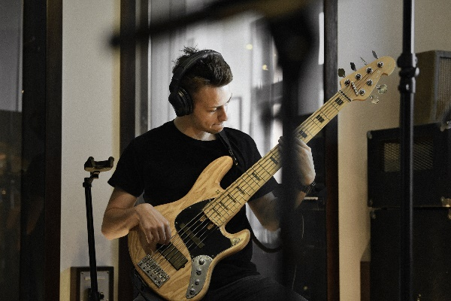 | 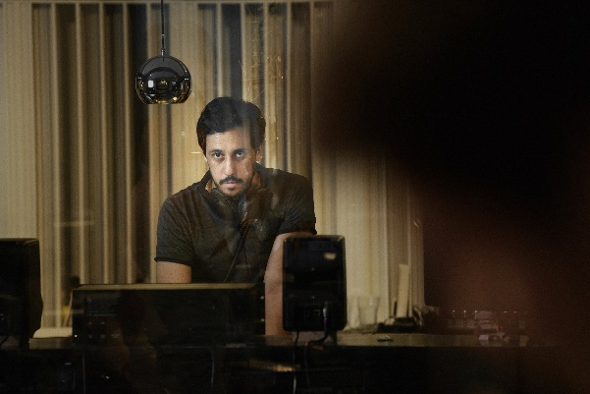

The HD 280 PRO feature soft earpads for a comfortable fit even during long mixing and monitoring sessions. The earcups fold and rotate for space-saving transport, the coiled cable is single-sided and tough.

Watch award-winning filmmaker Geert Verdickt as he and DJ Vinyl King put the HD 280 PRO through a series of tests: https://vimeo.com/411359789.

Special offers throughout Sennheiser’s 75th anniversary year
During its anniversary year, Sennheiser is offering incredible savings on selected wired microphones, wireless systems and headphones. Make sure to take a regular look at the campaign website www.sennheiser.com/special-deals to discover new promotions every month.

The images accompanying this press release plus additional photos can be downloaded at https://sennheiser-brandzone.com/c/181/ooiaxKem.

About Sennheiser
Founded in 1945, Sennheiser is celebrating its 75th anniversary this year. Shaping the future of audio and creating unique sound experiences for customers – this aim unites Sennheiser employees and partners worldwide. The independent family company, which is managed in the third generation by Dr. Andreas Sennheiser and Daniel Sennheiser, is today one of the world’s leading manufacturers of headphones, loudspeakers, microphones and wireless transmission systems. In 2018, the Sennheiser Group generated turnover totaling €710.7 million. www.sennheiser.com

Global Press Contact

Stephanie Schmidt
Stephanie.schmidt@sennheiser.com
+49 (5130) 600 – 1275

