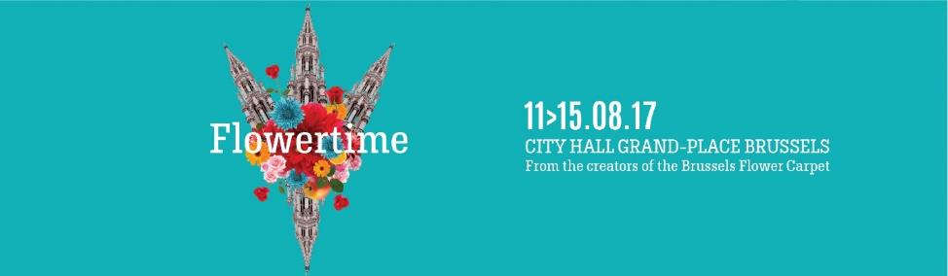

PRESS FILE FLOWERTIME 2017

"Brussels and its gardens share a long and beautiful love story. A story that is perfectly illustrated by the large number of parks and spaces that are ideally integrated in our urban geography, opening up oases of calm and relaxation to the locals. In parallel with the renowned biennial Flower Carpet, which needs no further introduction, let me present to you Flowertime 2017.
Encouraged by the success of the previous editions of this new floral art event in Brussels, we decided to organize a third biennial event, one that takes place during the summer in the heart of our capital!
This year, the flowery and summery collection will prove a genuine work of art. Between the 11th and the 15th of August 2017, the city centre will be submerged in an absolute botanical bounty: from the moment you arrive at the Grand-Place, you will be struck by the overwhelming sensuality of our 2017 theme, a festive fusion of flowers and fruits! The children of the City will take part in laying out small carpets of vegetables and fruits, creating an original and playful garden. Next, immerse yourself in the universe of the City Hall. Illuminated all along your walk, the itinerary will allow you to admire talent at work, the beauty of the arrangements and their integration in this millennial building. Get drunk on the scents, let your senses react to the floral proposals that punctuate this exceptional course.
Flowertime has chosen to "say with flowers" what she has been writing in capitals and flowers for 3 editions now: her permanence at the heart of our metropolis.
I wish you a wonderful summer!”

Philippe Close
Mayor of the City of Brussels

contents
Press release 2
Flowertime 2017: summery flower magic in the heart of Brussels 2
Flowertime: the concept 4
Flowernights 4
The floral artists of Flowertime 2017 5
Brussels City Hall: some information 9
Brussels Grand Place 13
Practical informations 14
Press Contact 15
Acknowledgements 16

Press release

Flowertime 2017: summery flower magic in the heart of Brussels

Brussels, 11 August 2017 - Over 100,000 flowers, 19 first-class Belgian florists, 13 historic rooms, three flower and vegetable carpets on the Grand Place and some hidden pieces of juicy fruit. These are the main ingredients of the third edition of Flowertime. This year the biennial Brussels celebration of floral art will adorn the Grand Place and Brussels City Hall from 11 to 15 August. The Flowernights are a new addition. During this evening event visitors can enjoy exquisite culinary delights by a Belgian Masterchef entirely in the spirit of the event.

Flowers and fruit in the heart of Brussels

Exceptionally the rooms of Brussels City Hall will be open to the public from 11 to 15 August 2017, and will not only be filled with the scent of flowers but also succulent fruit and even vegetables. This is because the theme of this edition of Flowertime, a colourful cocktail that instantly creates a summer atmosphere, is 'flowers and fruit'.

"This year, the theme is a wink to the urban gardening and farming trend that is increasingly emerging in major cities. Not all residents of a large city like Brussels have a garden, but do show an interest in gardening. Urban farms and gardens are expanding to become places for new encounters. Flowertime combines all these elements in a single event," explains Annette Katz of the NPO Flower Carpet of Brussels. "And naturally it is also a highly rewarding theme for our florists. They can have a ball with the surprising textures, scents and colours of the fruit." As in previous editions of Flowertime Ghent Floralies will be responsible for the artistic layout.

The 19 floral artists participating this year include a lot of young, up-and-coming Belgian talent who will surprise visitors with unusual floral creations and decorations. In addition, several big names such as Mark Colle, Tom Nackaerts, Ness Klorofyl and Chantal Post, will be present once more.

Flower and vegetable carpets on the Grand Place

As always, the Flowertime experience starts on the Grand Place. This year's eye-catcher comprises the three small flower and vegetable carpets that organisers will create with 60 children of all ages during the opening of the event on Friday 11 August 2017.

The carpets can be admired up to and including Tuesday 15 August 2017. Anyone eager to do so with a tasty snack or drink in hand, can visit one of the surrounding Flowertime market stalls.

New: Flowernights

This year visitors will also have the opportunity to explore Flowertime in an unusual manner on the evenings of 12, 13, 14 and 15 August. During the ‘Flowernights’ they can indulge all their senses in the fairytale spectacle in the City Hall. The dozens of floral artworks can naturally be admired in all their scented and colourful glory. However, the taste buds will not believe their luck either with the floral tasting menu, designed especially for the occasion by Belgian Masterchef and kitchen gardener, Claude Pohlig. And lastly, the ears will be treated to several classical concerts. These will be performed by promising young musicians from the Royal Conservatory of Brussels, selected by the renowned musicians Hugues Navez and Grégoire Dune. In short, a total experience not to be missed!

Flowertime: a unique collaboration
Flowertime will be backed by three renowned organisations:
- The Ghent Floralies (www.floralien.be), made in Belgium organisation which has been master of floral and botanical art for centuries (it was set up in 1808!);
- the non-profit organisation Flower Carpet of Brussels (www.flowercarpet.be), expert in begonia arrangements for over 25 years;
- the City of Brussels (www.brussels.be), specialist in organising events on the Grand-Place and in its different historical buildings.

Flowertime: the concept
For the third time in a row, Brussels City Hall and the Grand Place form the stunning backdrop for Flowertime, a prestigious floral art event organised from 11 to 15 August 2017. For five whole days the centre of Brussels becomes the ultimate meeting place for contemporary floral art, plant masterpieces and Belgian craftsmanship.

Flowertime is organised every two years, alternating with the Flower Carpet on the Grand Place. This means flower lovers have something to look forward to every year. This year it is Flowertime's turn once again and around twenty floral artists from Brussels, Flanders and Wallonia will let their creativity run free in the City Hall, around the theme of 'flowers and fruit'.

The theme also relates to the urban gardening and farming movement that is becoming increasingly popular in large cities. Gardening and kitchen gardening are gaining popularity in Belgium and Brussels, in the form of urban allotments, baskets of organic produce, an increasing appreciation for seasonal fruit and vegetables and many other initiatives. Urban gardening and farming promotes the transition to a sustainable food system and brings people together. The three flower and vegetable carpets on the Grand Place are also a playful wink to this new trend.

Flowernights
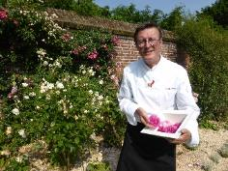
The Flowernights are new to this edition. Every evening from 12 to 15 August, visitors have the opportunity to explore the temporary floral exhibition in the City Hall in a unique manner. With culinary tastings in the spirit of the event, a more relaxed visit to the exhibition and a series of live, classical concerts, Flowernights offer a total experience that will have all your senses tingling. The culinary component will be organised by Claude Pohlig, Belgian Masterchef, kitchen gardener and specialist in cooking with flowers. On the occasion of Flowertime he will serve you an exclusive tasting menu based on the theme of 'flowers and fruit'.

About Claude Pohlig
A gastronomical and culinary luminary for over 30 years, Claude Pohlig entices people on a culinary discovery, both in terms of quality and biodiversity, creativity and challenges. His cuisine promotes organic, healthy and sustainable food, always relying on a network of market gardeners who offer organic and natural seasonal produce that is grown without pesticides or chemical fertilizers.

Having studied hotel management in Brussels, Claude Pohlig has developed a strong reputation as a chef in touch with the terroirs. In 1983, he opened his first restaurant "Les 2 Singes" in Brussels. In 1996, he was awarded the Best Artisan of the Year award as well as a Michelin star and he became a member of the Association of Master Cooks.

The floral artists of Flowertime 2017

The selection of florists and development of the creative concept is managed by Ghent Floralies, Flowertime's permanent partner. The organisation behind Ghent Floralies, the Royal Society for Agriculture and Botany (KMLP), was founded 209 years ago. It owes its royal title to King William I of the Netherlands, who agreed to be its patron in 1815. The very first flowers and plants exhibition was organised in 1808, in a Ghent inn and has since experienced the most spectacular growth and evolution. In 2016, the Floralies will leave the exhibition halls at Flanders Expo and return to the city.

Anne Guns (Brussels)
Anne Guns is a distance-learning teacher in Flanders and the Netherlands and shares her passion for flowers with her students. She derives inspiration for her floral creations from music, art and nature.

Her creations during Flowertime can be viewed in the Stairwell.

Arnauld Delheille (Namur)
Young and ambitious perfectly sums up Arnauld Delheille. This 27-year-old florist has already worked with organisations such as Upcoming Florists. He has also won numerous competitions. A young fellow from whom the floral community can expect a great deal.

His creations are on display in Le Grand Dégagement (Grand Lobby).

Audrey Leboutte (Dinant)
Audrey was already passionate about art as a child. She describes floral design as a temporary art that blends different art forms. Her creations are surprising and out-of-the-box.

During Flowertime her creation can be admired in Le Grand Dégagement (Grand Lobby).

Chantal Post (Vielsalm)
Chantal comes from the Vielsalm region, which is blessed with beautiful flora and fauna. To improve her language skills the nature lover set off for the Netherlands, where she followed a master's degree in floral art. Chantal opened her own florists in 2003. She effortlessly produces a creative, elegant and dynamic world of plants with a personal touch.

Her creations are on display in Le Grand Dégagement (Grand Lobby).

Dieter Vercoutere (Ghent)
After having worked in the social sector for several years, Dieter Vercoutere decided to pursue his childhood dream. He followed courses with several florists. Seven years ago, he made his passion his profession and opened his own shop 'Plant-aardig'.

His creations are on display in Le Grand Dégagement (Grand Lobby).

Geoffroy Mottart (Brussels)
In 2016, Geoffroy Mottart became the focus of attention with his extraordinary creations: he completely enveloped various statues in Brussels parks in flowers. His aim was to give the statues, which often go unnoticed, a new lease of life. This project illustrates how, being a poet and dreamer, he enjoys inviting the public to discover nature using a remarkable approach. During Flowertime find out how he brings a breath of fresh air to the City Hall.

His creations can be found in the Entrance Hall and the Interior Courtyard.

Joëlle Ghion (Gembloux)
Joëlle became acquainted with floral art at the age of 16, at the Institut Redouté Peiffer in Anderlecht. It has been her passion ever since. Following her course in horticulture in Gembloux this busy bee went on to open her own store. She continued her training and took part in several competitions. Since then she has decorated exclusive locations such as Antwerp City Hall, Beloeil Castle and the Landcommanderij of Alden Biesen. Soon she will be able to add Brussels City Hall to her list of achievements.

During Flowertime her creations will be on display in the second Stairwell.

Jolien Vanderstappen (Brussels)
Jolien Vanderstappen, from Brussels, is just 24 years of age, but has already proved herself during several tournaments. In 2016, she won the Junior Cup of Belgium. This year she is representing Belgium at Eurofleur 2017. You can hardly call it a coincidence, five generations of Jolien's family have been active in the flower sector.

During Flowertime her creation can be admired in the Council Chamber.

Mark Colle (Antwerp)
Mark Colle left school at the age of fifteen and ended up creating floral art. It was not love at first sight, but working with flowers tempered his rebellious nature. His work for Raf Simons at Dior placed him firmly on the international map as a florist. His works are often festive, but simultaneously exude a kind of sadness. This first-class floral artist combines his international assignments with his shop 'Baltimore Bloemen' in Antwerp.

During Flowertime his creations can be found in the Antechamber of the Mayor's office.

Natalia Sakalova (Gembloux)
In Belarus Natalia Sakalova followed an accountancy course, but once she arrived in Belgium she soon discovered her passion for flowers and plants. In 2007, she resolutely made a career switch. She followed a florist's course and launched her own business in 2009. She quickly achieved success thanks to her magnificent bridal bouquets. So, it's no surprise that she is back this summer in the City Hall's Wedding Room.

During Flowertime her creations will be on display in the Wedding Room.

Ness Klorofyl (Dilbeek)
Ness Klorofyl opened her flower business in March 2009, but she did not view this as the 'end of the line' for her career. She works on various projects with which she aims to astonish the public with her creations. Imagination and creativity are key to her designs, and with success, because this florist has already won many prizes.

During Flowertime her creations can be admired in the Galeria Grangé.

Samantha Authelet (Villette, France)
Samantha Authelet is a young, rising floral star, aged just 24, about whom we will undoubtedly hear a lot more in the future.

Her creation can be discovered in the last Stair hall.

Sébastien Dossin (Etterbeek)
Sébastien Dossin discovered floral art during his youth and it was love at first sight. He now experiments with different styles at numerous exhibitions and competitions.

During Flowertime his creation can be admired in the Antechamber and in the Aldermen's Room.

Sofie Reyns (Roeselare), in association with Rekad
Following several work experience opportunities at florists, Sofie Reyns opened her own flower business in Roeselare in 2013. During the previous edition of Ghent Floralies she participated in many competitions and displayed her talent in one of the city greenhouses.

During Flowertime her creations can be found in the Entrance Hall.

Homage to Stijn Simaeys
PTI Kortrijk and Fred Verhaege will bring an homage to the florist Stijn Simaeys, who passed away unexpectedly last year. He took part in Flowertime in 2013 and 2015, with his stunning creations that illustrated his passion and talent for floral art.

The homage can be admired in the Entrance Hall.

Stijn Cuvelier (Bertem)
Stijn Cuvelier loves everything about flowers; most of all he prefers to be creative with them and integrate them in a larger project. New techniques and creativity are two success factors that allow his work to constantly evolve.

His creations are on display in Le Grand Dégagement (Grand Lobby).

Stéphane Brassart (Komen)
As the son of a baker Stéphane grew up around the craft, but knew from a young age that his passion was for floral art. When he left school, he opened his own business in Komen. His work is inherently innovative, emotional and original, thanks to his use of different materials, lines and colours.

His work can be admired in the Maximilian Room.

Tom Nackaerts in association with Upcoming Florists (Leuven)
Tom Nackaerts and his partner Peter Van Dessel are the brains behind ‘Young Amadeus’. Initially, they planned to focus exclusively on decorations for major events and private parties, but today, can also be seen at various exhibitions and floral projects. In 2012, Young Amadeus was named best florist in Belgium and the business was also crowned with the golden award 'Laureaten van de arbeid' (Laureates of labour). For this edition of Flowertime Tom Nackaerts is supported by Upcoming Florists.

Their creations will decorate the Gothic Room.

Upcoming Florists
Since 2012, Upcoming Florists have been giving young florists the opportunity to develop their talent during floral events. This offers them the chance to discover new techniques and learn from other, experienced floral artists.

The creations of these young talents can be found in the first corridor.

Brussels City Hall: some information

Brussels City Hall is a masterpiece of Gothic civil architecture from the fifteenth century. Paintings, sculptures and tapestries remind us of local and national episodes from the past in one of the most beautiful décors of the country. Exceptionally, the hall, corridors, offices, meeting rooms and reception rooms of Brussels City Hall will be open to the public for five days on the occasion of Flowertime.

The City Hall's decorated rooms will inspire and surprise visitors with their beauty, blooming creations and decorative trends.

A gothic gem
The City Hall, celebrated countless times by the greatest figures that have gone through the Brussels Grand-Place, is a gothic architectural gem. The superb spire with its openwork design that sublimates the building, can be seen spring up from the neighbouring streets and heights – an architectural landmark that has graced the Brussels urban landscape for more than five centuries. The 300 statues or so that decorate the building pay homage to different figures that have left their mark on the political, economic and cultural life of Brussels through the centuries. The City Hall has housed the municipal authorities since the 15th century, and the mayors and aldermen that have followed each other are fully aware that they work in a prestige setting marked by their illustrious predecessors. The balcony on the first floor is the preferred spot from which sovereigns, Belgian personalities and distinguished guests attend the festivities held on the Grand-Place and are acclaimed by the populace.

Saint Michael, emblem of the city
Rising more than 90 metres, the Archangel Michael striking down a daemon – the symbol of the city – casts a tireless glance over the Brussels panorama. The current five-metre gilt metal weather vane at the top of the spire is a copy of the original work by Martin Van Rode dating from 1455.

Two falsely similar wings
The two wings of the building, separated by the tower and fringed by two turrets, were not built concurrently, which explains the difference in style. The six arcades on the right rest on rectangular bases alternating with columns, whereas the narrower eleven arcades on the left rest on pillars. In what is a unique feature, two pillars were replaced in the 19th century by hanging keystones that allow for an easier access to the Lion stairway that leads to the interior of the building. The left wing is decorated with rectangular bay windows. The windows on the second floor are capped by a blind arch, the gothic trefoil shape of which goes well with the openwork top of the high windows of the right wing. The effigies of the historical figures are repeated and repeated over the entire façade. A series of closely spaced statues separates the two upper floors of the left wing and the tower, whilst two continuous lines of more spaced statues decorate the piers of the bay windows, running from one turret to the other, and seem to escape to the side façade. They contribute to the building’s fine unity of style, reinforced by the balcony that unifies the two wings and the balustrade with openwork crenellation, reminiscent of the crenels of old fortifications. Four rows of dormer windows give rhythm and relief to the immense surface of the roof. The lightness of this fine architectural entity is accentuated by the absence of external pillars, replaced by hanging keystones suspended in the void.

The Lion stairway
As of the 15th century, a stairway decorated simply by a balustrade led to the main entrance of the building, which opens onto two large ceremonial rooms on the first floor, the Great assembly hall used for ceremonies, and the Court room, where the guilds met as well. Lions were added in 1770. In 1866, during the restoration works on the City Hall, Pierre-Victor Jamaer designed a new set of front steps with an openwork balustrade, quatrefoil motifs and two small columns with a lion each bearing 9 the arms of Brussels.

Inner courtyard
Dating from the beginning of the 18th century, and built by Jean de Kinder and Pierre-Denis Plumier respectively, the two fountains are decorated with allegorical statues representing the two big rivers that cross Belgium, the Meuse and the Scheldt. In the middle of the courtyard, the large star represents kilometre zero, the geographic centre of Belgium, from which the distances to other cities are calculated. The dates inscribed on the ground attest to the major construction phases of the City Hall, 1402 and 1444 for the two gothic wings of the main façade, 1715 and 1717 for the rear building.

Large hallway
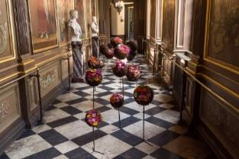
A gallery with portraits of the sovereigns and their governors who have reigned over the different States to which Brussels has belonged is located in the vestibule on the first floor and in the Grangé gallery which continues from it. These portraits belonged to the States of Brabant, the parliament of the duchy which had the south and west wings of the Town Hall built after the bombardment of 1695. The large painting that dominates the vestibule shows the canal superintendents and collectors inspecting the lock of the Willebroek canal at Petit- Willebroek. The municipal council room was arranged in the 18th century by the States of Brabant which held their sessions there. The three tapestries on the wall represent key moments in the city’s political life. The municipal executive (the mayor and aldermen) meet in the Maximilian room.
Figure 1- Copyright Wim Vanmaele

Grangé gallery – Portrait gallery
A long corridor that leads to the Mayor’s antechamber, the gallery is lined with the busts of Kings Leopold II and Albert I, and their respective spouses, Marie-Henriette and Elisabeth. A series of six paintings painted by Louis Grangé in 1718 represent the line of Spanish sovereigns, Philip the Fair, Charles V, Philip II, Albert and Isabella, Philip IV and Charles II.

Municipal council room
In Louis XIV style, the décor of this hall, which was designed to host the assembly of the States of Brabant, is lavish and intricate. The imposing tapestries depict the inaugurations of Philip the Good and Charles the VI as Dukes of Brabant in 1430 and 1717 respectively, as well as the abdication of Charles V in 1555. The fireplace is decorated by the mitre and the cross, symbolising the clergy, on the left, and by the helm and the banner, symbols of the nobility on the right. Facing the fireplace, on the piers that separate the windows, are the coats of arms of Antwerp, Brussels and Leuven, three of the main cities of the Duchy of Brabant. Painted by the Brussels painter Victor Honoré Janssens, the ceiling represents crown to an allegorical depiction of the Duchy of Brabant amidst the assembly of the gods. This room is today used to hold the sessions of the municipal council, attended by the mayor, the aldermen and the municipal counsellors.

Maximilian Room
The room in which the board of aldermen meets owes its name to the portraits of the Emperor Maximilian of Austria (1459-1591) and his wife Mary of Burgundy (1457-1482), Duchess of Brabant, painted by Cluysenaar in 1889. The tapestries date from the 18th century and depict certain memorable events from the life of Clovis, first king of the Franks.

Mayor’s antechamber
The paintings that decorate this antechamber were painted by Jean Baptise Van Moer between 1872 and 1874. They represent different quarters of Brussels before the drainage works on the River Senne decided by Jules Anspach in 1867. This gigantic undertaking would change the appearance of Brussels and lead to the creation of major arteries on the model of Haussmann’s boulevards in Paris.

Main staircase
Bathed in light, the stairway and the landing are decorated with busts of the mayors of Brussels since 1830. The paintings on the walls and the ceilings, created in 1893 by Count Jacques de Lalaing, illustrate “The Glorification of Municipal Power”. This feeling of pride is reinforced by the presence of a number of emblematic figures such as Jean de Locquenghien or Everard t’ Serclaes. At the foot of the stairway, the fountain is topped by an imposing statue of the Archangel Michael, the city’s patron saint, executed in 1890 by Charles Van der Stappen.

Gothic room
Reserved for major receptions and official meetings of the city, this room is panelled entirely in wood and decorated with Mechelen tapestries produced between 1875 and 1881 that evoke old Brussels trades: goldsmiths, embroiderers, painters, tapestry-makers, brewers and masons. Two other tapestries hanging on either side of the entrance door show the four oaths of Brussels seemingly keeping guard. The bronze statues represent mainly former Brussels mayors who served from 1386 to 1500. It is in this prestigious room that the Dukes of Brabant swore to protect and preserve the rights and privileges of the city, that the Charter of the Union of Cities of 1577 was signed, and the most magnificent of banquets was held in honour of Philip the Good. It was decorated with sumptuous tapestries and paintings at the time – inestimable treasures which were unfortunately reduced to ashes during the bombardment of 1695.

Wedding room
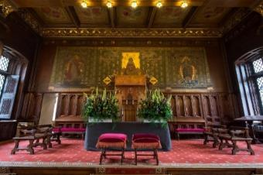
The walls of this former courtroom still resonate with the pronouncement of the death sentence of Counts Egmont and Hornes in 1568. Known also as the Room of nations, it served as the meeting place of the guilds assembled as nine nations, as still attested by the motifs painted on the ceilings. In this room have been held the civil marriage ceremonies for inhabitants of the City of Brussels through the ages, as illustrated by the triptych painted by Charles-Léon Cardon in 1881. It represents the City presiding over the institution of marriage, surrounded by Law and Justice, both of which are personified by the Archangel Michael.
Figure 2- Copyright Wim Vanmaele

Text excerpted from the book “Toute la lumière sur la Grand-Place de Bruxelles” [Everything You Always Wanted to Know about the Brussels Grand-Place] by Lillo Chiarenza, Valérie Paelinck and Philippe Denis, Queen II 2013 publication. The paragraph on the “Large hallway” is excerpted from the “Guide de Poche Bruxelles” [Brussels Pocket Guide], VisitBrussels 2013 publication.

Brussels Grand Place

Visitors can also enjoy Flowertime on the Brussels Grand Place, included on the Unesco World Heritage List since December 1998. During the opening of Flowertime, on Friday 11 August 2017, the organisers will create three small flower carpets with the help of 60 children. Divided into age categories (5-10 years, 10-15 years and 15+), the children, in groups of 20, will each be responsible for one carpet. This means that the youth will also become familiar with the tradition of flower laying.

Unusually, these carpets will not only be created out of flowers, but also out of vegetables, which will later be donated to a charity.

The carpets can be admired up to and including 15 August 2017 on the Grand Place. Anyone who wants to do so with a snack and a drink in hand can visit one of the stands available on the Grand Place.

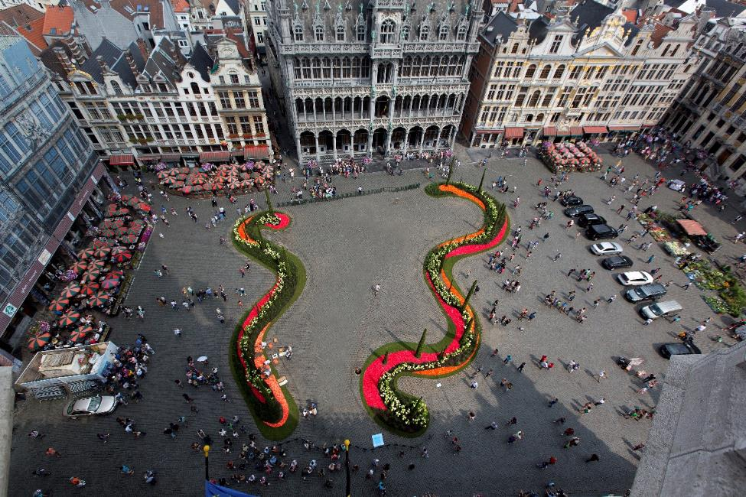
Figure 3- Copyright Batistini

Practical informations

8, 9, 10 and 11 August 2017: exhibition assembly

10 August from 9 a.m.: florist Geoffroy Mottart dresses up Manneken Pis with a floral flourish.
8, 9, 10 and 11 August, only by appointment: the opportunity to witness the installation of Flowertime.

11 August 2017: press day and opening to the public

From 9 a.m. to 12 p.m.: press session. The florists put the final touches to the exhibition. On the Grand Place almost 60 children will lay three flower and vegetable carpets.
The press can meet the organisers and florists the entire morning.

At 1 p.m. the exhibition opens to the public, until 7 p.m. (last entry at 6.30 p.m.)

12, 13, 14 and 15 August 2017: Flowertime & Flowernights

Regular exhibition visit: the exhibition is accessible from 10 a.m. to 10 p.m. (last entry at 9.30 p.m.). From 7 p.m. to 10 p.m. visitors can enjoy live music.

Flowernights: from 7.30 p.m. to 10 p.m. (last entry at 9 p.m.), evening event with a floral tasting menu by Masterchef Claude Pohlig.

Tickets

Regular exhibition visit:
Price: 7 euro (free access to the Grand Place).
Advance purchase online via www.flowertime.be and on the day itself at the entrance desk.
Free entry: for children younger than ten years old.

Flowernights (evening event with a floral tasting menu):
Price: 35 euro.
Sales: online only via www.flowertime.be.

Press Contact
Voice Agency

Alexandra Curelea (FR/ENG) – Alexandra@voice.be - +32 (0) 487 38 66 17

Laure Vandeghinste (NL/ENG) – Laurev@voice.be - +32(0) 479 60 45 92

Visual material and interviews available on request.

Website: www.flowertime.be

Acknowledgements
The City of Brussels and its services  The Brussels-Capital Region  Our floral artists and contributors  The National Lottery  Godiva  Koninklijke Maatschappij voor Landbouw en Plantkunde  Hotel Amigo  Villo!  STIB  SNCB  Interparking  Visit Brussels  RTBF – La Première, Viva Bruxelles en OUFtivi  VRT - Radio 2  Cibel-Cebon  À La Mort Subite  ADAM  Asbl Bruxelles Port de Mer  Atomium  Aux Gaufres de Bruxelles  AVBS  Belgian Art / Laces  Belgian Frit ‘n Toast  Biscuiterie Dandoy  Bocconi  Bollaerts Primeurs  Chocopolis  Cuisine Potager – Traiteur Claude Pohlig  Daoust  De Wase Vijverwinkel  European Parliament  Fact  Fintro  Fleur Creatief – Rekad  Florigineel  Funambule  Galeries Royales Saint-Hubert de Bruxelles  Gaston Batistini Photographer  Grand Casino Brussels  Grégoire Dune  Häagen Dazs  Hoegaarden – AB InBev  Hotel Léopold  Hotel Plaza | Hugues Navez  Jazz Club « The Music Village »  JCDecaux Belgium  Juwelier De Greef  KBC Brussels  Kip van Troje  Union Royale des Fleuristes de Belgique  L’Estaminet du Kelderke  L’Occitane en Provence  La Belgique Gourmande  La Belle Maraîchère  La Brouette  La Cave du Roy  La Cure Gourmande  La Maison des Brasseurs  La Musée de la Ville de Bruxelles – Maison du Roi  La Rose Blanche  Labo River  Le Comptoir de Mathilde  Le goût du fruit  Le Grand Café  Le Plaza  Le Renouveau du Quartier Grand-Place  Le Roy d’Espagne  Les Chapeliers  Mini-Europe  Océade  Open-Tours (Hop On Hop Off)  Peter & Lila – Artisans glaciers  Poechenellekelder  Quick Agora  Restaurant Vincent  Saint Michel  Samahuma Brussels Juice & Superfood  Scheltema  Taverne Du Passage  Taverne le Cirio  Théâtre Royal des Galeries  Thill S.A.  T’Kelderke  Tuinhier  Van Malder  Villo!  Wittamer

