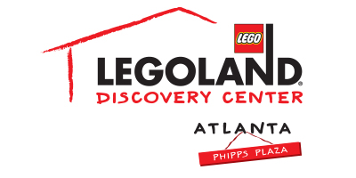
For more information:
Katie Clark
BRAVE PR, 404.233.3993
kclark@bravepublicrelations.com

*MEDIA ADVISORY*

LEGOLAND® Discovery Center Atlanta to “arghh-fer” special deals for
International Talk Like a Pirate Day on September 19
Kids who give their best pirate impression will receive a Kids Go Free coupon!

ATLANTA (August 29, 2017) – It’s a pirate’s life for me! LEGOLAND® Discovery Center Atlanta invites all pirate lads and lassies to celebrate International Talk Like a Pirate Day on Tuesday, September 19. Guests who talk like a pirate at admissions will receive a Kids Go Free coupon* and a pirate eye patch, while supplies last.

Guests can experience the permanent attraction, Pirate Adventure Island, at LEGOLAND® Discovery Center Atlanta as an interactive adventure as it is designed to encourage both children and adults alike to participate in free play and tactile activities. Families can explore treasure island themed build spaces to create their own LEGO® sandcastle or treasure map, construct a LEGO® pirate ship and set sail through an aquatic obstacle course, battling fellow shipmates by setting off air cannons. The exhibit has a soft play element and sends guests on a pirate adventure as they climb the rigging, walk the plank and capture the flag!

*The Kids Go Free coupon may be used immediately (or at a later date) at admissions.

WHAT: International Talk Like a Pirate Day at LEGOLAND® Discovery Center Atlanta
WHEN: Tuesday, September 19
10 a.m. – 5 p.m.

WHERE: LEGOLAND® Discovery Center Atlanta
Third Floor, Phipps Plaza | 3500 Peachtree Road in Buckhead

HOW: Guests who talk like a pirate at admissions will receive a Kids Go Free coupon* and a pirate eye patch, while supplies last

For more information, visit www.facebook.com/LDCatlantaor atlanta.legolanddiscoverycenter.com.

###

