SHELLEY LANE

Shelley Lane Salon

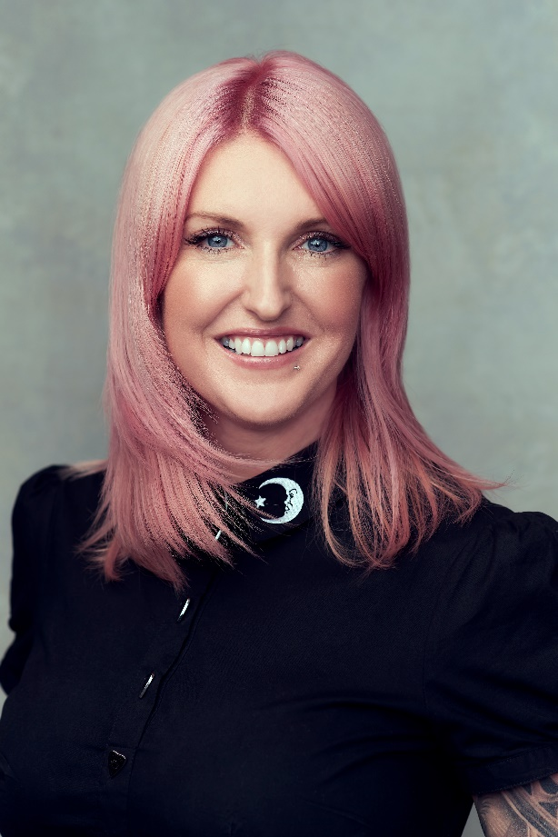
Shelley Lane Salon is a true hidden gem in a small Welsh town called Aberkenfig. It is a boutique salon, completely designed by the hairdresser and where she has put all her heart and soul.
When Shelley Lane was 4 months old, her parents bought their first home and 25 years later, she turned it into her dream salon. This is the place where she began dreaming of becoming a hair artist, and 16 years later, she is still just as in love with the space, where she offers a relaxed and homely atmosphere that clients love.
She discovered her passion for hairdressing at 14, when she started working on Saturdays and after school in a salon. At 15 she decided to train as a hairdresser and, at 19, when she finished her training, she was totally in love with the profession. Then she decided to continue her learning at Vidal Sassoon.

In 2002 she did her first editorial and the photoshoot opened her eyes to the whole new world of creative hairstyling. Years later, in 2005, she opened her salon, Shelley Lane Salon, and since 2012 she has trained with all brands, as well as different artists. From there, her career took a new direction in the sector. Her confidence grew, she began to participate in contests and won. In 2014, she was asked to join the Milk Shake Hair UK tour. That was the first time she got on stage, an experience that she greatly enjoyed. For 6 years she traveled the world showing her work and offering international training in hairdressing and styling courses in the United Kingdom, New York, Australia, Canada, Italy, Portugal, Denmark and in many other countries.

She has participated in the two annual editions of Zone Concept Italy for the last 8 years. She has taken ghd, Vidal Sassoon and also color courses by Wella and Joico, among others.

In recent years she has created different creative collections. In 2016, "Elysium"; in 2017, "Persephone"; in 2018, "Moonlight"; in 2019 "Efflorescence", and in 2021 "Pili-Pala", which means butterfly in Welsh.

As for her team, she is very proud to have a diverse group of hairdressers who are passionate about any style, very professional and experienced, who take care of clients from the moment they make an appointment until they leave, always with individualized attention.

She has received numerous recognitions:

• Avant-garde Hairdresser of the Year finalist in the HJ British Hairdresser Awards (2021).
• Finalist in I Want Her Hair by Hair Magazine Awards (2019)
• Finalist in Ultimate Stylist by Salon Business Awards (2019)
• Avant-garde Hairdresser of the Year finalist in the HJ British Hairdresser Awards (2018).
• Avant-garde finalist in the International Visionary Awards, Alternative Hair Show (2018, 2019, and 2021)
• Finalist in the Salon Business Awards (2018)
• Hairdresser of the Year winner in the Welsh Hair & Beauty Awards (2017)
• Best Salon Team winner in the Welsh Hair & Beauty Awards (2016)
• Guest artist for the British tour and the international show of Milk Shake Hair (2015)
• Hairdresser of the Year and Salon of the Year winner in the Welsh Hair & Beauty Awards (2014)

In addition, she is an a Milk Shake Hair Up ambassador and Global Educator for Z.one Concept Italy, of whom she is a member of the artistic team and with whom she has created the "Blue Velvet" (2017) and "Pure" (2018) collections.

In 2018 she traveled around the world to show her avant-garde looks and offer educational workshops on fashion, bridal style, and publishing.

She has also worked at the London Men's Fashion Week (2018) and the Paris Fashion Week (2020).

