WATCH: Chrome Sparks Makes the Subsequent 25 Synth Sing in New Video from Moog Music

Two weeks ago, Moog Music unveiled the Subsequent 25 analog synthesizer, a 2-note paraphonic successor to the beloved bass-centric Sub Phatty. In a new video from Moog, electronic musician Chrome Sparks proves the new instrument goes well beyond the grit and growl of its predecessor.

Hi-res photo selects

Watch as the artist demonstrates Subsequent 25’s vast sonic possibilities, from harmonic-rich leads to powerful synth bass, using Ableton Live to stack layers of the synthesizer’s analog sound: youtu.be/hp6McFTjmEk.

Subsequent 25 is now available for order worldwide.
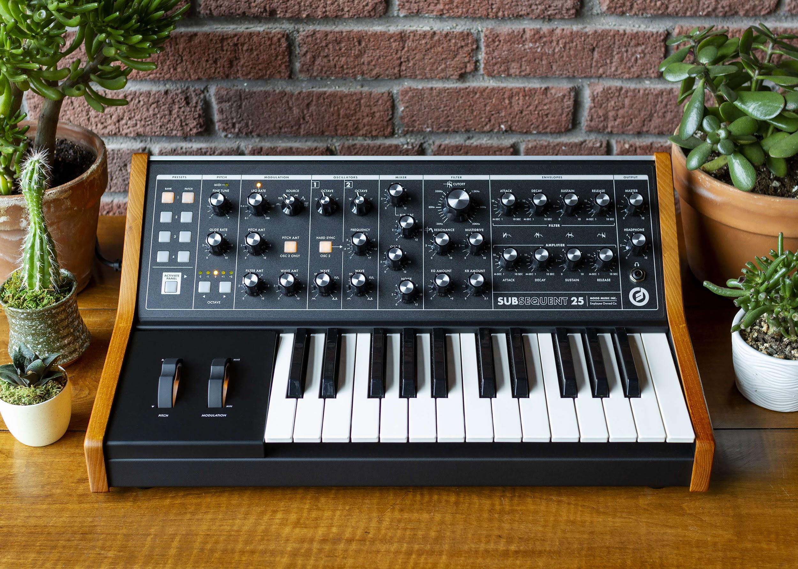

More about Subsequent 25
Subsequent 25 is a modern sound design machine with a classic analog soul. Designed for portability, it’s the most compact Moog keyboard synthesizer, equally reliable moving from stage to studio and every stop in between. The instrument features a full MIDI implementation, making for seamless integration into modern digital workflows and DAW environments. Learn more here.

More about Moog Music
Moog Music is the world’s leading producer of analog synthesizers. The employee-owned company and its customers carry on the legacy of its founder, electronic musical instrument pioneer Dr. Bob Moog. All of Moog’s instruments are hand built in its factory in downtown Asheville, North Carolina. Learn more here.

