**J5 Productions – Building events with passion, precision and purpose**

**Backed by Sennheiser’s EW-DX system, the company continues to raise the bar in live event execution**

***Singapore, 14 August 2025* — In the fast-paced world of live event production, where precision, speed, and reliability are non-negotiable, Singapore-based J5 Productions stands out as a key player. Founded in 2010 by Mr Justin Tan with a bold vision, J5 Productions is a technical production and media equipment rental company that has grown from a one-man operation into a team capable of producing mid to large-scale MICE events and arts festivals.**

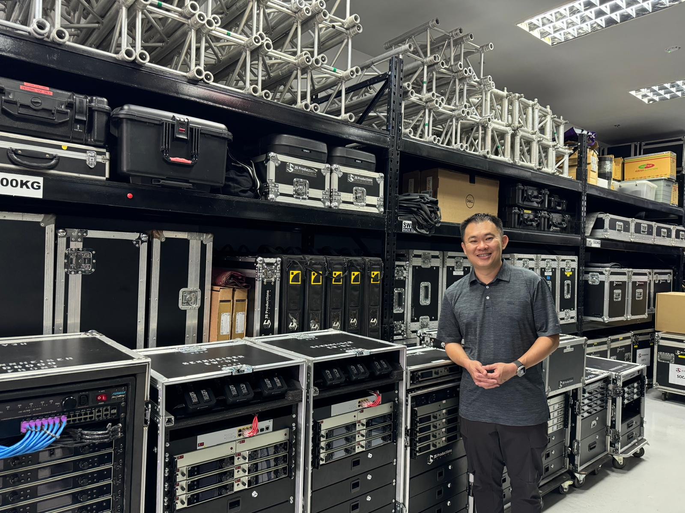

Mr Justin Tan, Founder and Managing Director of J5 Productions

Central to J5 Productions’ continued growth and technical evolution is a long-standing partnership with Sennheiser. The company’s wireless inventory, which includes Digital 6000, EW 100 G4, EW 300 G4, as well as the 2000 series, is now further strengthened by the implementation of Sennheiser EW-DX digital wireless systems.

**Simplicity and ease of use**

When Sennheiser launched Evolution Wireless Digital starting with the EW-D series, it quickly caught the attention of J5’s technical team, but it was the introduction of EW-DX that truly impressed them. In late 2023, J5 Productions added 24 channels of EW-DX to their inventory and an additional 16 channels in 2024.

“We did A/B testing with our existing systems and the EW-DX, and it stood out immediately,” says Mr Justin Tan, Founder and Managing Director of J5 Productions. “It’s an extremely versatile digital all-rounder that performs equally well in conference and performance settings.”

In Singapore’s high-pressure live events scene—where time is limited, and expectations run high—streamlined workflow efficiency is essential. “There’s no time to fuss—we need equipment that’s simple, smart, and intuitive, and the EW-DX delivers exactly that,” Mr Justin explains.

**Designed with the user in mind**

The EW-DX system’s intuitive, user-centric design has proven invaluable for the J5 Productions team. One helpful feature is the e-ink display on the transmitters, which retains information on the display even when the device is powered off.

“During large conferences where many microphones are deployed, unlabelled microphone batteries taken out for charging can quickly lead to confusion and wasted time,” Mr Justin shares. “With the e-ink display, information is always ‘on’, and we no longer need to label the transmitters. It is a small detail, but this saves us a lot of time.”

Another standout feature that won the J5 team over is Bluetooth syncing, which speeds up deployment onsite. Combined with the Smart Assist app, technicians can monitor and control the system remotely via an iPad—no laptop or fixed workstation required.

“With the Smart Assist app, we can move freely during setup or shows while maintaining complete control over the system,” Mr Justin shares. “The user interface is clean, intuitive, and customizable—simple but effective.”

J5 Productions’ arsenal of Sennheiser Wireless Systems

**A system that scales and sustains**

J5 Productions has since deployed EW-DX at many small and large scale corporate and local government events. One of the most memorable events for them included a large-scale conference, where they had to manage eight stages spanning six exhibition halls and more than 100 microphone channels.

“The Link Density Mode and equidistant channel spacing of EW-DX allow us to deploy many microphones in a congested spectrum environment. This eliminates intermodulation and simplifies frequency coordination,” Mr Justin says. “That is crucial for events with large wireless set-ups where multiple AV vendors compete for bandwidth. It also gives us the confidence to allocate frequencies to other vendors and exhibitors while maintaining performance and reliability on our end.”

Another important plus point of the EW-DX wireless microphone system is the rechargeable batteries. “We used to dispose of a large amount of AA batteries after each event. Now, we’ve significantly reduced battery waste with the use of rechargeable batteries. By cutting down on single-use batteries, the team not only reduces toxic landfill waste but also aligns with a growing industry-wide shift toward more sustainable practices. The major advantage of the EW-DX is its use of rechargeable batteries—a small change with a big environmental impact,” Mr Justin explains.

**A partnership built on trust and shared passion**

Beyond the product itself, Mr Justin highlights the importance of Sennheiser’s customer service and technical support. “The sales team is always responsive—whether it’s a last-minute quote or a technical query, they go above and beyond to support us,” he says. This partnership is rooted in a shared understanding of the live events industry.

**From vision to reality**

Mr Justin has always been an audio engineer at heart, guided by an innate passion for sound and precision. For him and his team, success isn’t just about growth—it’s about purpose.

“We are builders, engineers, and creators. To the team, there’s nothing more rewarding than building an event from the ground up—from an empty space into something extraordinary. We aim to serve our clients to the best of our abilities and improve with every project,” Mr Justin says. “Our best work should always be the next one.”

**About the Sennheiser Brand – 80 Years of Building the Future of Audio**

We live and breathe audio. We are driven by the passion to create audio solutions that make a difference. This passion has taken us from the world’s greatest stages to the quietest listening rooms – and made Sennheiser the name behind audio that doesn’t just sound good: It feels true. In 2025, the Sennheiser brand celebrates its 80th anniversary. Since 1945, we stand for building the future of audio and bringing remarkable sound experiences to our customers.

While professional audio solutions such as microphones, meeting solutions, streaming technologies and monitoring systems are part of the business of Sennheiser electronic SE & Co. KG, the business with consumer devices such as headphones, soundbars and speech-enhanced hearables is operated by Sonova Holding AG under the license of Sennheiser.

[www.sennheiser.com](http://www.sennheiser.com)

[www.sennheiser-hearing.com](http://www.sennheiser-hearing.com)

**Press Contact**

Phang Su Hui

suhui.phang@sennheiser.com

T +65 6932 5930

M +65 91595024