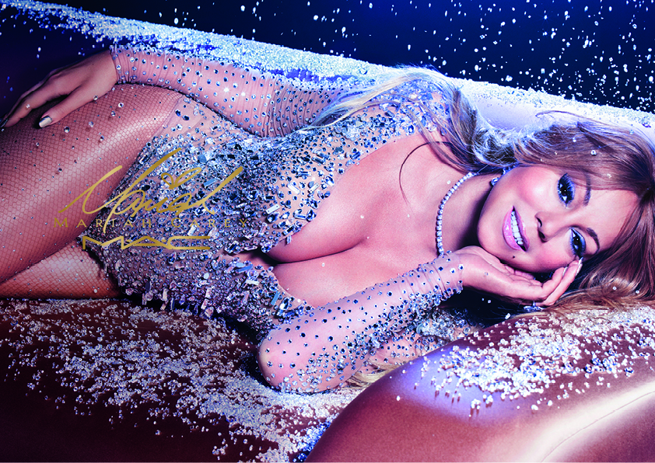

The Elusive Chanteuse and

“SONGBIRD SUPREME”

is back! Mariah Carey has dazzled us

with her smash hits and timeless

contributions to music for decades and

now brings her impeccable glamour

to an iconic makeup collection

that’s all you’ll ever want.

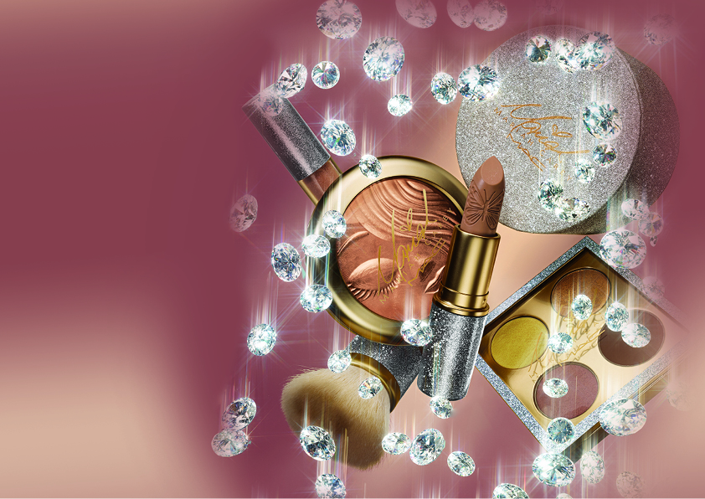

LIPSTICK

I Get So OOC: shimmering brown (frost)

All I Want: champagne shimmer (frost)

Bit of Bubbly: soft pinky nude (cremesheen)

Dahhlinggg!: pinky peach (cremesheen)

MCizzle: cool peach (cremesheen)

Verkoopprijs: €23

LIPGLASS

It’s Just Like Honey: tan shimmer

Rainbow Interlude: soft white shimmer

Little Miss Monroe: true gold shimmer

Dreamlover: dirty pink shimmer

(Online Only) Butterfly Bling: pink bronze shimmer

Verkoopprijs: €23,50

PRO LONGWEAR LIP PENCIL

So Dramatique: deep brown

New Ombré: cool peach

Verkoopprijs: €21,50

I’m That Chick You Like/eye shadow x4

Whenever You Call: yellow gold (veluxe pearl)

Can’t Escape Me: dirty mocha with gold pearl (satin)

Golden Petals Scattering: cool brown shimmer (frost)

How You Thrill Me: rich dark brown (satin)

Verkoopprijs: €43

IT’S EVERYTHING/Eye shadow x4

Diamond Butterfly: silver white shimmer (frost)

I’d Give My All: muted mid-tone grey (lustre)

Images of Rapture: muted black with red shimmer (velvet)

Twinks: deep plum with pearl (veluxe pearl)

Verkoopprijs: €43

LIQUID EYE LINER

This Is My Night: rich brown-black

Verkoopprijs: €22

LASH

05

36

Verkoopprijs: €14

EXTRA DIMENSION SKINFINISH

My Mimi: warm gold shimmer

Verkoopprijs: €48

POWDER BLUSH

You’ve Got Me Feeling: light candy pink

Sweet Sweet Fantasy: deep coral

Verkoopprijs: €25

LOOSE POWDER

Touch My Body: radiant gold shimmer

Verkoopprijs: €25

BRUSH

183 Buffer SRP: Verkoopprijs: €50

239 Eye Shader SRP: Verkoopprijs: €30

**EMBARGO** december nummer

**BESCHIKBAAR** 17 december 2016 bij alle M.A.C verkooppunten en op www.maccosmetics.nl.  
Voor meer informatie en beeld aanvragen: UNLIMITED PR, E: bente@u-pr.nl, T: 020 626 6176