superior sound, No compromise
Sennheiser introduces new CX True Wireless

Marlow, UK, June 29, 2021 – While it is perfectly fine to compromise on many things, when it comes to sound, nothing less than superior quality is acceptable. The new CX True Wireless earphones from Sennheiser offer an outstanding personal audio experience with crystal-clear sound, great battery life and effortless ease of use at an affordable price point.

Sennheiser’s new CX True Wireless earphones stand out by delivering sound quality that’s a class above, thanks to the audio specialist’s proprietary TrueResponse transducer which is designed and manufactured at the company’s headquarters in Germany. Developed for Sennheiser’s premium earphones, this bespoke acoustic system delivers high-fidelity stereo sound with deep basses, natural mids and clear, detailed treble. The Sennheiser Smart Control App and built-in EQ allow for custom tailoring of the listening experience, whether notching up the intensity of music with the Bass Boost preset, relaxing with a podcast, or enhancing audio for a phone call. Bluetooth 5.2 compatibility and SBC, AAC and aptX audio codec support ensure brilliant wireless sound and effortless management of Bluetooth connections via the Smart Control app.
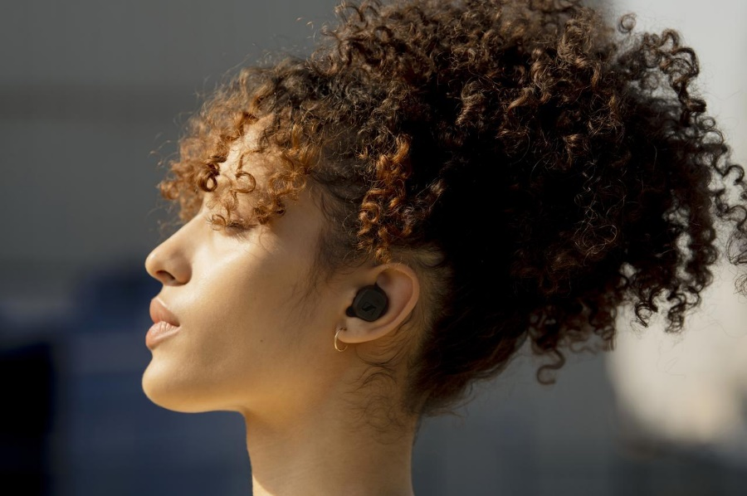
Sennheiser’s new CX True Wireless earphones offer an outstanding audio experience, 9 hours of battery life and ease of use at an affordable price point

“The CX True Wireless delivers truly superior sound at an accessible price point,” said Anton Zgurskiy, Product Manager at Sennheiser. “Featuring state-of-the-art technology and offering proven ergonomics, the earbuds have been developed according to user comfort studies. They also offer an outstanding personal audio experience that anyone can enjoy anywhere, every day.”

Experience all-day entertainment in total comfort
With 9 hours of battery life and up to 27 hours available when charging on-the-go with the supplied case, the CX True Wireless will keep listeners productive or entertained throughout the day – with all-day comfort to match. Stylish, minimalist, and perfectly balanced, the ergonomics of the earbuds were developed according to user comfort studies. For a perfect fit in the ear canal that keeps the earbuds securely in place and effectively attenuates outside noise, ear adapters are provided in four sizes. The earphones’ IPX4-rated splash resistance offers additional peace of mind.

A smarter, more connected user experience
The CX True Wireless features an intuitive touch interface. Via a firmware update, the user can make the touch controls customisable, letting the listener define their preferred way of controlling audio, calls or accessing voice assistants such as Google Assistant or Siri. The charging case is similarly intuitive, with the earbuds automatically powering on when taken out of the case and powering down to save energy when replaced.

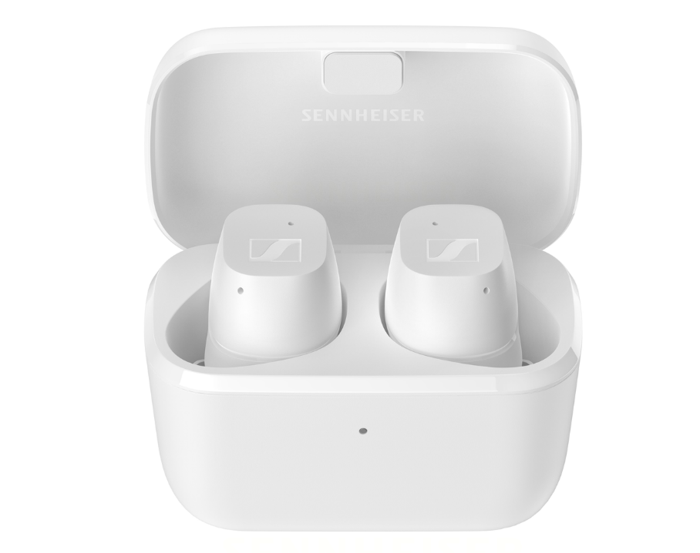

The CX True Wireless offers effortless ease of use with intuitive, customisable touch controls

Using dual microphones on each earphone for better voice pick-up, the CX True Wireless optimises speech for calls and voice assistant access, even when using a single earbud. A convenient ‘role switching’ feature allows either earbud to be used on its own for added versatility. The Sidetone feature, which makes phone calls more comfortable by letting the user hear their own voice during calls, is adjustable via a slider setting in the Smart Control app.

The CX True Wireless will be available in matte black or matte white from 8th July for £119.99 / €129 (RRP).

ABOUT SENNHEISER
Shaping the future of audio and creating unique sound experiences for customers – this aim unites Sennheiser employees and partners worldwide. Founded in 1945, Sennheiser is one of the world’s leading manufacturers of headphones, loudspeakers, microphones and wireless transmission systems. Since 2013, Sennheiser has been managed by Daniel Sennheiser and Dr. Andreas Sennheiser, the third generation of the family to run the company. In 2019, the Sennheiser Group generated turnover totaling €756.7 million.
www.sennheiser.com

Local Press Contacts
Maik Robbe
Communications Manager UK, Ireland & Nordics
maik.robbe@sennheiser.com
T +44 (0) 7393 462484

Emily Ackland
Harvard
sennheiser@harvard.co.uk
T +44 (0) 7393 758442

