Sennheiser Group esittelee laajaa audioinnovaatioiden valikoimaa ISE 2026 -messuilla
Rinnakkaiset osastot hallissa 3 tarjoavat immersiivisen matkan uusimpiin audio- ja AV-hallintateknologian sekä yhteistyöratkaisujen innovaatioihin.

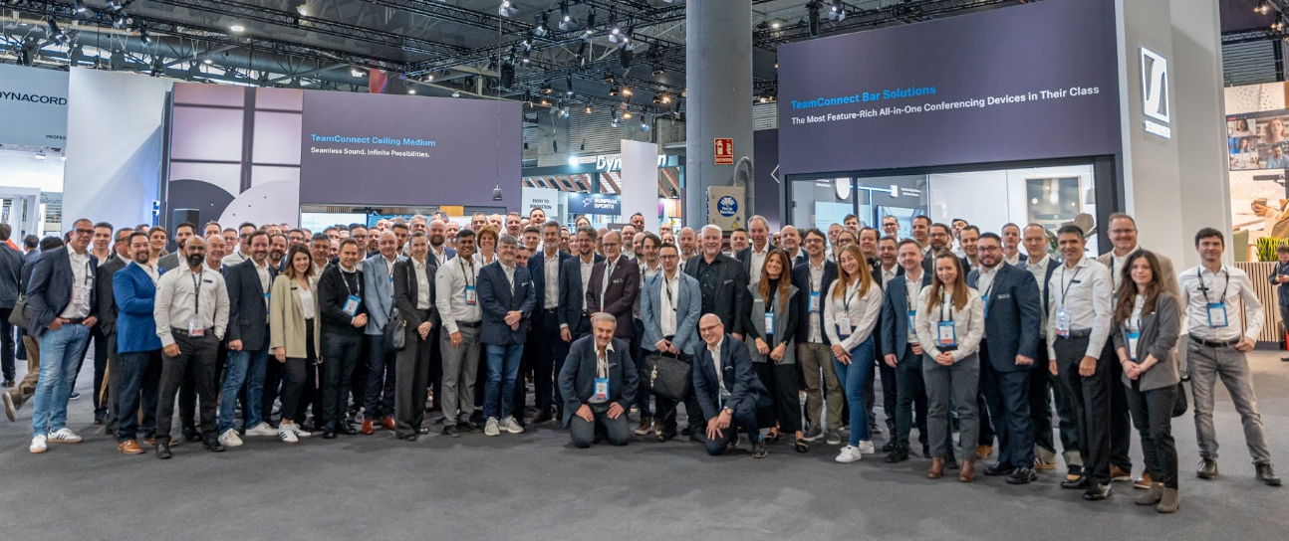
ISE 2026 -messuilla Sennheiser Group kutsuu osallistujat tutustumaan uuteen, alueista 3B500 ja 3B700 koostuvaan messuosastoon, joka on suunniteltu brändeille Sennheiser, Neumann.Berlin, AMBEO, Merging Technologies ja SoundBase. Osastolla esitellään käytännön kokemuksia ja mukaansatempaava demotilaa, jotka esittelevät konsernin uusimpia audioinnovaatioita koulutus-, yritys-, live-ääni-, lähetys- ja studiotiloihin.
Lisää alla englanniksi

A Booth Designed for Discovery
Every zone of the Sennheiser Group’s booth is crafted to inspire. Visitors can experience firsthand how Sennheiser’s scalable audio solutions adapt seamlessly to any application, environment or need. From interactive demos to hands-on product showcases, the booth encourages meaningful conversations with passionate experts ready to guide attendees through every innovation.

Experience Cutting-Edge Technologies
Sennheiser will present its latest advancements in:
- AV Management – Simplifying workflows for IT and AV teams via cloud-based management.
- Voice Lift Technology – Delivering crystal-clear speech in challenging environments.
- RF Coordination and Wireless Audio – Setting new standards for reliability and scalability.
- Immersive Audio – Transforming how professionals experience sound.

Daniel Sennheiser Live on Stage
To kick the show off, Daniel Sennheiser, Chairman of the Board of Directors of the Sennheiser Group, will participate in the ISE 2026 Investor Forum. As part of the forum, Mr. Sennheiser will sit on the “Reflections from the Money-side” panel, scheduled for 10:30 a.m. on Tuesday, 3 February, in the Fira Barcelona Gran Via, Room CC5.1. Panellists will share the opportunities and challenges they have found in exploring investments in the pro AV space, including perspectives from all manner of investor types, whether venture capital, private equity, or corporate.

Solutions for Business Communication
Sennheiser’s Business Communication zone focuses on making collaboration and learning easier. Whether designing hybrid learning spaces, managing AV across campuses or integrating BYOD solutions, Sennheiser offers tools that simplify complexity. A highlight is the state-of-the-art soundproof demo room, where visitors can explore the TeamConnect Bar and TeamConnect Ceiling Solutions. Here, Sennheiser will also demonstrate TruVoicelift in one of the most hostile audio environments — the trade show floor — proving how effortless and powerful voice lift can be.

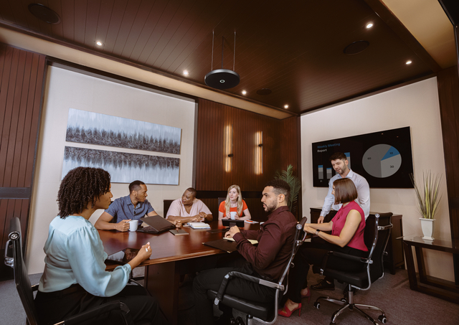

Interactive Engagement
Visitors can join the ISE26 Hunt, an interactive challenge that highlights Sennheiser’s Partner Ecosystem. By scanning QR codes and completing quick tasks, participants can unlock exclusive prizes—including this year’s coveted Sennheiser socks—while discovering how Sennheiser and its partners create connected, flexible environments.

Introducing DeviceHub: A New Era in AV Management
At ISE 2026, Sennheiser will officially launch DeviceHub, a secure, cloud-based platform designed for IT and AV managers, as well as system integrators. DeviceHub centralizes device visibility and remote management, streamlining workflows across enterprise, education, and corporate settings.

DeviceHub provides real-time insights, simplified setup, and unified control, supporting organizations in creating better spaces for communication, learning, and teamwork. Following a successful private beta, ISE marks the transition to public availability. Visitors can explore DeviceHub’s capabilities and speak directly with product experts about how it can transform their AV and IT operations.

Initially available for TeamConnect Bar Solutions, compatibility will expand to additional Sennheiser devices throughout 2026.

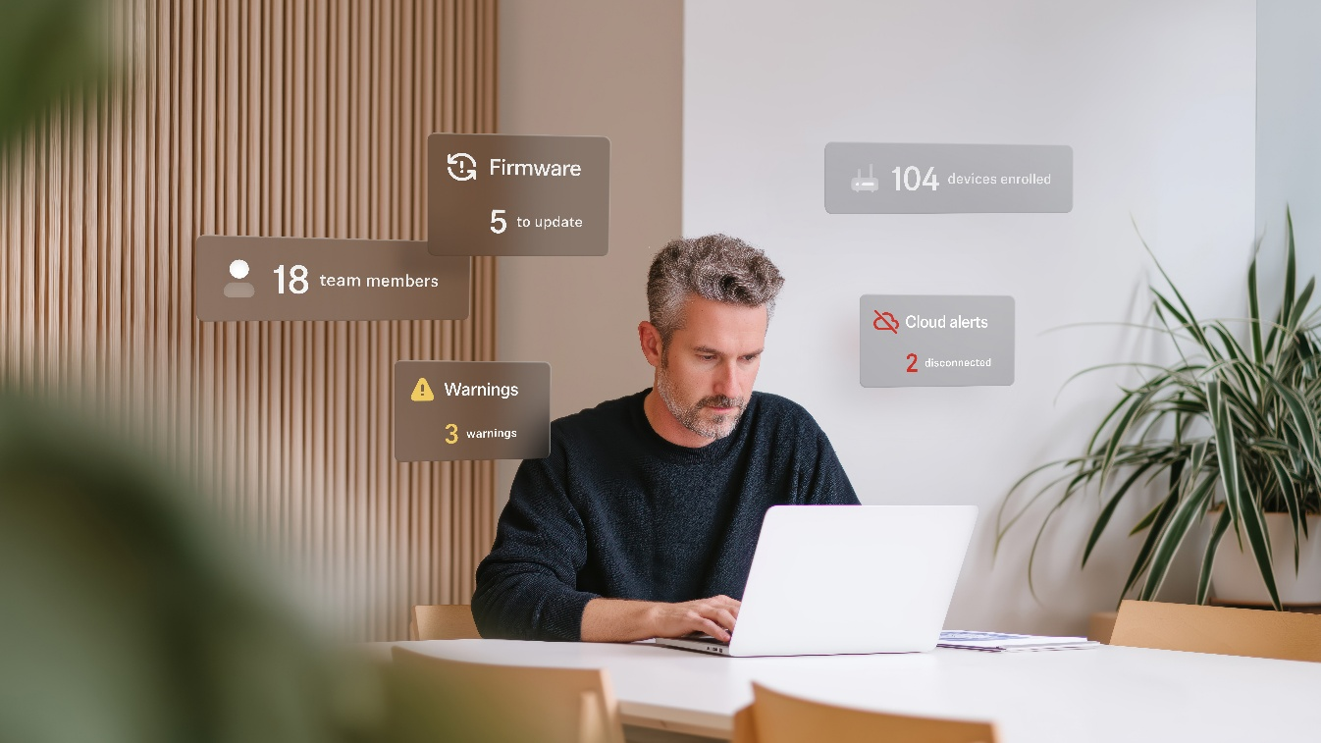
DeviceHub is a secure, cloud-based platform designed for IT and AV managers as well as system integrators

Spectera Lab at ISE 2026
Spectera, the world’s first bidirectional wideband wireless ecosystem, continues to evolve, with the Spectera Lab previewing the most exciting upcoming functionalities. For example, ISE visitors can explore the SKM handheld transmitter including the Command adapter and the Base Station ZMAN for SMPTE 2110 broadcast workflows. Also, Sennheiser will in future give access to Spectera’s API, allowing for advanced customization and control across multi-vendor workflows. Sennheiser’s Spectera experts will be on site to give guests a deep dive into the Sennheiser implementation of WMAS and the many advantages it brings to wireless workflows.

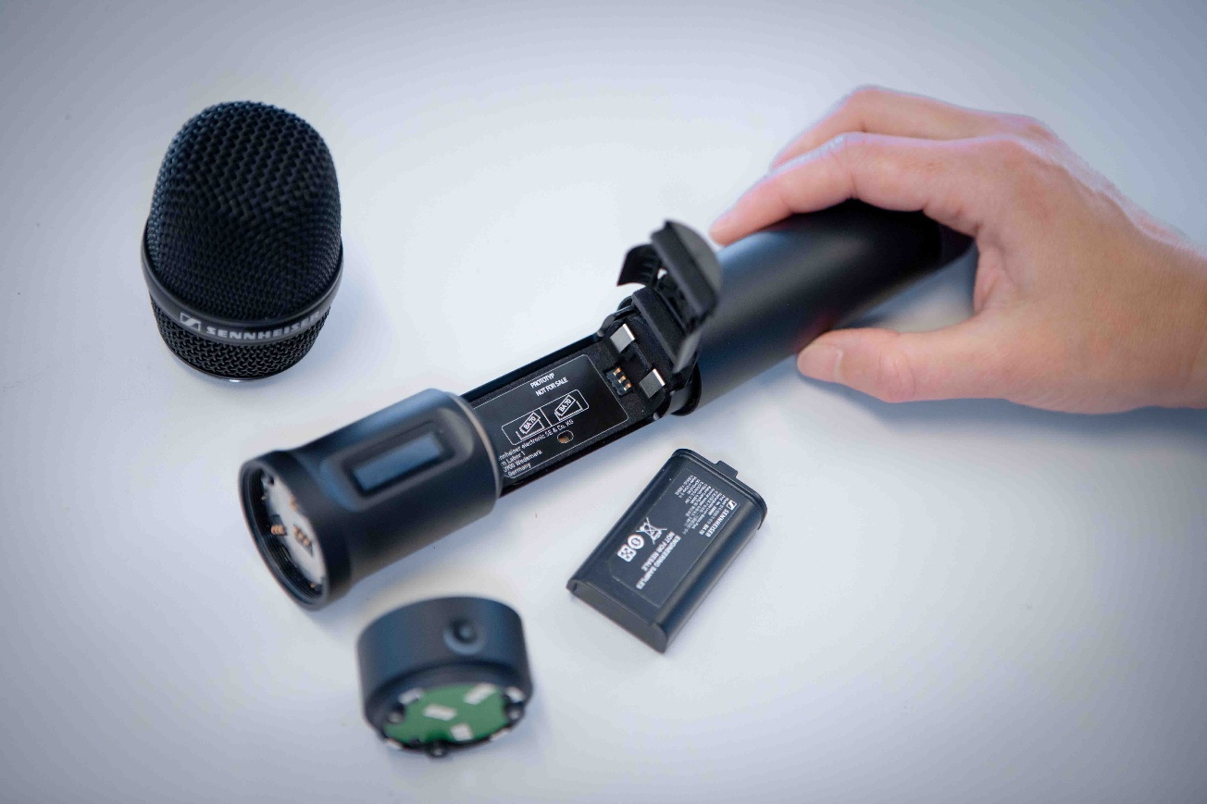
The modular Spectera handheld transmitter with the programmable Command adapter

SoundBase, the world’s first brand-neutral RF coordination tool
The Sennheiser team are delighted to welcome SoundBase as a partner, and will be demoing their app, which is the world’s first universal wireless audio management software. Universal RF planning and collaborative workflows are the hallmarks of the SoundBase app (https://soundbase.app/), which eliminates the need to switch between different manufacturers’ software when frequency-coordinating a wireless audio system. Developed by audio veterans Matt Dale and Donny Kuser, the app integrates with equipment from all major manufacturers and enables seamless remote collaboration. At ISE 2026, an exciting addition to the free version of the app will be announced.

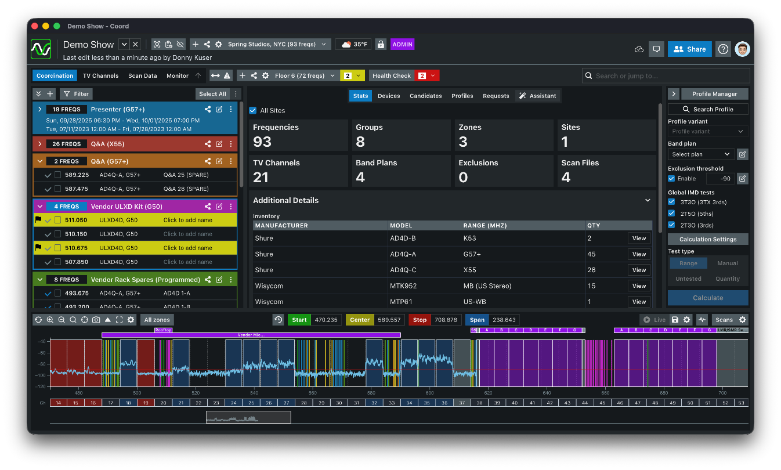SoundBase works with wireless systems from every major manufacturer, providing the audio team with a single, time-saving and efficient workflow

Neumann’s end-to-end solutions for immersive audio
The booth also features an immersive studio area by Neumann featuring a full 7.1.4 setup with KH 150 and KH 120 II studio monitors as well as the brand-new KH 810 II subwoofer with multichannel bass management. The immersive setup will be controlled via Neumann’s high-end audio interface MT 48, seamlessly paired with several Merging Hapi MK III units featuring all available I/O extension cards. A MassCore system will run Merging’s acclaimed Pyramix 15 and Ovation 11 software. Also on display will be Merging’s Anubis interface featuring the AMBEO spatial audio plugin.

Another highlight will be VIS – Virtual Immersive Studio, Neumann’s groundbreaking app for Apple Vision Pro. VIS is the missing link between spatial audio and spatial computing, making immersive mixing intuitive. Users can see and arrange audio sources around them in three-dimensional space using hand gestures. Visitors are invited to experience VIS for themselves and get a glimpse of the future of immersive audio. Although VIS can be used with an immersive loudspeaker setup, it also supports RIME, which will also be demonstrated separately. RIME, recently updated to version 1.5, is Neumann’s solution for immersive monitoring on NDH 20 and NDH 30 headphones – with stunning realism.

Also on display will be Neumann’s famous KU 100 binaural head (aka “Fritz”) as well as a selection of reissued microphone legends such as the M 49 V and U 67.

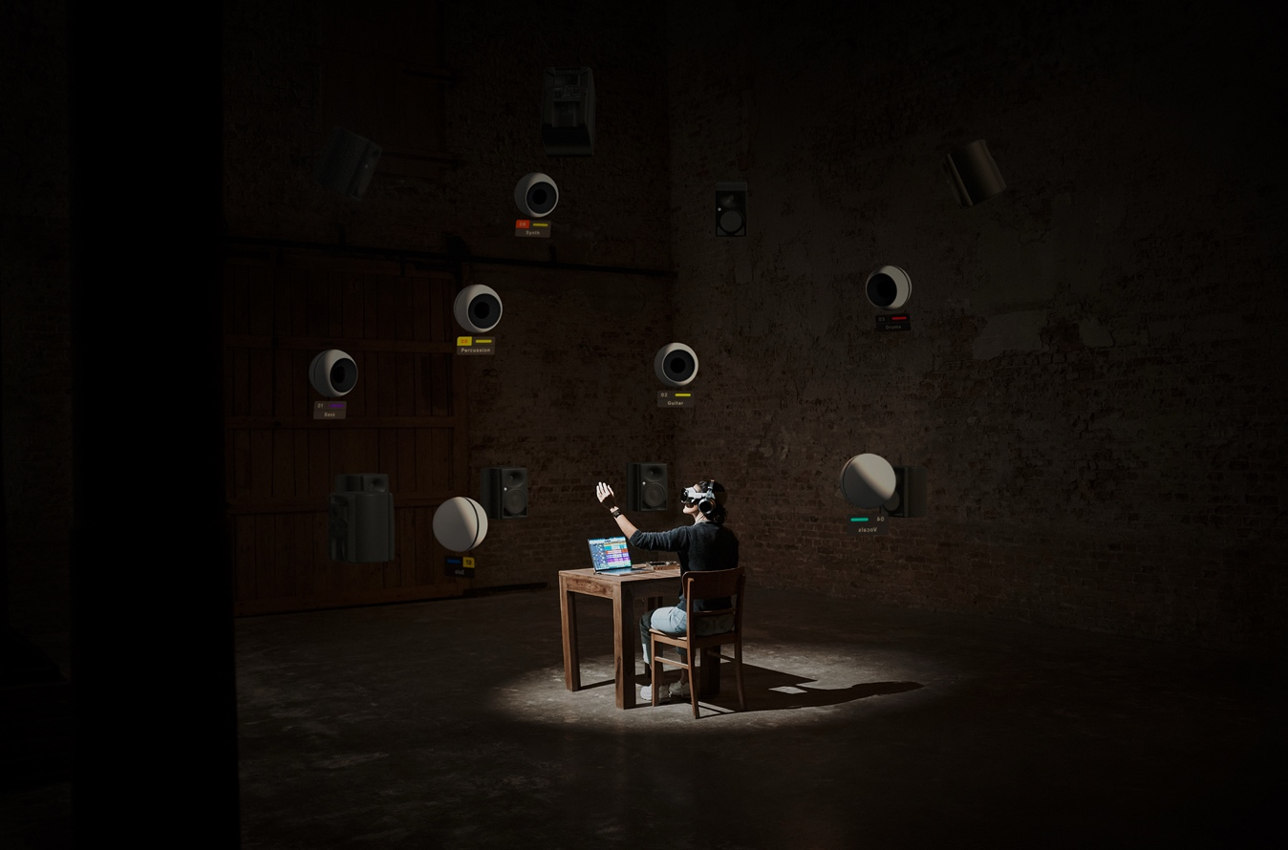
Discover the future of immersive audio mixing with Neumann’s VIS – Virtual Immersive Studio

(Ends)

The high-resolution images accompanying this media release can be downloaded here.

About the Sennheiser Group
Building the future of audio and creating unique sound experiences for our customers - this is the aspiration that unites the employees of the Sennheiser Group worldwide. The independent family-owned company Sennheiser was founded in 1945. Today, it is managed in the third generation by Dr Andreas Sennheiser, and is one of the leading manufacturers in the field of professional audio technology.
Press contact
Burson Finland Oy (previously Hill and Knowlton)
sennheiser.finland@hkstrategies.com

