DIVE INTO MUSIC WITH AQL™

UNDER EMBARGO UNTIL 06 SEPT 9 AM

Cellularline S.p.A., the European leading company in the development and sales of accessories for smartphones and tablets, showcases at IFA 2019 (September 6-11) the new references of Audio Quality Lab™, the brand entirely dedicated to the music world.
Composed by headphones, speakers and Bluetooth earphones, AQL™’s new line-up presents technological high-performing innovations keeping an excellent quality/price ratio.

The brand new AQL™’s headphones ASTROS are ideal for young music lovers always looking for the next summer hit. ASTROS feature unique stylish design and high sound quality and they are perfect to listen to your favorite songs everywhere in total relaxation.

AQL™ ASTROS
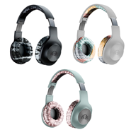
Light, colorful and super cool: thanks to their foldable design you can easily bring ASTROS everywhere or put them safely in your bag or backpack. ASTROS guarantee a play-time up to 25 hours, perfect for those who love listening to all the nuances of their favorite song, as the pump bass button allows to boost the deep bass.
Available in 6 colors: 3 monochrome colors and 3 patterned ones.
Price: 34,95€

Plump, Hurricane and Typhoon are the new Bluetooth speakers by AQL™, as well as the novelties of the fall line-up, designed to listen to music everywhere.
Thanks to the fastening cord you can safely bring the speakers with you in any place you like: at the park, in the mountains with friends, at home or in your school bag.
All three models are provided with IPX7 certification which allows underwater diving up to 1 meter deep, plus they are equipped with TWS –True Wireless Stereo- function that makes it possible to connect two devices to each other via Bluetooth in order to have a more definite and powerful sound and even deeper bass.

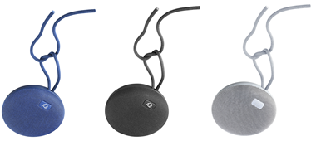
AQL™ PLUMP
The music never stops with PLUMP speaker, the ideal discreet partner to always create the right atmosphere. PLUMP is small but ultra-resistant and powerful (5 WATT) and it is provided with a long-lasting battery capable of performing up to 7 hours of play-time.

UNDER EMBARGO UNTIL 06 SEPT 9 AM
Available in three colors: white, blue and black.
Price: 29,95€
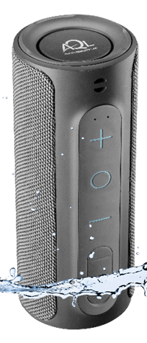

AQL™ HURRICANE

HURRICANE is the Bluetooth speaker that combines minimal design and a pure, dynamic and definite sound thanks to its 20WATT of an output. With HURRICANE you can have fun and long-lasting energy even in wider environments thanks to its 10 hours play-time.
Price: 79,95 €

AQL™ TYPHOON

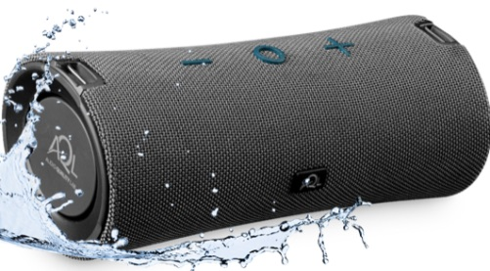
TYPHOON is the most powerful speaker of the range, ideal to always experience your music at its maximum. Its 30WATT of an output guarantee a super definite sound and deep bass. TYPHOON guarantees up to 10 hours of play-time .
Price: 99,95 €

ELUSION and EVADE are the new pocket-size Bluetooth earphones designed with a mini size but capable of great performances. Not only they allow to use the smartphones while listening to music everywhere in complete comfort, but they also ensure a long lasting charge.

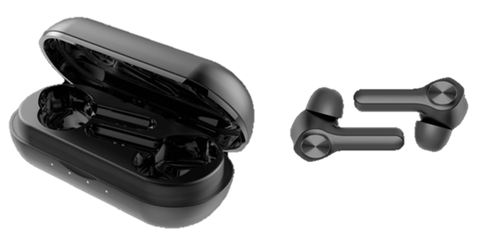
AQL™ ELUSION
ELUSION is the leading product of the line, and its earphones combine total comfort and unique design. An advanced technology guarantees the maximum of handiness: the Touch Control system for example allows to access the commands with a simple touch. The IPX4 certification ensures rain and sweat resistance. Thanks to its 15 hours of play-time ELUSION is the must-have accessory for smartphones.
Available in two colors: white and black

UNDER EMBARGO UNTIL 06 SEPT 9 AM
Price: 79,95 €
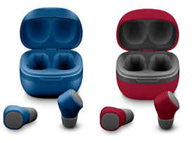
AQL™ EVADE

Still Bluetooth but even more pocket-sized, EVADE earphones feature a basic yet captivating design. Their 22 hours of play-time allow to talk and listen to music all-day-long! Available in six different colors EVADE can be matched to any style.
Price: 59,95 €

About Cellularline S.p.A.
Cellularline S.p.A. is the leading company in the accessories’ market for smartphone and tablet. Cellularline brand is the technological and creative landmark concerning the accessories for multimedia devices and aims to offer excellent performances and easy-to-use products for a unique user’s experience. Currently, Cellularline S.p.A. counts about 200 employees and boasts an intercontinental distribution in over 60 countries.

INTERNATIONAL PRESS CONTACTS: SAY WHAT? Srl (Milan, Italy)
Geraldina Soldadino, Senior Account Manager Media Relations: g.soldadino.cons@saywhat.it, Mob. + 39 388 3938334
Letizia Castiello, Junior Account Media Relations: l.castiello@saywhat.it, Tel. +39 02 3191181

PRESS CONTACTS BELGIUM: EVOKE (Etterbeek, Belgium)
Gilles Dujardin, PR Consultant : gilles@evokepr.be, Mob. +32 474 818 999
Ymke Deprez, PR Consultant : ymke@evokepr.be, Mob. +32 479 75 52 32

