For immediate distribution

BAE Audio President Mark Loughman to Present on Preamplifiers and EQs
During Welcome to 1979 Recording Summit
Venerable 1073 among topics to be shared and discussed

Nashville, TN - November 6, 2017 – BAE Audio, a manufacturer of premium analog hardware built to vintage specifications, announced that its President, Mark Loughman, will participate in a panel at the 9th annual Welcome to 1979 Recording Summit in Nashville, Tennessee. The panel is entitled ‘Inside The World’s Most Famous EQs’ and discusses a range of classic vintage equalizers. He will joined by Jeff Steiger of Classis Audio Products, EveAnna Manley of Manley Labs, and Bill Skibbe of Key Club Recording Company.
Loughman, who first worked for BAE Audio as a technician repairing and repackaging vintage console hardware before taking the helm of the company in 2009, has helped burnish the company’s reputation for crafting the most authentic recreations of vintage circuits on the market, like the famous 1073 equalizer. The company’s hand-wired products are built entirely in California and feature the same premium components that helped give the vintage hardware they are based upon their characteristic sound.
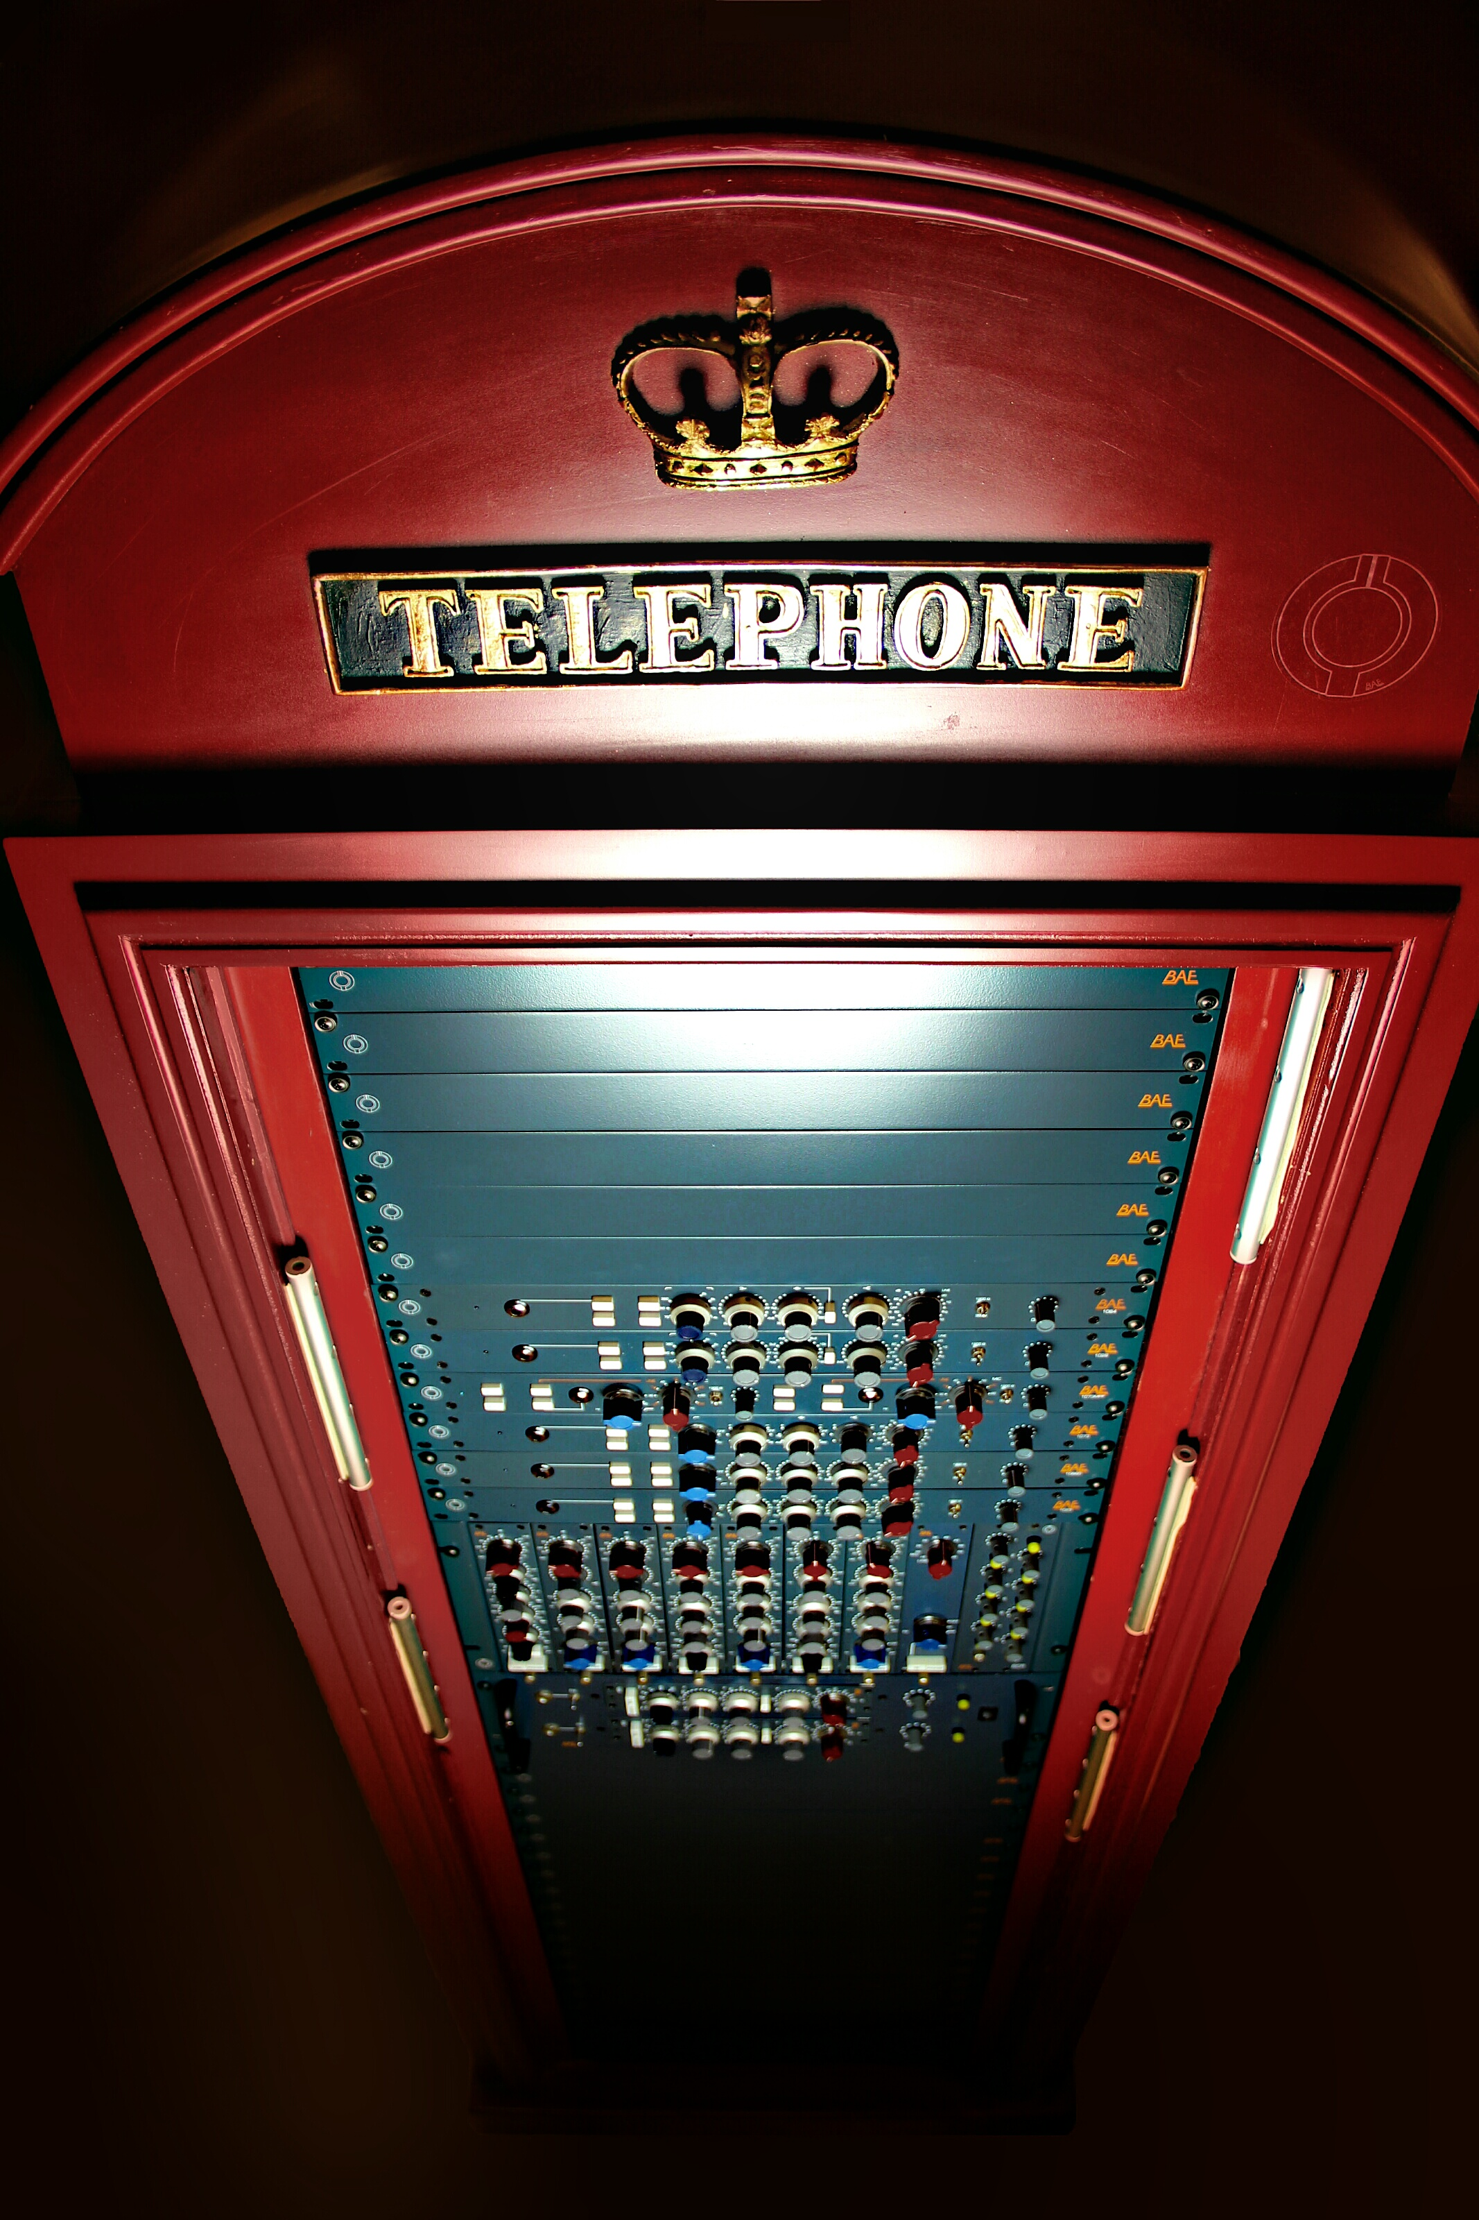
“I’m always eager to delve into the finer points of these great EQs that have been featured on just about every record you’ve ever heard,” says Loughman. “They’re truly remarkable feats of design and engineering, and BAE Audio’s success is a testament to how coveted these over forty-year-old designs remain. They really came to define the sound of recorded music as we know it.”
Intimate Knowledge
The Summit, held at the analog-centric Welcome to 1979 studio complex, provides an opportunity for attendees to take in panels from top experts in the audio community in the intimate environs of the spacious 7,500 square foot studio. Without microphones, a stage, or slides, the intimate panels more closely mimic natural conversations about craft amongst engineers without the formality of a conventional trade show setting. The Panels are generally followed by an open question and answer period. Other highlights of the weekend include a live recording session cut to vinyl and listening parties of classic recordings. The recording summit is limited to 60 attendees is this year’s event is sold out.
“I’m really excited to welcome Mark Loughman to this year’s Recording Summit,” says producer, engineer, and Welcome to 1979 studio proprietor Chris Mara, who started the annual event after feeling dissatisfied with the playing-it-safe approach he found himself taking with his own panel appearances at show floor panels at the larger audio conventions. “I know how well-respected Mark is in the industry and I’ve used BAE Audio products myself. BAE really takes the time to really get to know the original hardware and create something faithful to it, so I’m excited to hear what he has to tell us.”
To learn more about BAE Audio, please visit http://www.baeaudio.com.
To learn more about the Welcome to 1979 Recording Summit, please visit: http://welcometo1979.com/what-we-do/recording-summit/
About BAE Audio
BAE Audio is a U.S.-based manufacturer of high-end microphone preamp and equalizers, all of which are faithful to vintage designs of the seventies and before. The company is committed to the vintage philosophy of hand wiring and hand soldering all of its components to achieve a high quality and authentically vintage sound. For more information on BAE Audio, please visit our website at www.baeaudio.com.

Media contact
Jeff Touzeau
Public Relations
Hummingbird Media
+1 (914) 602 2913
jeff@hummingbirdmedia.com

