

Biuro prasowe better. gaming agency
bettergamingagency.prowly.com

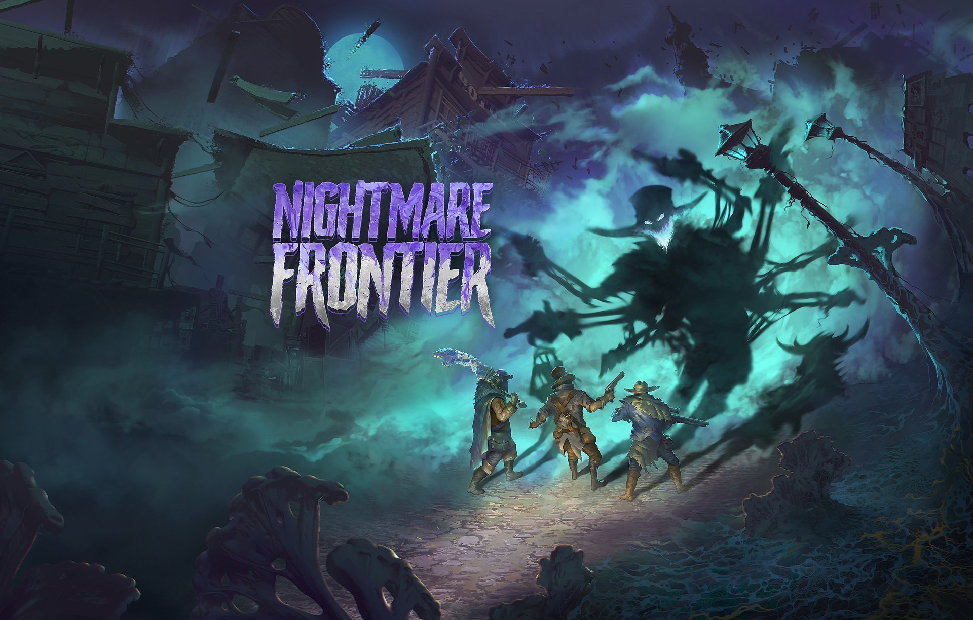

Nightmare Frontier opens the gates of terror – new gameplay footage and demo available now

Nightmare Frontier – the latest title from Ice Code Games, the studio behind the critically acclaimed Hard West 2 and Rogue Waters – was officially unveiled in early May. The first look captured the attention of gamers thanks to its original setting and fresh gameplay ideas. This time, the developers have released a video showcasing the key features and challenges awaiting players. Starting today, a demo is available on Steam, offering a taste of what’s coming this summer.

Nightmare Frontier – gameplay overview

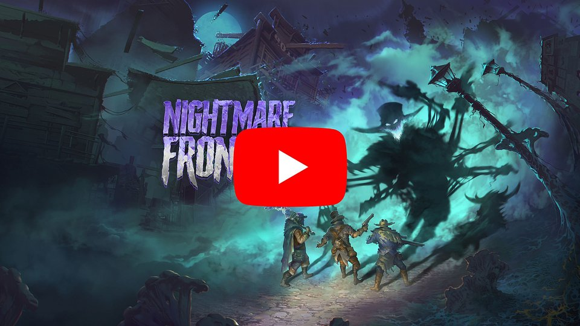
https://youtu.be/AdaxGy9n-7Q

Ice Code Games, a studio specializing in turn-based strategy games, continues to push boundaries across genres. Nightmare Frontier is a Tactical Extraction Looter that combines the tactical gunfights established in Hard West 2 with the intense melee combat that impressed players in Rogue Waters. The game also brings in roguelite elements, steering the experience toward gameplay characteristics of extraction looter titles. One of the core gameplay mechanics is the constant tension between taking risks and pursuing potential rewards. However, a reckless chase for precious loot can lead to painful consequences for the entire team.

The attention that Nightmare Frontier has received since its reveal reassures us that we’re making an intriguing title set in a compelling setting. Players familiar with our previous games know they can expect another solid tactical experience. We hope that by trying out the demo, they’ll get a taste of the challenges we’re preparing for them this summer — and we can’t wait to hear what they think. We’re confident that Nightmare Frontier will surprise genre fans with its fresh approach and engaging gameplay, built around a constant risk-reward mechanic and strategic choices

– said Mateusz Pilski, CEO of Ice Code Games.

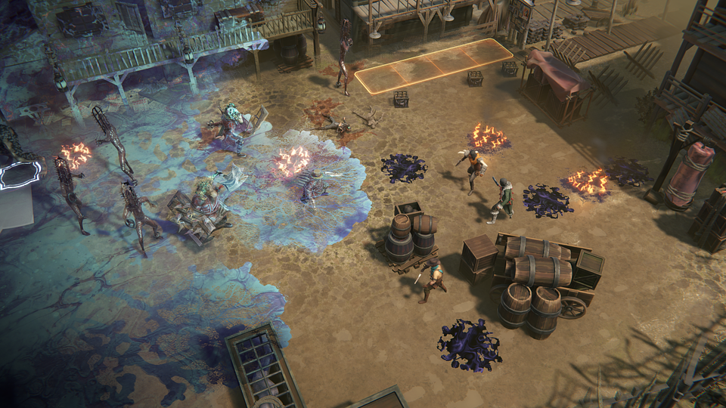

The demo provides an opportunity to check out firsthand the core gameplay features such as tactical battles, risk management, and scavenging resources and items. The number of mechanics available at this stage is limited, but players can embark on multiple expeditions in one of the available city districts. This allows them to take on the challenge of pushing as far as possible with only basic team improvements. The full release of Nightmare Frontier will offer a greater number of enemies, items, tactical mechanics, and strategic depth, as well as a wider range of options in the headquarters, including a team progression system between expeditions.

Nightmare Frontier is coming to Early Access on Steam this summer. The demo is available now (starting May 27th), and along with Ice Code Games, we encourage you to give it a try. Anyone eager to face the American Nightmare can already add the game to their wishlist.

Nightmare Frontier will also participate in Steam Next Fest, which will take place from June 9th to 16th. More details about the game can be found on the official website and on social media - Facebook, Bluesky and X.

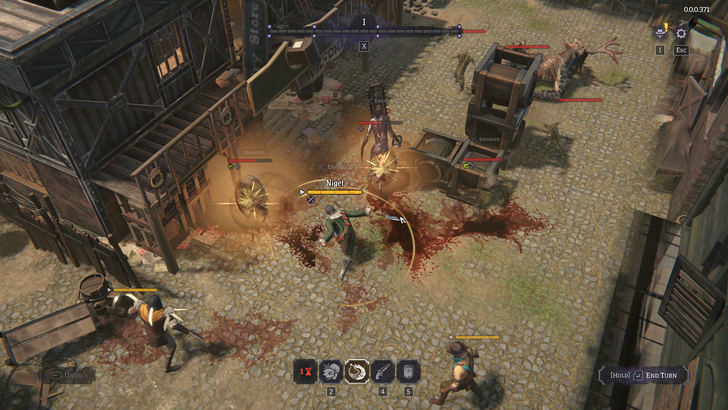

More about Nightmare Frontier

The story of Nightmare Frontier unfolds in an alternate version of 19th-century America, shortly after a mysterious event that forever changed the world. The line between reality and an unknown horror has started to fade, and those who remain are left to uncover what truly happened that night – and what’s behind the titular Nightmare. The streets were overrun by monsters emerging from the dark abysses of the terror dimension – the survivors called these creatures Dreadweavers. These beings are the physical embodiment of people's deepest fears. Players will step into the shoes of the ringleader, who, despite overwhelming terror, finds a chance for survival in this new reality. Leading other scavengers, they venture deep into the city, risking everything they have left in search of loot.

As the terrifying events unfold, the city is mostly consumed by the Nightmare – a metaphysical and mysterious force. As it grew, the surroundings became increasingly tangled and destroyed. The chance that deadly anomalies will allow for enhancement of combat abilities goes up as well. Only a team willing to face their darkest fears is able to venture deeper into it and survive. However, the terror has left its mark on everyone, and each character will struggle with their own inner demons, which will influence challenges.

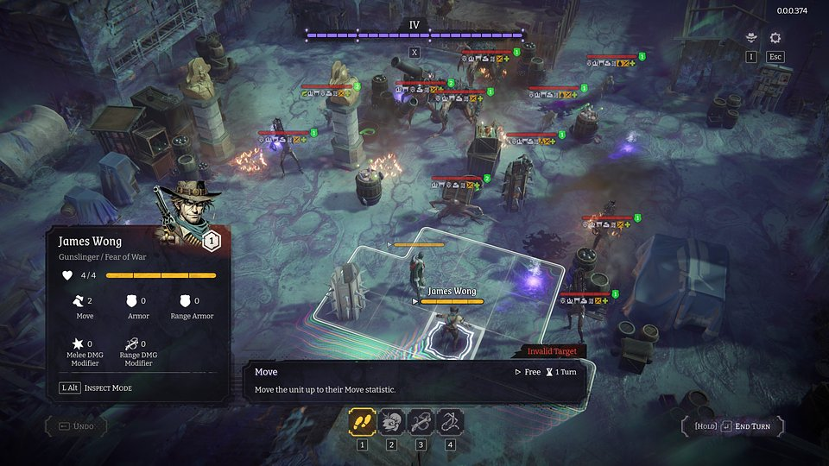

Nightmare Frontier – key features:

● Turn-Based Gun 'n' Slash – a combat system where every detail matters. Nightmare Frontier blends deep tactical gameplay with dynamic combat, using well-known and beloved mechanics from Ice Code Games' previous titles. Push enemies around the battlefield, use the environment to your advantage, chain skills, and get the most out of turn. Showcase your tactical creativity like never before.

● No risk, no reward – in the spirit of extraction looters, players walk the path that leads between risk and opportunity, deciding whether to push deeper into the dark city, risking everything, or retreat to safety and preserve their gains. The greater the risk, the more tempting the rewards – valuable items, resources, and upgrades that can alter the course of the game.

● Otherworldly terror – the titular Nightmare affects all aspects of gameplay – from shaping locations and challenges to the abilities of team members and enemies. Its growing power brings new challenges – every choice and battle is influenced by its increasingly strong presence.

● One more fight – Oversee your team, complete missions, and gather resources to forge powerful weapons. Explore the Nightmare and its dark capabilities by sending your team on dangerous raids into the devastated city, where every step deeper brings you closer to uncovering terrifying secrets.

● Crafted by veterans – Nightmare Frontier builds upon refined and highly praised mechanics known from Hard West 2 (including the famous Bravado), as well as the innovative approach to melee combat showcased in Rogue Waters. Thanks to their previous projects, Ice Code Games has earned a reputation as experts in tactical turn-based games.

Full press kit is available HERE.

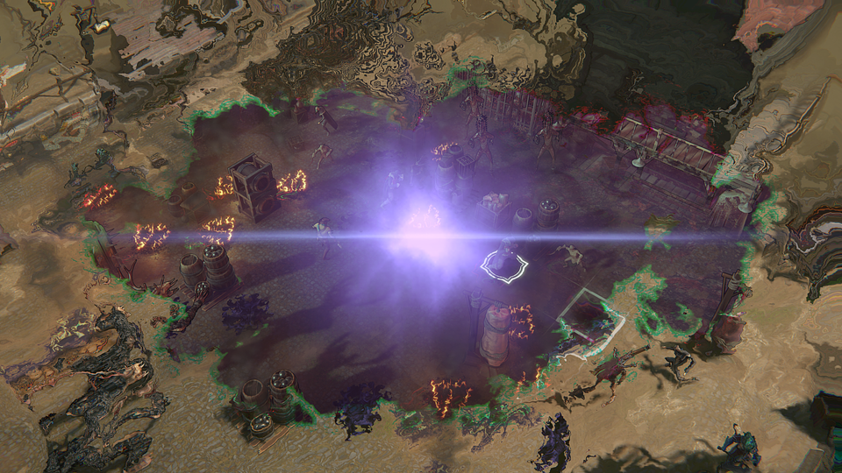

About Ice Code Games:

Ice Code Games is an independent studio based in Warsaw, Poland, best known for the award-winning Hard West 2 and Rogue Waters, released in 2024. The studio specializes in developing strategy, turn-based, and tactical games, and is currently working on a new project titled Nightmare Frontier. At the same time, it is conducting a research and development initiative focused on expanding the use of machine learning in the game testing and balancing process. More details about the company can be found on its official website.

