Sennheiser Consumer Innovation event lays out future path
Marlow, UK, 3 March 2022 – Combining the future of audio with the delight of hearing, the Sennheiser Consumer business is now officially part of Sonova Holding AG. Sennheiser consumer products under Sonova will continue to be at the forefront of audio, providing consumers with the perfect solution, be it an immersive audio experience with premium headphones and AMBEO Soundbars, or at a noisy restaurant with speech-enhanced hearables.
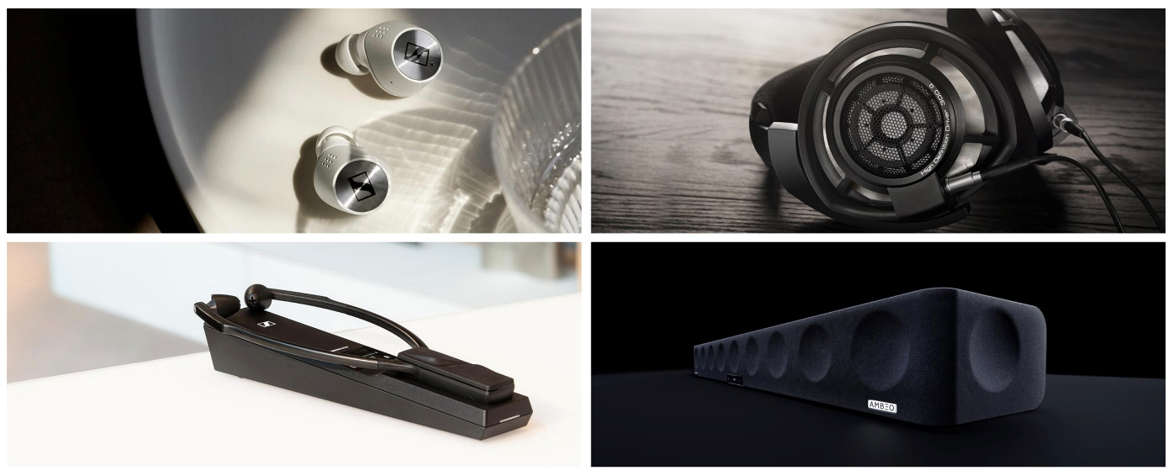
“Sennheiser and Sonova share many values and will leverage various complementary strengths,” says Martin Grieder, who will be responsible for the newly formed business at Sonova as GVP Consumer Hearing. “Both brands have a passion and dedication to high-quality audio with innovation at the heart of the business.”
Sennheiser and Sonova will operate under the Sennheiser brand umbrella and provide Sennheiser customers with best-in-class audio solutions. A long-term licensing agreement was agreed with Sonova for the use of the Sennheiser brand. The new setup perfectly caters to the top consumer needs when choosing a new pair of headphones. Hi-Fi sound quality, wearing comfort, long battery life, noise reduction, and enhanced hearing are key attributes for Sennheiser Consumer products and Sonova.
Yesterday’s Sennheiser Consumer Innovation press event also confirmed that premium headphones, audiophile, enhanced hearing, and soundbars will be the four key product segments. Sonova Consumer Hearing has announced a packed innovation pipeline with new products expected in all four of its categories in 2022, including new products in its flagship MOMENTUM range. The company also doubled down on its investment into audiophile headphones following the recently launched award-winning IE headphone series, with many more exciting products to come.
The premium headphone market is currently valued at around USD 20 billion and is expected to grow threefold to USD 60 billion in the next seven years. This growth will be driven by smartphone attachment as currently only about 20% of smartphone users have true wireless headphones, this will grow to 70% in the next seven years.* The Sennheiser brand will be at the forefront of this transition with its premium true wireless sound.
The technology behind true wireless headphones and hearing aids is also converging to create a rapidly growing enhanced hearing segment. Sonova’s acquisition of the Sennheiser Consumer business puts it in a very strong position to lead the market.
Sennheiser consumer products will continue to convince with a renewed focus and exciting technology innovations to come, while staying true to the Sennheiser sound and brand which users have come to love.
*UBS Report, 30 June 2021: Smart wireless earphones, the next device to reach annual sales of 1bn units.
ABOUT the Brand SENNHEISER
We live and breathe audio. We are driven by the passion to create audio solutions that make a difference. Building the future of audio and bringing remarkable sound experiences to our customers – this is what the Sennheiser brand has represented for more than 75 years. While professional audio solutions such as microphones, conference systems, streaming technologies and monitoring systems are part of the business of Sennheiser electronic GmbH & Co. KG, the business with consumer devices such as headphones, soundbars and speech-enhanced hearables is operated by Sonova Holding AG under the license of Sennheiser.
www.sennheiser.com
www.sennheiser-hearing.com
Global Press Contact
Sennheiser Consumer Audio GmbH
Milan Schlegel
PR and Influencer Manager Consumer - EMEA, Sennheiser Consumer Audio GmbH
milan.schlegel@sennheiser-ce.com
+49 (0) 5130 600 – 1139

Emily Ackland
Harvard
sennheiser@harvard.co.uk
+44 2078 613 945
+44 7393 758442

