

Biuro prasowe better. gaming agency
bettergamingagency.prowly.com

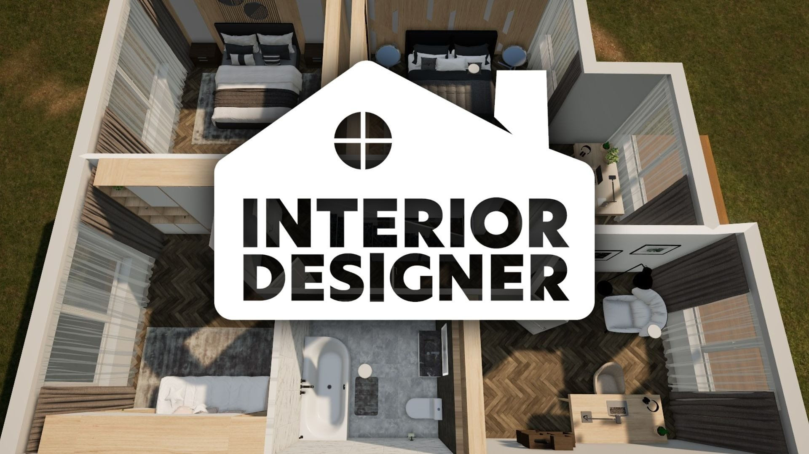

Design your dream home with Interior Designer!

Interior Designer is the latest title from developers at Roomvas. This rich and detailed simulator will allow players to design the perfect living spaces for themselves and for clients of their design studio. A wide array of tools will empower creative expression during the transformation of any room.

Interior Designer will enable players to unlock the potential of blank canvases. As interior designers, they will have control over nearly every aspect – from crafting roofs to fine-tuning lighting and selecting distinct furniture types and unique colors. The limitless options in Design Sandbox mode will ensure that each project is unique.

Interior Designer - announcement trailer

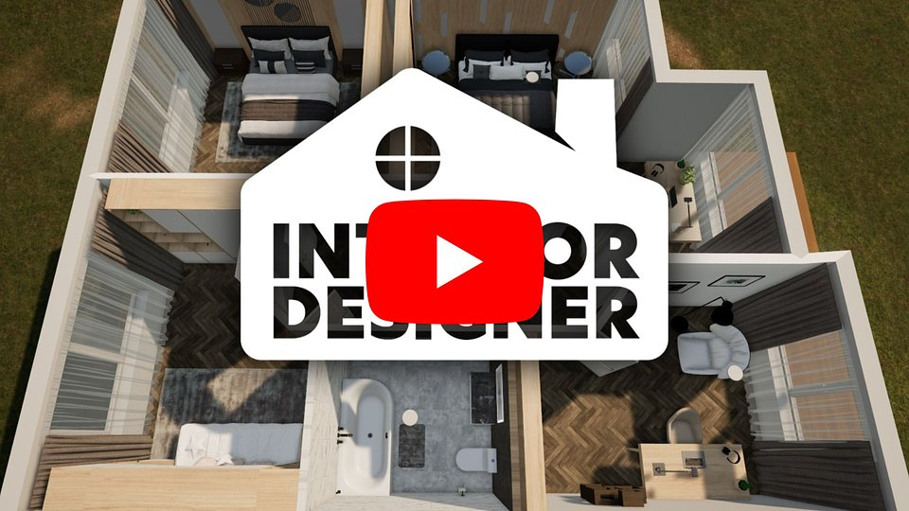
https://youtu.be/lIrYYqzoDVk

In Career Mode, players will need to meet the expectations of clients by designing living rooms, bedrooms, bathrooms, home gyms, and, most importantly, gaming rooms! The Designer League awaits for the most ambitious designers – here they can showcase their creativity, competing with other aspiring creators. Successful endeavors will ensure progress in virtual rankings and grant access to special rewards. The extensive catalog of furniture, decorations, and architectural elements will be regularly expanded to ensure there's always inspiration for new designs. Players with even bigger needs will have the choice to upload their own 3D models to utilize in the game.

With Interior Designer, crafting home spaces will become more accessible than ever before. Developers have prepared special tools that make object manipulation effortless and flexible. Stretchable furniture and dynamic cabinets are merely the starting point for aspiring designers. Moreover, players will be able to export created projects and use them as inspiration while decorating their own homes.

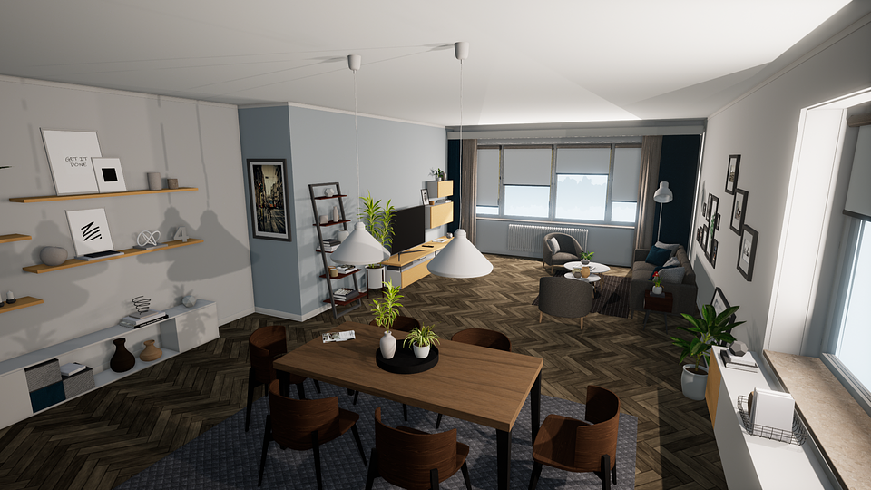

Interior Designer – key features:

🛠️Create your dream home - experiment with layouts, colors, and furniture in Design Sandbox mode, which allows you to craft spaces that reflect your unique style.🛠️The customer is king - meet the demands of clients by completing various requests in career mode. From cozy bedrooms to luxurious bathrooms and gaming rooms, investors will often surprise you with their requirements, so be prepared to meet every challenge, fulfilling their dreams and realizing your ambitions.🛠️Present your style and skills - join the Designer League, where you'll showcase your creativity, by competing with other aspiring designers. Climb the ranks, earn rewards, and become a legend in the field.🛠️Designing is for everyone!– experience a revolution in design with the best tools, including automated roof creation, stretchable furniture, adjustable lighting, and dynamic cabinets, allowing you to easily control every aspect of the project.🛠️ Don't limit yourself – explore an extensive catalog of furniture, decorations, and architectural elements that will stimulate your creativity, allowing you to prepare visionary projects. Share your creations with the world and inspire others with your work.

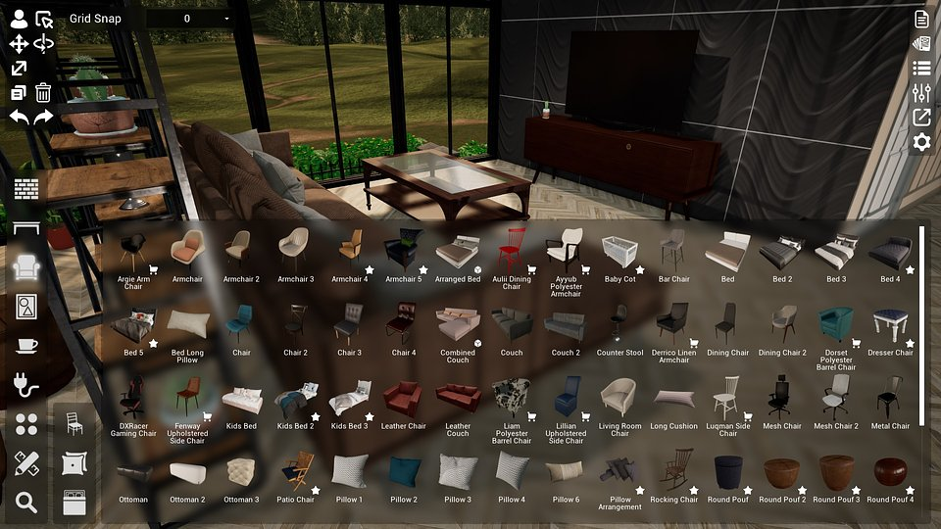

Interior Designer is being developed for PC, and all those intrigued by the possibility of designing their dream spaces can already add the game to their wishlist.The press kit is available here.



Jakub Smolak
PR Specialist at better. gaming agency
jakub.smolak@bettergaming.pro
Twitter

