Nurses Make the Difference: The Case of MSF’s Manicaland Nurse-Led Project on the Management of Diabetes and Hypertension (2016-2020)

By Heather Koga
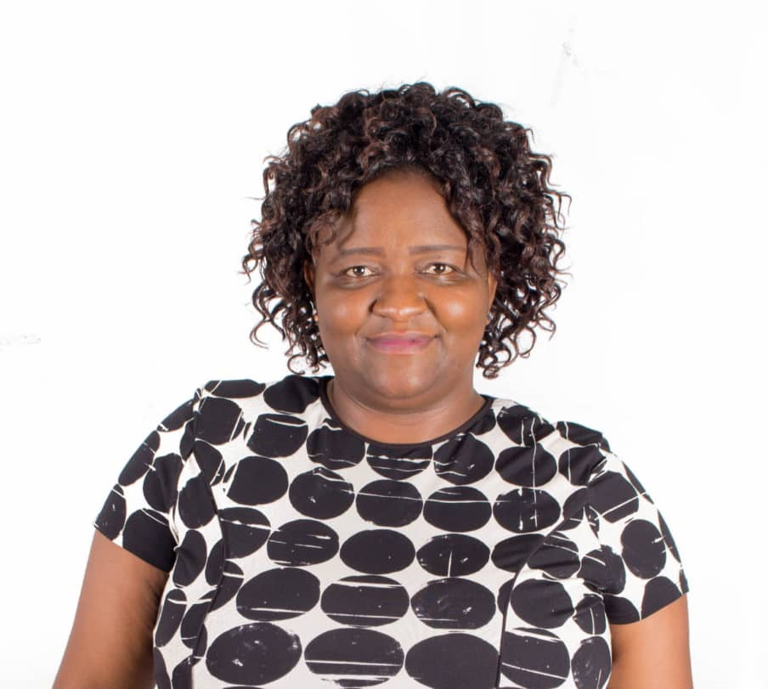

Heather Koga has been living with type 2 Diabetes since 2013. She is passionate about diabetes awareness and education, and has been involved in a number of Diabetes projects under the banner of the IDF Blue Circle Voices Network. She writes in her capacity as a diabetes advocate in Zimbabwe.

Introduction
The theme for this year’s World Diabetes Day on November 14, 2020 is “Diabetes: Nurses make the Difference”, which focuses on the crucial role that nurses play in supporting people with diabetes. As the number of people with diabetes continues to grow across the globe, the role of nurses is becoming increasingly important in the management of this condition. Nurses are often the first, and sometimes the only, professionals that patients interact with when seeking treatment; therefore, the quality of the assessments and care they provide is vital. The world over, attempts have been made to equip nurses with the skills to support people with diabetes and other chronic conditions and those at risk of developing them. This article focuses on the success of the nurse-led diabetes and hypertension model that was implemented by the Médecins Sans Frontières (MSF) in Zimbabwe.
MSF adopted a first of its kind healthcare model for the treatment of non-communicable diseases (NCDs) in Zimbabwe from 2016 to 2020. The organization collaborated with the Zimbabwe Ministry of Health and Child Care to institute a nurse-led approach that addresses the double burden of diabetes and hypertension in rural Manicaland province. This pilot programme used valuable lessons learned from the successful MSF programme on HIV at national and international levels for the past two decades. In Manicaland, as in all rural Zimbabwe, nurses are the frontline workers at the closest point of entry into the primary health care (PHC) system. In its four years of implementation, the programme proved to be a success for Manicaland, with prospects for replication throughout the country and region.
Background
Non-communicable diseases, such as diabetes and hypertension, and their complications are important contributors to mortality and morbidity the world over, including in low- and middle-income countries like Zimbabwe. There has been a continuous increase in the prevalence of NCDs, but the attention given to these diseases has not grown at the same rate. NCDs account for 31% of global morbidity (World Bank 2016). In Zimbabwe, approximately 33% of the adult population is hypertensive, while at least 6% are diabetic (WHO 2018). Diabetes and hypertension often exist together, share many causes and tend to worsen each other’s symptoms. If the conditions are not properly managed, patients can die prematurely (before they reach the age of 70).
In Zimbabwe, the problems of diabetes and hypertension are exacerbated by the state of the health system, which has continued to deteriorate over recent years. In addition to being underfunded, the health sector has also suffered a massive brain drain and infrastructure dilapidation. In a study carried out by the government in 2010, there were 1.6 physicians and 7.2 nurses for every 10,000 people. This scarcity of doctors has led to healthcare workers being overwhelmed, especially in rural areas. Millions of Zimbabweans are disconnected from health networks, living far away from larger cities and unable to afford the cost of travel and even treatment.
Because of a lack of resources, investment in prevention and management of NCDs has been largely inadequate, resulting in poorer health outcomes. The implementation of the nurse-led model was a welcome development in this context, as it sought to address these and other challenges in the health system in an affordable and feasible manner.
The Project
The MSF pilot programme ran in 12 MSF-supported facilities with 11 sites in Chipinge district and a twelfth site at Mutare Provincial Hospital, now called Victoria Chitepo Provincial Hospital. The main objective of the programme was to develop a nurse-led model of care for the diagnosis and management of diabetes and hypertension through simplified and standardized guidelines and cost-effective medicines. This pilot sought to develop ways to manage NCDs that are suitable for rural and resource-limited settings. Part of that goal was to ensure access to affordable medications and laboratory consumables and create strategies that maximize community involvement. This focus on the capacitation of nurses was vital, as it ensured the transfer of skills to the relevant healthcare professionals, since there is a scarcity of doctors in Zimbabwe and nurses are available to fill that gap.
The pilot was heavily inspired by experiences with HIV Anti-Retroviral Therapy (ART), where initially only doctors were allowed to prescribe the ARVs until simplification and standardization of guidelines permitted nurses to take a leading role in the prescription and follow up of patients on ART at the primary health care level throughout the country. Similarly, before the implementation of this programme, only doctors could diagnose and manage diabetes and hypertension at a centralized hospital level in Zimbabwe.
Training was also done on the use of basic diagnostic tools (such as blood pressure sets and devices for on-the-spot testing of blood samples) to diagnose and monitor patients’ conditions. Through this structured intensive mentoring, nurses developed the knowledge and skills to diagnose, initiate treatment and monitor diabetes and hypertension patients. This was a crucial step in a community where nurses are the frontline health professionals.
Overall, more than 3000 patients with diabetes and/or hypertension accessed medical care. MSF provided comprehensive support, including free medicines, diagnostics and medical tests such as blood sugar and blood pressure measurement. Furthermore, medical refills were extended up to three months to reduce patient travel and time spent at medical facilities. More than 8000 patients on ART also benefitted from the technical support offered by Ministry of Health nurses in the 12 MSF supported facilities. Various patient groups were formed for continuous peer support, and other interventions included mentoring on ART, viral load monitoring, and the rehabilitation of health care facilities and water supply systems.
The programme also embedded an advocacy component to develop national guidelines for nurses on management of diabetes and hypertension and increase funding for NCD programmes from both the government and other stakeholders.

Results

The project proved to be innovative and a notable success. Before the programme started, patients had to travel far distances to access health facilities where doctors could diagnose their conditions. In addition, the medications were not always available in sufficient quantities to allow for long duration refills. This meant additional cost and time spent in seeking health care.

Although adapting HIV treatment models to set up nurse-led NCD programmes is not an entirely new concept, this project marked the first nurse-led NCD model to be attempted in Zimbabwe. The model reflected the local challenges and opportunities and led to the empowerment of 35 nurses (including MSF and Ministry of Health staff) who participated in the programme, who are now able to diagnose and manage diabetes and hypertension. Through this program, patients have been empowered through education to take greater control and responsibility for their own condition through self-management. The project proved that through a simplified and standardised approach, nurses can be empowered to provide quality NCD care, in the same way they were trained to treat HIV decades ago.

Recommendations

The application of the nurse-led model has proved that such an approach can be successful and that there is need to ensure that health professionals, particularly nurses, are prepared to best support people with diabetes in their communities. The best way this can be done is through better education and funding for nursing care. Non-communicable diseases, such as diabetes and hypertension, often lack adequate funding from governments and international organizations. Governments, international and local health organizations—including the World Health Organization (WHO)—and other health providers, civic society organizations and stakeholders must continue to escalate the training and employment of nurses in all countries, including low- and medium-income countries.

According to the WHO (2020), the number of nurses trained and employed needs to grow by 8% a year to prevent alarming shortfalls in the profession by the year 2030. Efforts such as those by the International Diabetes Federation (IDF), which currently runs free online courses like “The Role of the Diabetes Nurse Educator” with the aim of facilitating opportunities for nurses to learn more about the condition, should be commended and emulated by other stakeholders.

Conclusion

As MSF hands over its project to the Ministry of Health, the organization hopes that the government of Zimbabwe will continue to build on the successes of the Manicaland Nurse-Led Model, by replicating it throughout the country, particularly in the rural provinces. The project’s success has shown that both nurses and patients are ready to support a successful NCD care management model. Moreover, with NCDs high on the international agenda and with increased vulnerability of people with non-communicable diseases due to the COVID-19, there is even greater need to capitalize on the capacity of rural communities to manage the conditions, as they make up the greater part of the Zimbabwean population. With the right support and expertise, nurses can indeed make a difference for people living with diabetes and hypertension in Zimbabwe.

